PART F1. Index Maps and Diagrams (Plates F1-1 to F1-10) and Tables (Tbls. F1-1 to F1-6);
with Names and Acronyms of Hydrogeologic Subdivisions and Fault Zones
PLATE and TABLE Numbers
Pl. F1-1. (p. 3) Index map of the Mesilla Basin region (MBR) showing locations of the Study Area
(Fig. 1-3, red outline), major landscape features in the northern Mexican Highland section of the B&R province, and basins of the southern RG-rift province (Fig. 1-1). Blue shading shows the approximate extent of the areas inundated by pluvial-Lakes Palomas and Otero at their respective Late Pleistocene high stands in the Zona Hidrogeológica de Conejos Médanos/El Barreal basin complex, and the Tularosa Basin. Swanson Geoscience, LLC compilation on a 2017 Google Earth® image-base.
Pl. F1-2. (p. 12) U.S. Bureau of Reclamation Map showing locations of major surface-water management structures of the Rio Grande Project between the San Marcial (removed 1964) and Fort Quitman Gaging Stations. EBID indicates Elephant Butte Irrigation District operations (courtesy of Rhea Graham; cf. USBOR 2011).
Pl. F1-3. (Rpt. PL. 1A; p. 4) Study Area index map showing locations of the Mesilla, Southern Jornada, and El Parabién groundwater (GW) basins (MeB, SJB and EPB; outlined in green, orange and red, respectively). Also shown are the locations of hydrogeologic cross-section A-A′ to S-S′ (Report PLATES 5a to 5s), major terrain features (incl. the Mesilla Valley, Selden Canyon and El Paso del Norte of the Rio Grande), and the Las Cruces and El Paso/Ciudad Juárez metropolitan centers. USGS DEM base, with UTM-NAD83 SI-system and latitude/longitude coordinates
Pl. F1-4. (F1-4a and 1-4b; p. 7) Index maps to major geohydrologic features of the Study Area (Fig. 1-3). The approximate pre-development (~1976) potentiometric-surface altitude (amsl) is shown on Pl. F1-4a with 20- and 100-ft contours, and on Pl. F1-4b with 5-, 10-, and 30-m contours. Major surface-watershed divides are shown by solid and dashed thick blue lines. The dashed blue line with arrows in the map’s SW corner marks the approximate boundary between EPdN- and Los Muertos Basin-directed GW flow.
Pl. F1-5. (Rpt. PL. 2B; p. 8) Index map for major hydrogeologic subdivisions of the Study Area
(Fig. F1-5). The Mesilla GW Basin (MeB) is in blue shades, and the Mesilla Valley of the
Rio Grande is in dark blue. El Parabién and Southern Jornada GW Basins (EPB and SJB) are in pink and light green, respectively. SCyn-Selden Canyon and EPdN-El Paso del Norte. Solid and dashed black lines are boundaries of interbasin-uplift and intrabasin subdivisions. Acronyms and names of hydrogeologic-subdivision categories, including fault zones (lines with bar and ball symbols), are defined in Tbl. F1-2 (Rpt. TBL. 2); and those for fault zones are listed on Tbl. F1-3. USG DEM base.
Table F1-1. (p. 9 and 10) Names and acronyms of hydrogeologic subdivisions shown on maps, cross-sections, and well-information spreadsheet (Rpt. PLS. 1 to 8, TBLS. 1 to 3).
Table F1-2. (p. 11) Names, and Acronyms for Basin- and Subbasin-Boundary Fault Zones (Pl. F1-5).
Pl. F1-6. (p. 12) Pliocene and Early Pleistocene geomorphic setting of the ARG distributive fluvial system (DFS-red lines) that terminated in the Lake Cabeza de Vaca (LCdV) basin complex of Strain (1966, 1971). Schematic depiction of ARG distributary channel-belt in the southeastern B&R province (adapted from Hawley 1975, Fig. 2). Explanations of the symbols that show the general positions of primary Distributive Fluvial System (DFS)-apex and channel-belt-segments of ancestral rivers with fluvial-deltaic termini in the LCdV basin complex on Table F1-3. The Rios Casas Grandes (violet), Santa Maria and Carmen (pink and orange), and the Mimbres River (yellow) remain as the major surface and subsurface flow fluvial contributors to ephemeral lake-plain remnants of Late Quaternary Paleo-Lake Palomas: Lagunas Guzman, Santa Maria and Patos, and El Barreal-Salinas de Uníon. Only parts of the Mesilla Basin and Hueco Bolson have surface/subsurface connection with Rio Grande at present (cf. Pls. F1-2 and F1-3; Hawley 1975, Gile et al. 1981, Connell et al. 2005, Castiglia and Fawcett 2006, Weissmann et al. 2011, Davidson et al. 2013, and Nichols 2015). 2018 Google Earth® image base.
Table F1-3. (p. 13) Explanation of Plate F1-6 alpha-numeric symbols for Pliocene and early Pleistocene Distributive Fluvial Systems (DFSs) of ancestral-river systems with fluvial-deltaic termini in the Paleo-Lake Cabeza de Vaca complex (LCdV) and Bolson de los Muertos (BdlM).
Plate F1-7. (p. 14) Schematic distribution patterns of major lithofacies assemblages (LFAs) in intermontane-basin and river-valley fills of the RG-rift province. Modified from Hawley and others (1995, Fig. 6) and Hawley and Kernodle (2000). See Plate 1-8 and Tables F1-4 to F1-6.
Plate F1-8. (p. 15) Idealized triangular diagram of dominant textural classes in lithofacies assemblages (LFAs) 1 to 10; and primary LFA composition of SFG Hydrostratigraphic Units (HSUs) - USF/MSF/LSF. See Plate F1-7 and Tables F1-4 to F1-6.
Table F1-4. (p. 16) Summary of depositional setting and dominant textures of major lithofacies assemblages (LFAs) in Santa Fe Group basin fill (1-10) and Rio Grande Valley fill (a-c) in the intermontane basins of the Rio Grande rift tectonic province. Modified from Hawley and Kernodle (2000). See Plates F1-7 and 8, and Tables F1-5 and F1-6.
Table F1-5. (p. 17) Summary of major sedimentary properties that influence groundwater-flow and aquifer-production potential of Lithofacies Assemblages (LFAs) 1 to 10 in Santa Fe Group basin fill. Modified from Haase and Lozinsky (1992). See Plate F1-7 and 8, and Table F1-4.
Table F1-6. (p. 17) Summary of major sedimentary properties that influence groundwater-flow and aquifer-production potential of Lithofacies Assemblages (LFAs) a to c in post-SFG RG-valley and basin fills. Modified from Hawley and Kernodle (2000). See Plates F1-7 and 8, and Table F1-4.
Pl. F1-9. (Modified from Hawley et al. 2009, Fig. 6; p. 18) Correlation diagram of major Time-Rock classes, and lithostratigraphic and hydrostratigraphic units of Cenozoic Age in the southern RG-rift region of New Mexico, Texas, and Chihuahua. Bedrock units: Qb–Quaternary basalt, Tb–Tertiary mafic volcanics, and Tv–older Tertiary intermediate and silicic volcanics, and associated plutonic-igneous and sedimentary rocks. See Pls. F1-7 and F-8, Tbls. F1-4 to F1-6.
Pl. F1-10. (p. 19) Definitions of Divisions of Geologic Time used in this report.

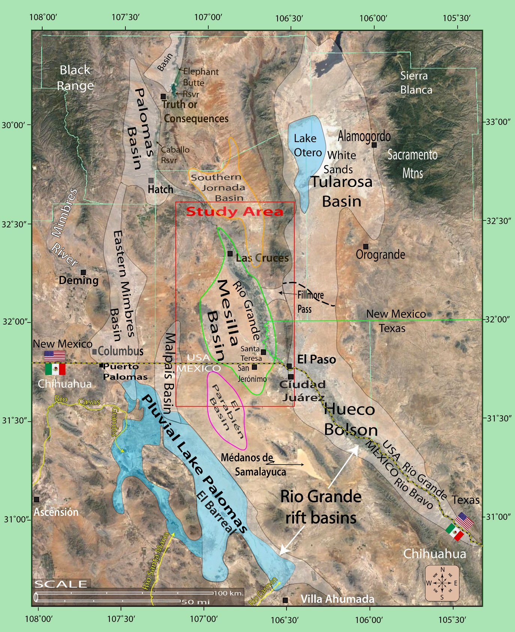
Pl. F1-1. Index map of the Mesilla Basin region (MBR) showing locations of the Study Area
(Fig. 1-3, red outline), major landscape features in the northern Mexican Highland section of the B&R province, and basins of the southern RG-rift province (Fig. 1-1). Blue shading shows the approximate extent of the areas inundated by pluvial-Lakes Palomas and Otero at their respective Late Pleistocene high stands in the Zona Hidrogeológica de Conejos Médanos/El Barreal basin complex, and the Tularosa Basin. Swanson Geoscience, LLC compilation on a 2017 Google Earth® image-base.
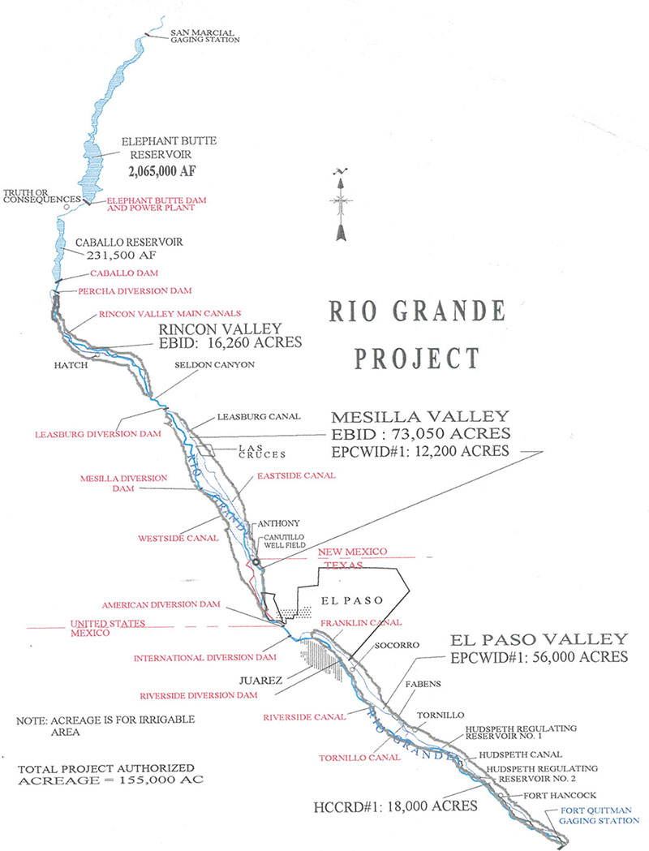
Pl. F1-2. U.S. Bureau of Reclamation Map showing locations of major surface-water management structures of the Rio Grande Project between the San Marcial (removed 1964) and Fort Quitman Gaging Stations. EBID indicates Elephant Butte Irrigation District operations (courtesy of Rhea Graham; cf. USBOR 2011).
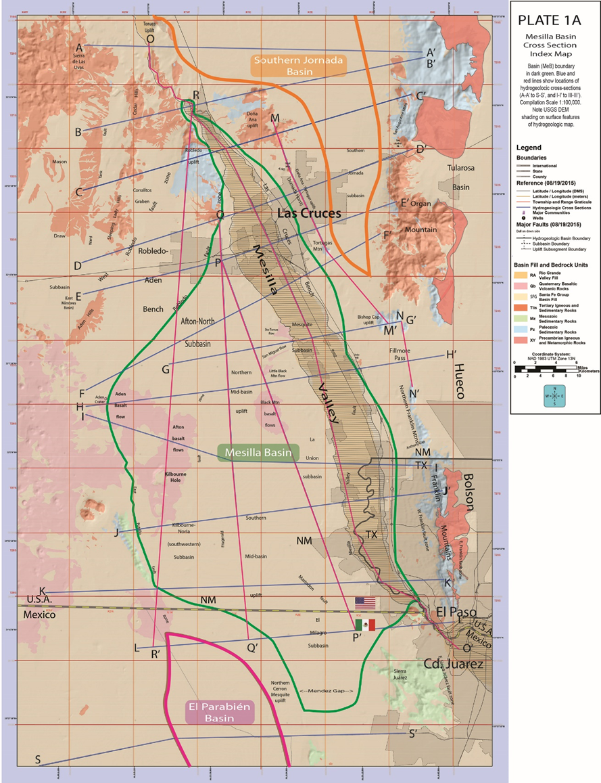
Pl. F1-3. (Rpt. PL. 1A) Study Area index map showing locations of the Mesilla, Southern Jornada, and El Parabién groundwater (GW) basins (MeB, SJB and EPB; outlined in green, orange and red, respectively). Also shown are the locations of hydrogeologic cross-section A-A′ to S-S′ (Report PLATES 5a to 5s), major terrain features (incl. the Mesilla Valley, Selden Canyon and El Paso del Norte of the Rio Grande), and the Las Cruces and El Paso/Ciudad Juárez metropolitan centers. USGS DEM base, with UTM-NAD83 SI-system and latitude/longitude coordinates.
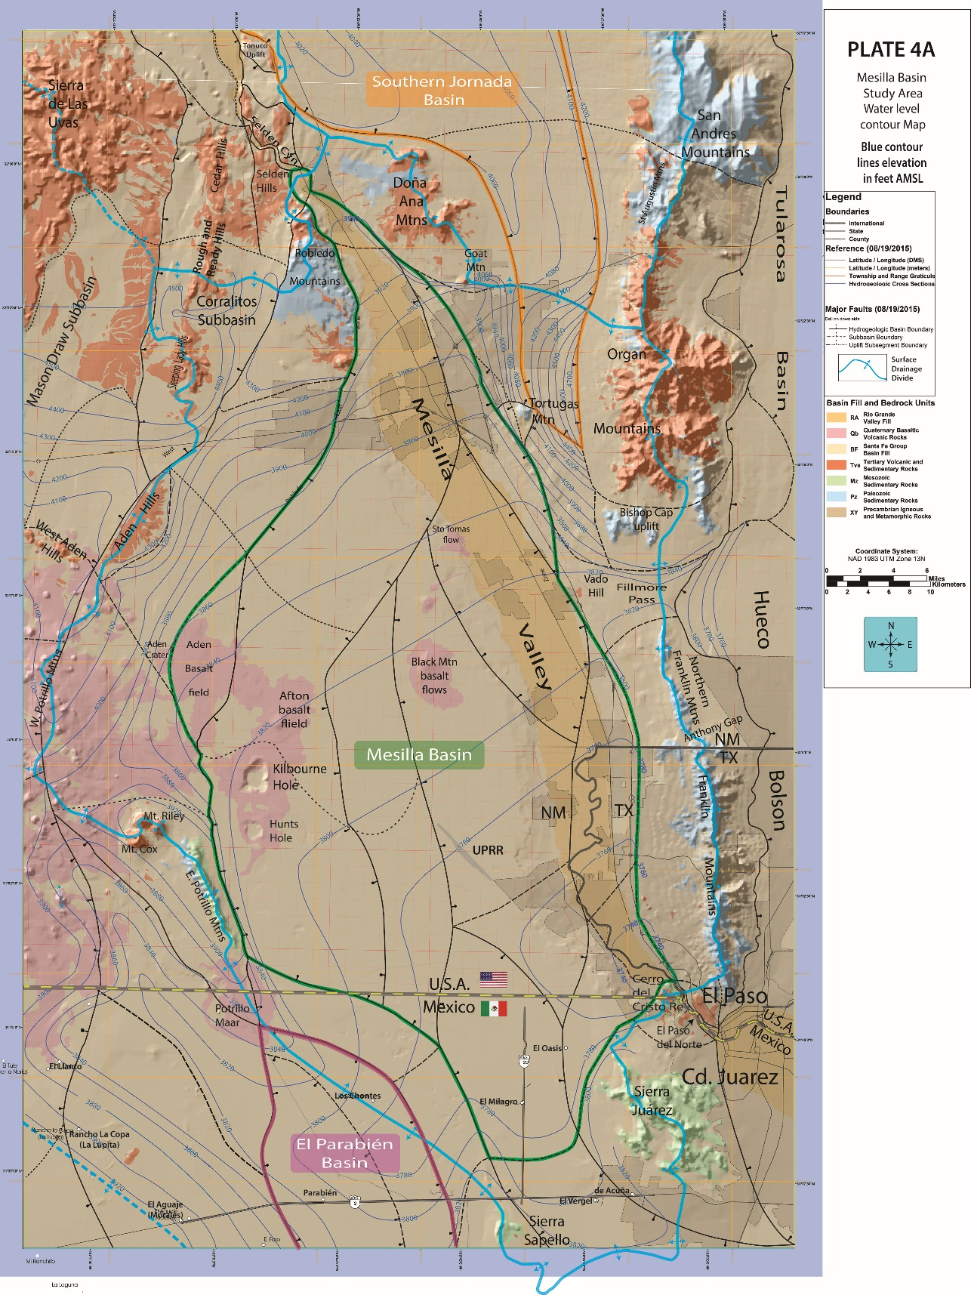
Pl. F1-4a. Index map to major geohydrologic features of the NM WRRI Study Area (Fig. 1-3). The approximate pre-development (~1976) potentiometric-surface altitude (amsl) is shown on Pl. F1-4a with 20- and 100-ft contours, and on Pl. F1-4b with 5-, 10-, and 30-m contours. Major surface-watershed divides are shown by solid and dashed thick blue lines. The dashed blue line with arrows in the map’s SW corner marks the approximate boundary between EPdN- and Los Muertos Basin-directed GW flow.
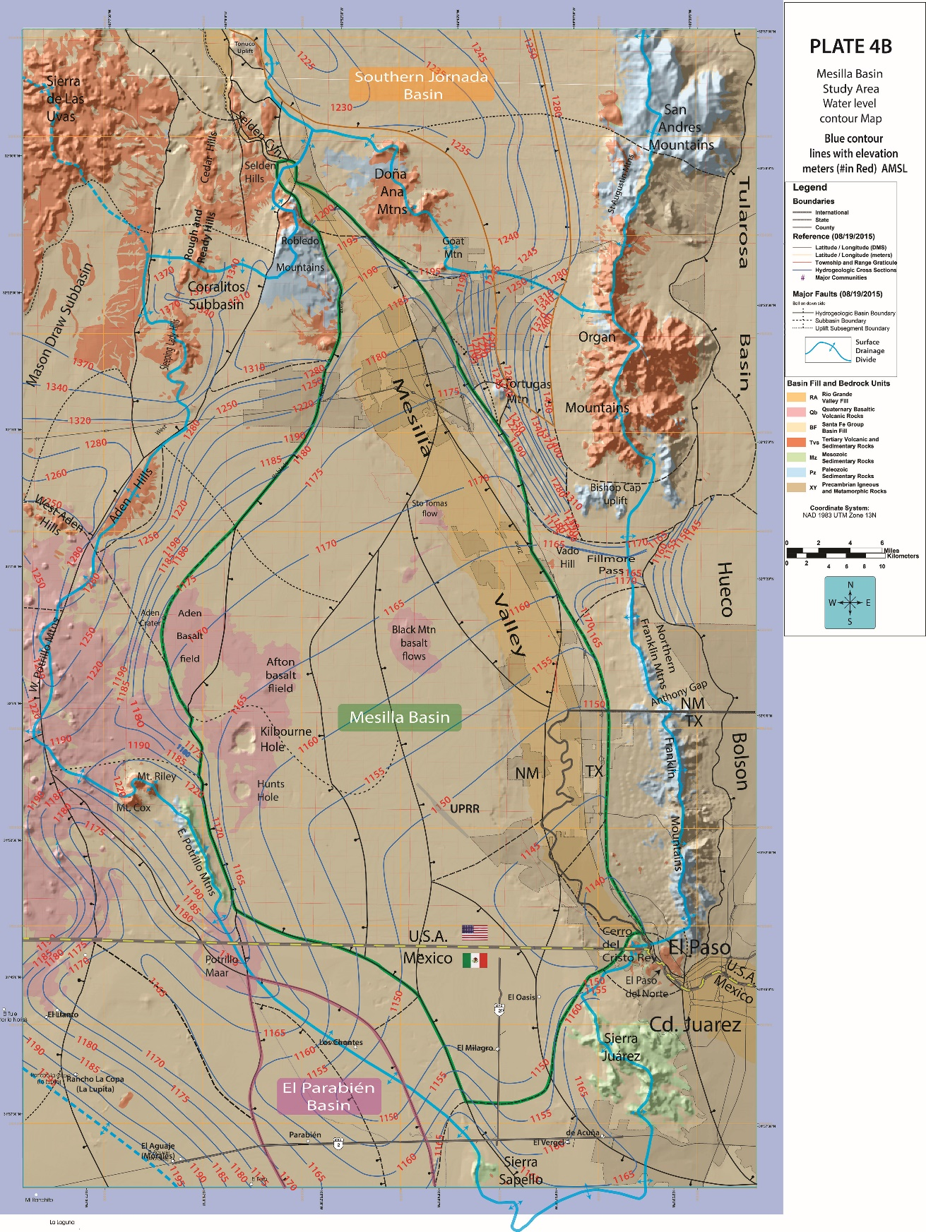
Pl. F1-4b. Index map to major geohydrologic features of the NM WRRI Study Area (Fig. 1-3). The approximate pre-development (~1976) potentiometric-surface altitude (amsl) is shown on Pl. F1-4a with 20- and 100-ft contours, and on Pl. F1-4b with 5-, 10-, and 30-m contours. Major surface-watershed divides are shown by solid and dashed thick blue lines. The dashed blue line with arrows in the map’s SW corner marks the approximate boundary between EPdN- and Los Muertos Basin-directed GW flow.
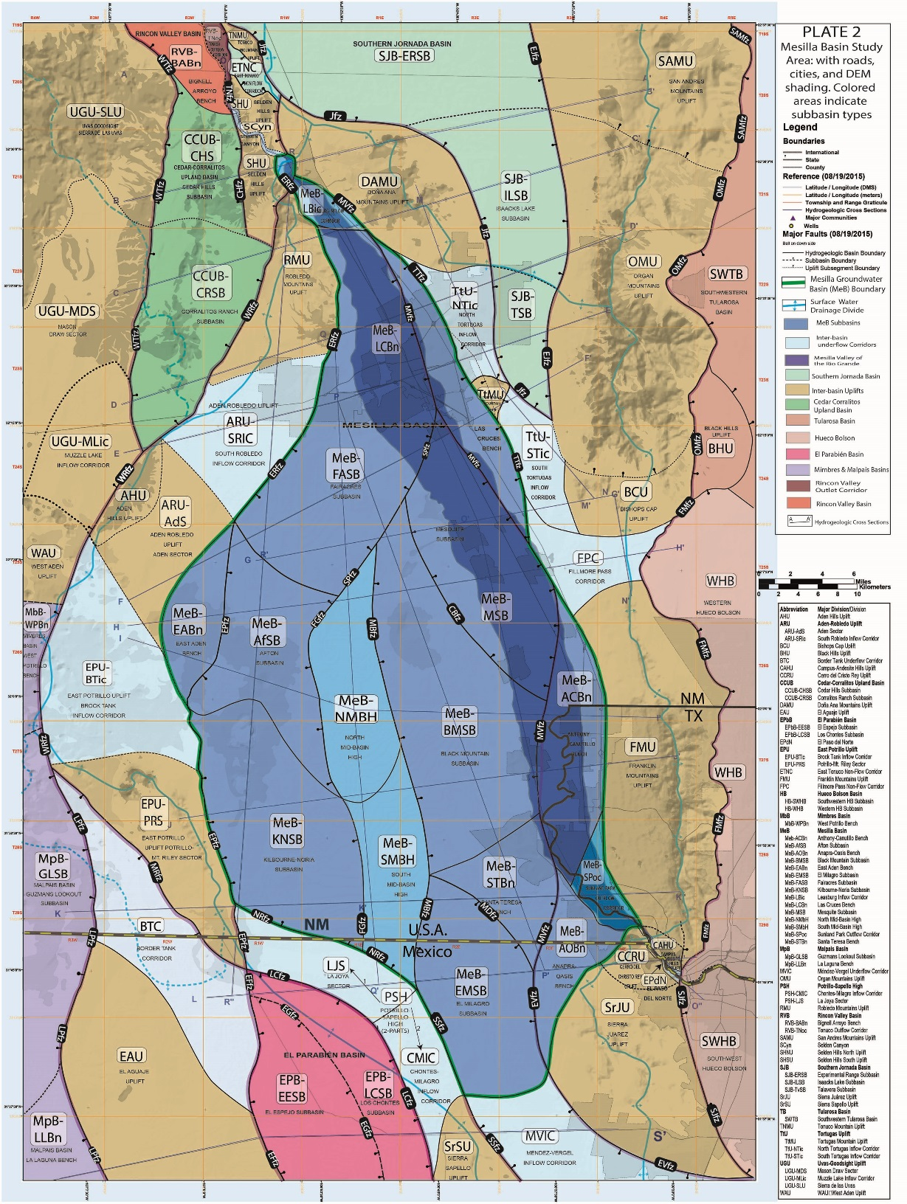
Pl. F1-5. (Rpt. PL. 2B) Index map for major hydrogeologic subdivisions of the Study Area (Fig. F1-5). The Mesilla GW Basin (MeB) is in blue shades, and the Mesilla Valley of the Rio Grande is in dark blue. El Parabién and Southern Jornada GW Basins (EPB and SJB) are in pink and light green, respectively. SCyn-Selden Canyon and EPdN-El Paso del Norte. Solid and dashed black lines are boundaries of interbasin-uplift and intrabasin subdivisions. Acronyms and names of hydrogeologic-subdivision categories, including fault zones (lines with bar and ball symbols), are defined in Tbl. F1-2 (Rpt. TBL. 2); and those for fault zones are listed on Tbl. F1-3. USG DEM base.
Table F1-1. Names and acronyms of hydrogeologic subdivisions shown on maps, cross-sections, and well-information spreadsheet (Rpt. PLS. 1 to 8, TBLS. 1 to 3).
ACRONYM RIO GRANDE (RG) VALLEY AND CANYONS (NARROWS)
EPdN El Paso del Norte (Cyn)
MeV Mesilla Valley
SCyn Selden Canyon (Cyn)
EPJV El Paso-Juárez Valley
ACRONYM MESILLA GW BASIN (MeB) SUBDIVISION (2,419: area in km²)
MeB-ACBn Mesilla Basin Anthony-Canutillo Bench (138)
MeB-AfSB Mesilla Basin Afton Subbasin (180)
MeB-AOBn Mesilla Basin Anapra-Oasis Bench (72.7)
MeB-BMSB Mesilla Basin Black Mountain Subbasin (353)
MeB-EABn Mesilla Basin East Aden Bench (70.7)
MeB-EMSB Mesilla Basin El Milagro Subbasin (203)
MeB-FASB Mesilla Basin Fairacres Subbasin (382)
MeB-KNSB Mesilla Basin Kilbourne-Noria Subbasin (278)
MeB-LBic Mesilla Basin Leasburg Inflow Corridor (25.4)
MeB-LCBn Mesilla Basin Las Cruces Bench (97.5)
MeB-MSB Mesilla Basin Mesquite Subbasin (228)
MeB-NMbH Mesilla Basin North Mid-Basin High (143)
MeB-SMbH Mesilla Basin South Mid-Basin High (121)
MeB-STBn Mesilla Basin Santa Teresa High (89.5)
MeB-SPoc Mesilla Basin Sunland Park Outflow Corridor (33.4)
ACRONYM OTHER GW BASINS (B) SUBDIVISION
EPB El Parabién Basin (N-part—Drains to MeB)
EPB-EESB El Parabién Basin El Espejo Subbasin (157)
EPB-LCSB El Parabién Basin Los Chontes Subbasin (126)
HB Hueco Bolson (W-edge—Receives inflow from MeB through EPdN)
HB-NWSB Hueco Bolson Northwestern Subbasin
HB-NWSB Hueco Bolson Southwestern Subbasin
MbB Mimbres Basin (No-flow boundary with MeB; surface and subsurface flow to Los Muertos Basin (LMB—Bolsón de los Muertos)
MbB-WPBn Mimbres Basin West Potrillo Bench
MpB Malpais GW Basin (E-edge—connects with BTC, MbB, and LMB)
MpB-GLSB Malpais Basin Guzmans Lookout Subbasin (SB)
MpB-LLBn Malpais Basin La Laguna Bench (Bn)
RVB Rincon Valley GW Basin (Drains to MeB through SCyn)
RVB-BASB Rincon Valley Basin Bignell Arroyo Subbasin (47.2)
RVB-TNoc Rincon Valley Basin Tonuco Outflow Corridor (5)
SJB Southern Jornada GW Basin (495-Drains to MeB and RVB)
SJB-ERSB Southern Jornada Basin Experimental Range Subbasin (264)
SJB-ILSB Southern Jornada Basin Isaacks Lake Subbasin (164)
SJB-TvSB Southern Jornada Basin Talavera Subbasin (68.2)
SWTB Southwestern Tularosa Basin
ACRONYM UPLAND GW BASIN SUBDIVISION
CCUB Cedar-Corralitos Upland Basin (UB)
CCUB-CHSB Cedar-Corralitos Cedar Hills Subbasin (96.2)
CCUB-CRSB Cedar-Corralitos Corralitos Ranch Subbasin (205)
Table F1-1. (concluded) Names and abbreviations of basin/inter-basin subdivisions.
ACRONYM INTERBASIN HIGH (IBH) SUBDIVISION
PSH Potrillo-Sapello High (163)
PSH-LJS La Joya Sector (93.5)
PSH-CMIC Chontes-Milagro Inflow Corridor (69.5)
(EPB-LCSB to MeB-EMSB)
ACRONYM INTERBASIN UPLIFT (U) SUBDIVISION
AHU Aden Hills Uplift
ARU Aden-Robledo Uplift
ARU-AdS Aden-Robledo Uplift Aden Sector (S)
ARU-SRic Aden-Robledo Uplift South Robledo Inflow Corridor (145)
BCU Bishop Cap Uplift
BHU Black Hills Uplift
CAHU Campus-Andesite Hills Uplift
CCRU Cerro del Cristo Rey Uplift
CMU Camel Mountain Uplift
DAMU Doña Ana Mountains Uplift
EAU El Aguaje Uplift (310)
EPU East Potrillo Uplift
EPU-BTic East Potrillo Uplift Brock Tank Inflow Corridor (227)
EPU-PRS East Potrillo Uplift Potrillo-Mt. Riley Sector (S)
FMU Franklin Mountains Uplift
OMU Organ Mountains Uplift
RMU Robledo Mountains Uplift
SAMU San Andres Mountains Uplift
SHU Selden Hills Uplift
SJU Sierra Juárez Uplift
SSU Sierra Sapello Uplift (41)
TMU Tonuco Mountain Uplift
TtU Tortugas Uplift
TtMU Tortugas Uplift Tortugas Mountain Uplift (U)
TtU-NTic Tortugas Uplift North Tortugas Inflow Corridor (63.5)
TtU-STic Tortugas Uplift South Tortugas Inflow Corridor (59.2)
UGU Uvas-Goodsight Uplift
UGU-SLU Uvas-Goodsight Uplift Sierra de las Uvas (U)
UGU-MDS Uvas-Goodsight Uplift Mason Draw Sector (S)
UGU-MLic Uvas-Goodsight Uplift Muzzle Lake Inflow Corridor (to Mimbres Basin-MbB)
ACRONYM MAJOR INTERBASIN GROUNDWATER-FLOW CORRIDORS
BTC Border Tank Corridor (214) (Malpais Basin to El Parabién Basin underflow)
ETNC East Tonuco Corridor (13.5)
(Jornada Basin to Rincon Valley Basin underflow)
FPC Fillmore Pass Corridor (73.7)
(Mesilla Basin-Hueco Bolson—potential inter-basin underflow)
MVIC Méndez-Vergel Inflow Corridor (115)
(possible Hueco Bolson to Mesilla Basin underflow)

Table F1-2. Names, and Acronyms for Basin- and Subbasin-Boundary Fault Zones (Pl. F1-5).

- Groundwater Basin/Intrabasin-
Boundary Fault Zones (fz)
- Mesilla and El Parabién Basins
- Mesilla Basin (MeB)
CBfz—Chamberino fz
EVfz—El Vergel fz
EPfz—East Potrillo fz
ERfz—East Robledo fz
FGfz—Fitzgerald fz
MBfz—Mid-Basin fz
MDfz—Mastodon fz
MVfz—Mesilla Valley fz
NRfz—Noria fz
SPfz—San Pablo fz
SSfz—Sierra Sapello fz
TTfz—Tortugas fz
2. El Parabién Basin (EPB)
EFfz—El Faro fz
EGfz—El Girasol fz
LCfz—Los Cuates fz
B. Southern Jornada and Rincon Valley Basins
- Southern Rincon Valley Basin (SJB)
TNfz—Tonuco fz
WTfz—Ward Tank fz
- Southern Jornada Basin (SJB)
EJfz—East Jornada fz
Jfz—Jornada fz
- Hueco Bolson and Tularosa Basin
- Northwestern Hueco Bolson (NWHB)
FMfz—Franklin Mountain fz
SJfz—Sierra Juárez fz
- Southwestern Tularosa GW Basin (SWTB)
OMfz—Organ Mountains fz
SAMfz—San Andres Mountains Fz
- Western-Border Basins
- Cedar-Corralitos Upland Basin (CCUB)
CHfz—Cedar Hills fz
WRfz—West Robledo fz
WTfz—Ward Tank fz
- Northeastern Mimbres Basin (MbB)
WTfz—Ward Tank fz
WRfz—West Robledo fz
- Malpais Basin (MpB)
LPfz—La Peña fz
- Inter-basin Uplift Fault Zones (fz)—Boundary and Interior
- Aden-Robledo Uplift (ARU)
- ERfz—East Robledo fz
- WRfz—West Robledo fz
- Doña Ana Mountain Uplift (DAMU)
- Jfz—Jornada fz
- MVfz—Mesilla Valley fz
- TTfz—Tortugas fz
- East Potrillo Uplift (EPU)
- EPfz—East Potrillo fz
- MRfz—Mount Riley fz
- El Aguaje Uplift (EAU)
1. EFfz—El Faro fz
2. LPfz—La Pena fz
- Franklin Mountains Uplift (FMU)
- FMfz—Franklin Mountains fz
- WFfz—West Franklin fz
- Organ Mountain Uplift (OMU)
- EJfz—East Jornada fz
- OMfz—Organ Mountains fz
- Robledo Mountain Uplift (RMU)
- ERfz—East Robledo fz
- WRfz—West Robledo fz
- Sierra Juárez Uplift (SJU)
1. SJfz—Sierra Juárez fz
2. EVfz—El Vergel fz
- Sierra Sapello Uplift
1. SSfz—Sierra Sapello fz
2. LCfz—Los Cuates fz
- Southern San Andres Mtns (SAMU)
- EJfz—East Jornada fz
- SAMfz—San Andres Mountains fz
- Tortugas Uplift (TtU)
1. Jfz—Jornada fz
2. TTfz—Tortugas fz
- Inter-basin Corridor Boundary-fault zones (fz)
- Border Tank Corridor (BTC)
- LPfz—La Peña fz
- MRfz—Mount Riley fz
- Fillmore Pass Corridor (FPC)
1. FMfz—Franklin Mountains fz
2. MVfz—Mesilla Valley fz
- Méndez-Vergel Corridor (MVC)
- EVFZ—El Vergel fz
- SSfz—Sierra Sapello fz

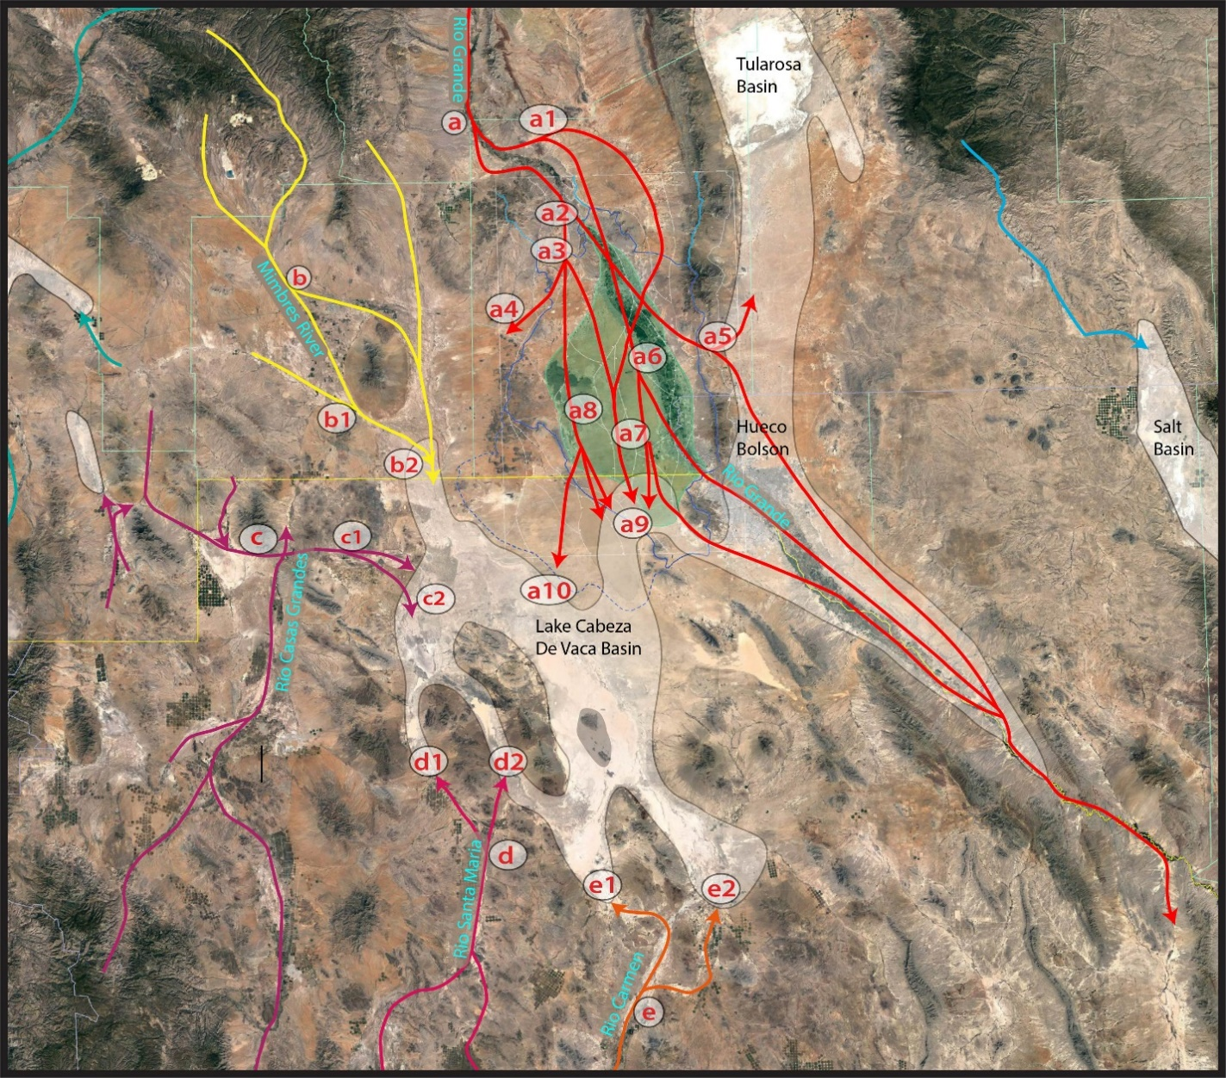
Pl. F1-6. Pliocene and Early Pleistocene geomorphic setting of the ARG distributive fluvial system (DFS-red lines) that terminated in the Lake Cabeza de Vaca (LCdV) basin complex of Strain (1966, 1971). Schematic depiction of ARG distributary channel-belt in the southeastern B&R province (adapted from Hawley 1975, Fig. 2). Explanations of the symbols that show the general positions of primary Distributive Fluvial System (DFS)-apex and channel-belt-segments of ancestral rivers with fluvial-deltaic termini in the LCdV basin complex on Table F1-3. The Rios Casas Grandes (violet), Santa Maria and Carmen (pink and orange), and the Mimbres River (yellow) remain as the major surface and subsurface flow fluvial contributors to ephemeral lake-plain remnants of Late Quaternary Paleo-Lake Palomas: Lagunas Guzman, Santa Maria and Patos, and El Barreal-Salinas de Uníon. Only parts of the Mesilla Basin and Hueco Bolson have surface/subsurface connection with Rio Grande at present. (cf. Pls. F1-2 and F1-3; Hawley 1975, Gile et al. 1981, Connell et al. 2005, Castiglia and Fawcett 2006, Weissmann et al. 2011, Davidson et al. 2013, and Nichols 2015). 2018 Google Earth® image base.

Table F1-3. Explanation of Plate F1-6 alpha-numeric symbols for Pliocene and Early Pleistocene Distributive Fluvial Systems (DFSs) of ancestral rivers with fluvial-deltaic termini in the Paleo-Lake Cabeza de Vaca complex (LCdV) and Bolson de los Muertos (BdlM).
a. Apex area of the Ancestral Rio Grande-Camp Rice Fm DFS (ARG-DFS) in the Southern Jornada Basin, Hueco Bolson, and Los Muertos BASIN (BdLM) —Red Lines
a1. Eastern Rincon Valley head of the ARG-DFS distributary-channel complex in the Southern Jornada Basin.
a2. Upper Selden Canyon head of the ARG-DFS distributary-channel complex in the central and eastern Mesilla Basin area.
a3. Lower Selden Canyon head of the ARG-DFS distributary-channel complex in the western Mesilla Basin area.
a4. Cedar-Corralitos Basin head of the ARG-DFS distributary-channel complex in the northwestern Mesilla and northeastern Mimbres Basin areas.
a5. Fillmore Pass head of the ARG-DFS distributary-channel complex in the western Tularosa Basin and northwestern Hueco Bolson area (Fig. 1-15, Seager 1981 [Fig. 84]).
a6. South-central Mesilla Basin head of the ARG-DFS distributary-channel complex in the El Parabién Basin-Paso del Norte area.
a7. Southeastern Mesilla Basin head of the ARG-DFS distributary-channel complex in the El Parabién Basin, Méndez-Vergel Corridor, and southwestern Hueco Bolson area.
a8. Southwestern Mesilla Basin head of the ARG-DFS distributary-channel complex in the El Parabién Basin and the northeastern LCdV-BdLM.
a9. South-central termini of ARG-DFS fluvial-deltaic distributaries in the northeastern LCdV-BdLM.
a10. Southwestern termini of ARG-DFS fluvial-deltaic distributaries in the northwestern LCdV-BdLM.
b. Apex area of the Ancestral Rio Mimbres-Upper Gila GP DFS (ARM-DFS—Yellow Lines) in the northern LCdV-BdLM
b1. Southeastern Mimbres Basin head of the ARM-UGDFS fluvial-deltaic distributaries.
b2. Southern termini of ARM-DFS fluvial-deltaic distributaries in the northern LCdV-BdLM.
c. Apex area of the Ancestral Rio Casas Grandes-Boca Grande DFS (ARCG-DFS—Violet Lines) in the northwestern LCdV-BdLM
c1. Head of ARCG-BGDFS fluvial-deltaic distributaries in the northwestern LCdV-BdLM
c2. Eastern termini of ARCG-DFS fluvial-deltaic distributaries in the northwestern LCdV- BdLM
d. Apex area of the Ancestral Rio Santa Maria DFS (ARSM-DFS—Pink Lines) in the southwestern LCdV-BdLM
d1. Eastern termini of ARSM-DFS fluvial-deltaic distributaries south of Laguna Santa Maria.
d2. Western termini of ARSM-DFS fluvial-deltaic distributaries south of Laguna Fresnal
e. Apex area of the Ancestral Rio Carmen DFS (ARC-DFS—Orange Lines) in the southeastern LCdV-BdLM
e1. Eastern termini of ARC-DFS fluvial-deltaic distributaries in the southeastern LCdV-BdlM near Villa Ahumada and Laguna Patos.
e2. Western termini of ARC-DFS fluvial-deltaic distributaries northwest of Carrizal in the southeastern LCdV-BdLM

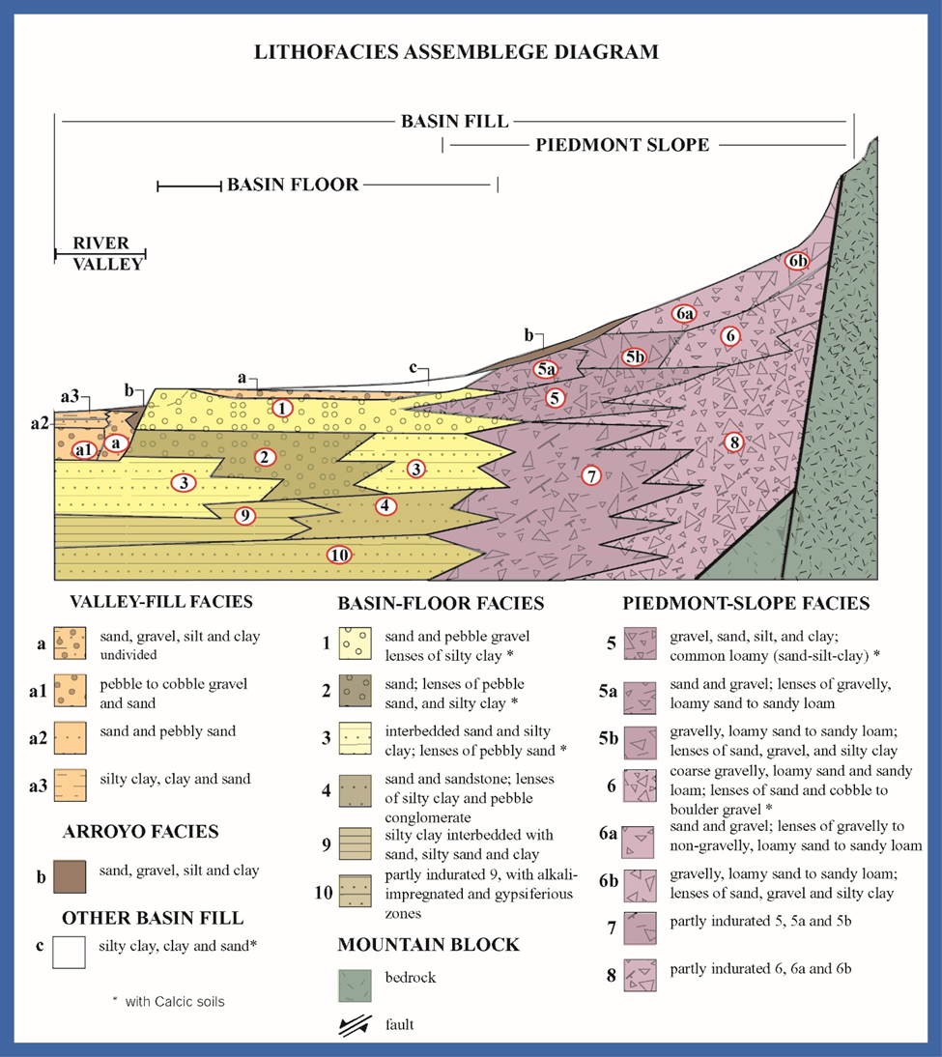
Pl. F1-7. Schematic distribution patterns of major lithofacies assemblages (LFAs) in intermontane-basin and river-valley fills of the RG-rift province. Modified from Hawley and others (1995, Fig. 6) and Hawley and Kernodle (2000). See Plate 1-8 and Tables F1-4 to F1-6).

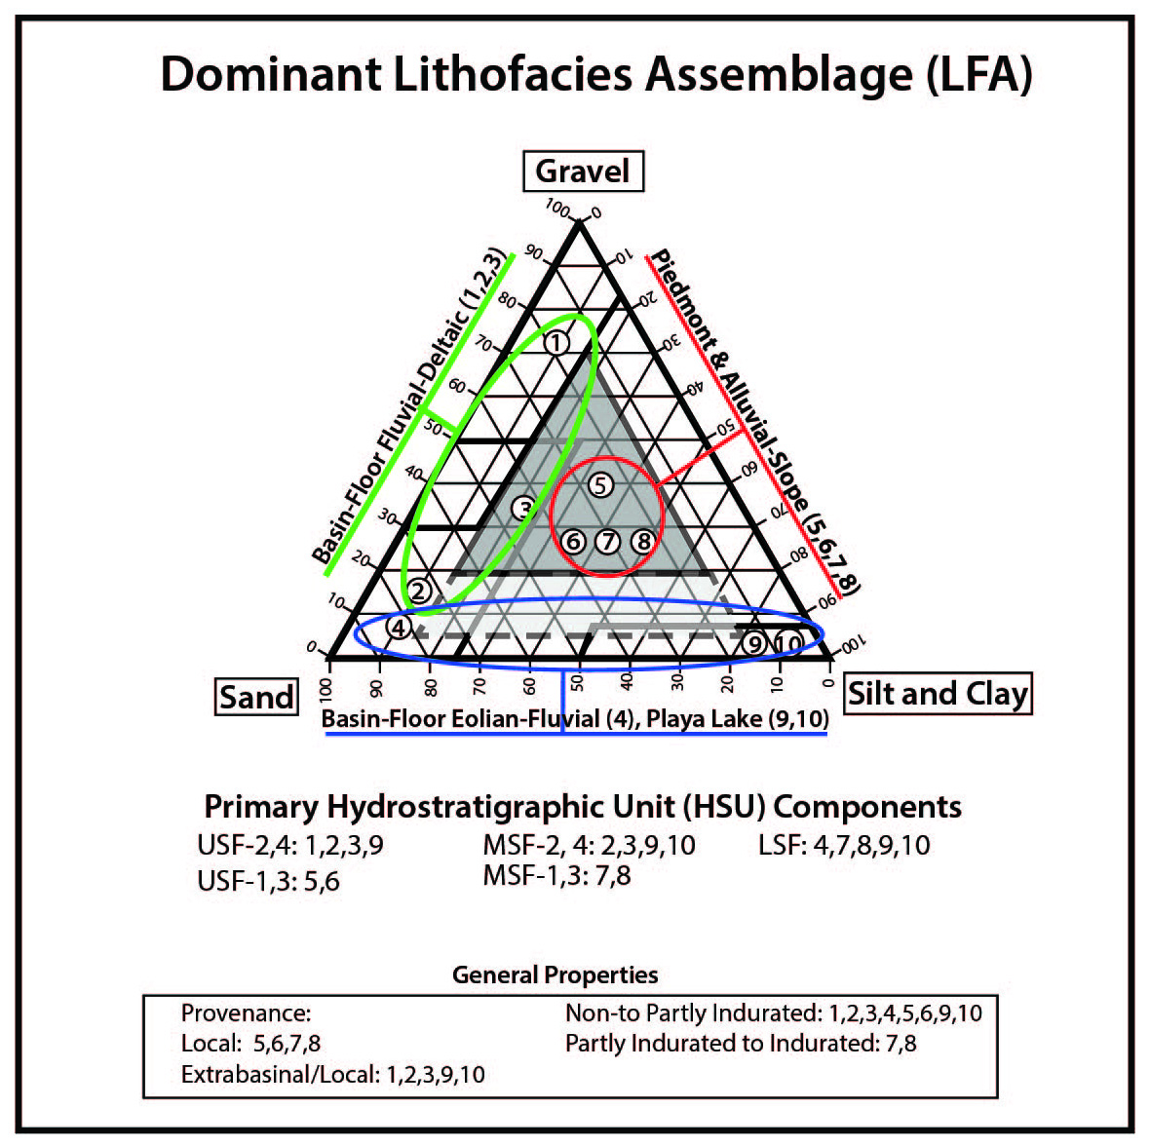
Pl. F1-8. Idealized triangular diagram of dominant textural classes in lithofacies assemblages (LFAs) 1 to 10; and primary LFA composition of SFG Hydrostratigraphic Units (HSUs) - USF/MSF/LSF. See Plate F1-7 and Tables F1-4 to F1-6).

Table F1-4. Summary of depositional setting and dominant textures of major lithofacies assemblages (LFAs) in Santa Fe Group basin fill (1-10) and Rio Grande Valley fill (a-c) in the intermontane basins of the Rio Grande rift tectonic province. Modified from Hawley and Kernodle (2000). See Plates F1-7 and 8, and Tables F1-5 and F1-6.
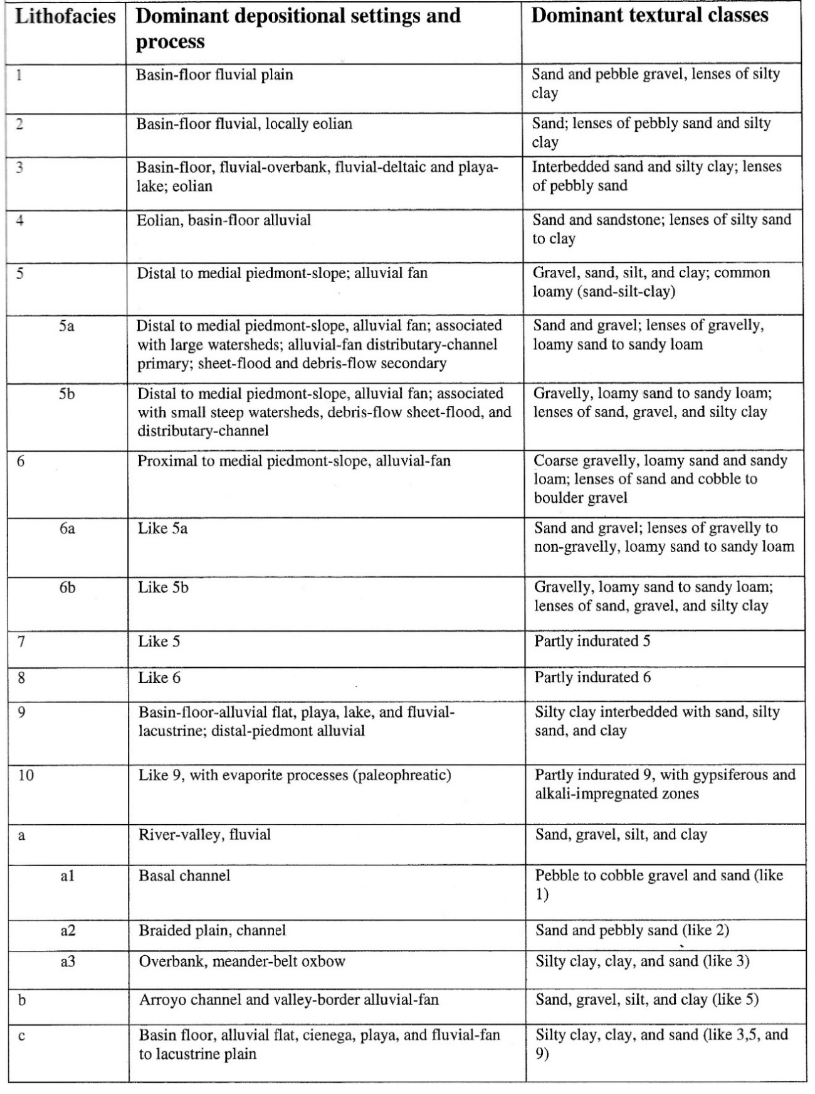
Table F1-5. Summary of major sedimentary properties that influence groundwater-flow and aquifer-production potential of Lithofacies Assemblages (LFAs) 1 to 10 in Santa Fe Group basin fill. Modified from Haase and Lozinsky (1992). See Plates F1-7 and 8, and Table F1-4.
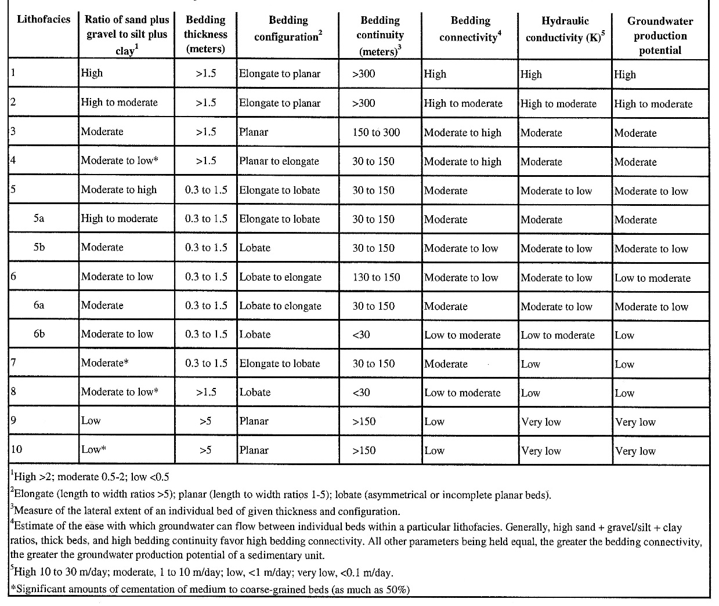
Table F1-6. Summary of major sedimentary properties that influence groundwater-flow and aquifer-production potential of Lithofacies Assemblages (LFAs) a to c in post-SFG RG-valley and basin fills. Modified from Hawley and Kernodle (2000). See Plates F1-7 and 8, and Table F1-4.
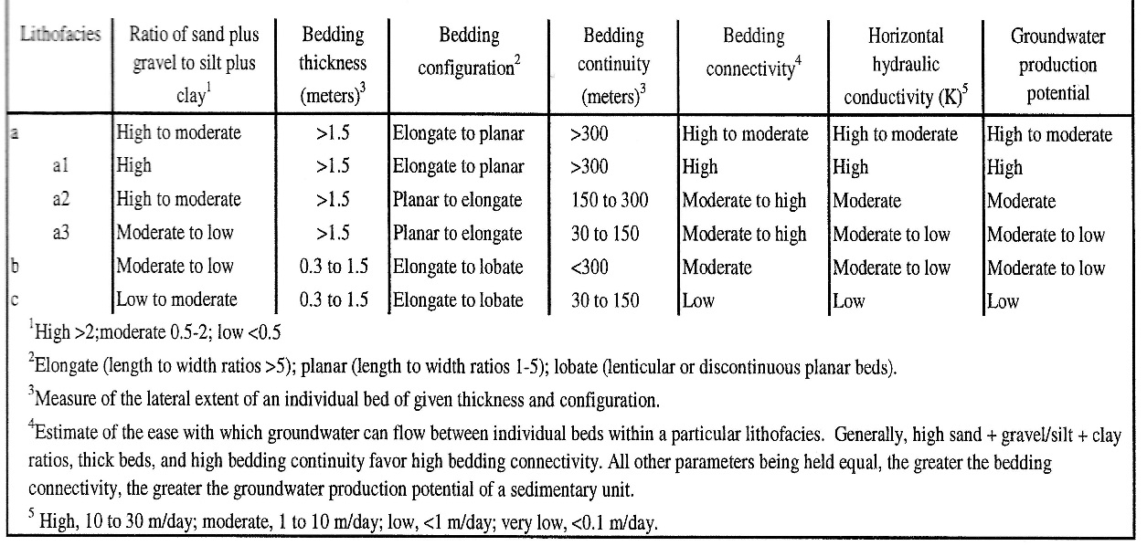
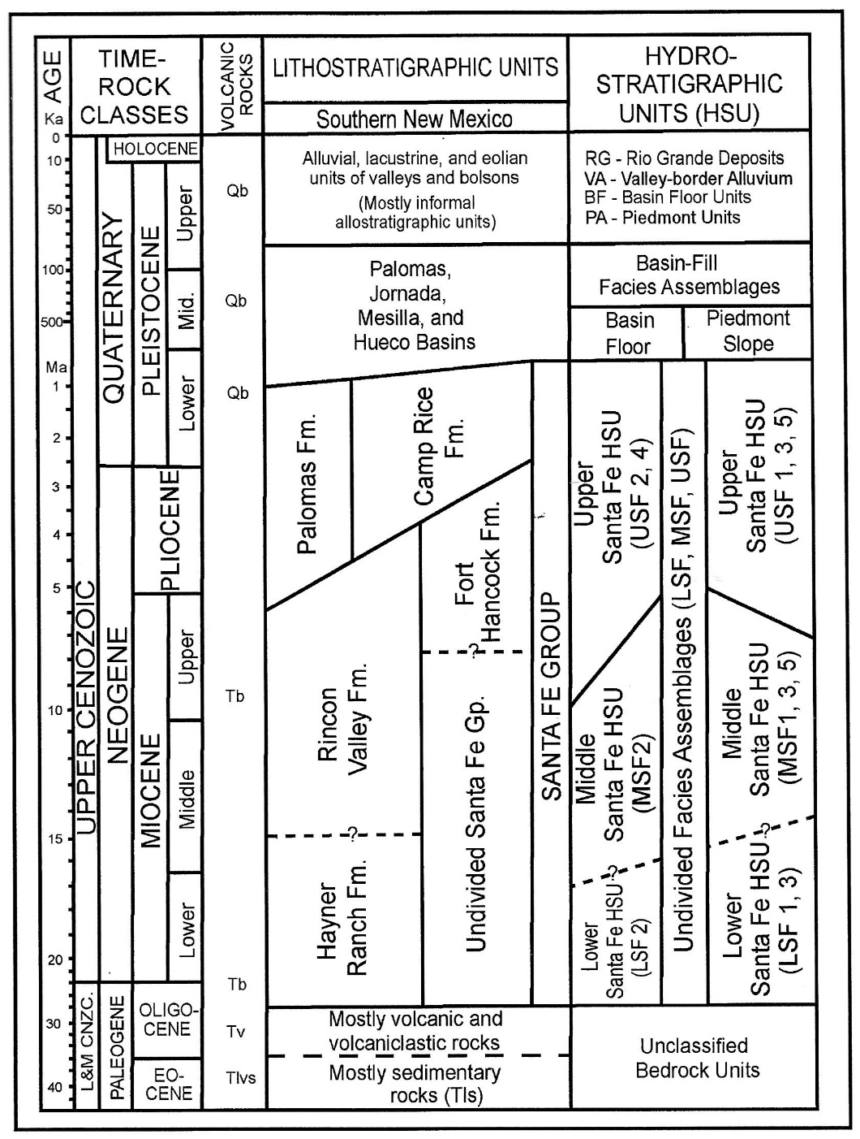
Pl. F1-9. (modified from Hawley et al. 2009, Fig. 6) Correlation diagram of major Time-Rock classes, and lithostratigraphic and hydrostratigraphic units of Cenozoic Age in the southern RG-rift region of New Mexico, Texas, and Chihuahua. Bedrock units: Qb–Quaternary basalt, Tb–Tertiary mafic volcanics, and Tv–older Tertiary intermediate and silicic volcanics, and associated plutonic-igneous and sedimentary rocks. See Pls. F1-7 and F-8, Tbls. F1-4 to F1-6.
Pl. F1-10. Definitions of Divisions of Geologic Time used in this report.
ERA Period Epoch (u/m/l*) Age (years**) _____________________________________________________________
CENOZOIC (Cz)
Quaternary (Q)
Holocene (Qu) 0-11,400
Historic 0-1580 CE
Pleistocene 11,400-2.6 Ma
Late (Qu) 11,400-126 ka
Middle (Qm) 126 ka-780 ka
Early (Ql) 780 ka-2.6 Ma
Tertiary (T)
Late: Neogene
Pliocene (Tu) 2.6-5.3 Ma
Late 2.6-3.6 Ma
Early 3.6-5.3 Ma
Miocene (Tu) 5.3-23 Ma
Late 5.3-11.6 Ma
Middle 11.6-16 Ma
Early 16-23 Ma
Early: Paleogene
Oligocene (Tm) 23-34 Ma
Eocene (Tl) 34-55.8 Ma
Paleocene (Tl) 55.8-65.5 Ma
__________________________________________________________________
MESOZOIC (Mz)
Cretaceous (K) 65.5-145.5 Ma
Jurassic (Jr) 145.5-199.6 Ma
Triassic (Tr) 199.6-251 Ma
___________________________________________________________________
PALEOZOIC (Pz)
Permian (P, Pzu) 251-299 Ma
Pennsylvanian (Pn, Pzu) 299-318 Ma
Mississippian (M, Pzu) 318-359 Ma
Devonian (D, Pzl) 359-416 Ma
Silurian (S, Pzl) 416-444 Ma
Ordovician (O, Pzl) 444-488 Ma
Cambrian (C, Pzl) 488-542 Ma
____________________________________________________________________
PRECAMBIAN-PROTEROZOIC (XY) 542 Ma-2.5Ba
PRECAMBIAN-ARCHAEN 2.5-3.85 Ba
*u/m/l = upper/middle/lower – rock[litho]-stratigraphic units
**Ba=billion years, Ma=million years, and ka=thousand years
Modified from Koning and Read (2010, Table 2)

