APPENDIX A
BACKGROUND ON DEVELOPMENT OF HYDROGEOLOGIC-FRAMEWORK MODELS OF BASIN-FILL AQUIFER SYSTEMS IN THE RG-RIFT REGION
This addendum to CHAPTER 2 provides more-detailed background information on development of hydrogeologic-framework models in the southern RG-rift region. Stages of conceptual model development between 1964 and the present are summarized; and recent (post-2000) advances in digital methods of framework characterization are emphasized. It remains incomplete as of July 2022 due to delays in completion of sections that outline the compilation of databases on 395 key-well (spreadsheet and digital-map format) . . . .
A1. EARLY-STAGE HYDROGEOLOGIC-FRAMEWORK MODELS OF BASIN-FILL AQUIFER SYSTEMS IN THE BASIN AND RANGE (B&R) PROVINCE
A1.1. Early Stages of Hydrogeologic-Framework Model Development in the Great Basin Section
of the Basin and Range (B&R) Province
Emphasis of this overview is on use of standard field techniques of geology and exploration geophysics in the development of semi-quantitative methods for characterization of the hydrogeologic framework of intermontane basin-fill aquifer systems in the eastern Basin and Range (B&R) physiographic province. The endeavor was initiated by the NM Water Resources Research Institute in 1964 in collaboration with the Soil Survey Investigations Division of the USDA-Soil Conservation Service (USDA-SCS), the NMSU Civil Engineering and Earth Sciences Departments, and the NM Bureau of Mines & Mineral Resources (NMBMMR) at NM Tech (Part A1.2; Hawley and Gile 1966; Taylor 1967; Hawley 1969a, b, 1970; Hawley et al.1969; King et al. 1969, 1971; Richardson et al. 1972; King and Hawley 1975).
Recently completed hydrogeologic phases of the Humboldt River Research Project in the
B&R Great Basin section served as prototype for initial investigations in the Rio Grande rift area
of the B&R Mexican Highland section (Hawley et al. 1961; Hawley 1962; Maxey and
Shamberger 1961; Figs. A1-1 and A1-2). These 1959 to 1962 studies were funded by the Nevada
Department of Conservation & Natural Resources and directed by Dr. George Burke Maxey,
future Head of the Desert Research Institute (DRI) water resources program (cf. Hawley and W.E. Wilson 1965; Maxey 1968). The following quotation and graphics from Maxey and Shamberger
(1961; p. 444-446, Figs. 4 to 6) illustrates the early stages of conceptual model development in a NW
Great Basin hydrogeologic setting that is similar to that of the southern Rio Grande rift region:
The combined effects of distribution of precipitation and lithology result in broad hydrologic variations. For example, the Humboldt River is a gaining stream in the Upper Valley unit and a losing stream farther westward primarily because of these factors and the added factor of increased evaporation opportunity to the west. Also, changes in flow of the river and in storage in ground-water reservoirs within the Winnemucca unit probably result in large part from the distribution of differing lithologies.
The detailed geologic and hydrologic work in the Winnemucca unit has given us considerable insight into these problems. In order to remain within the limitations of space and time allotted for this paper only a summary of the work and its results is possible.
Figure 4 [Fig. A1-1] is a detailed geologic map of the central part of the Winnemucca unit. This area, in which mapping of surficial geology is essentially completed, presents a good example of necessary detail of geologic mapping deemed advisable for analysis of water resource problems. In addition to this mapping, much shallow subsurface analysis has been accomplished as illustrated in profiles shown in figures 5 and 6 [Figs. A1-2a and 2b]. Much of this detail in mapping and analysis was made possible by a test-drilling program conducted by the U. S. Geological Survey in which 160 shallow wells (a few feet to 117 feet deep) were bored, primarily in the river channel and environs. The shallow drilling program has resulted in much valuable knowledge.
Drilling information is the basis for determination of specific yield of shallow sediments and other valuable hydrologic determinations, a primary aim of the Geological Survey study. It has confirmed the presence, extent, and thickness of an important sand and gravel aquifer which underlies the river channel from Golconda to Rose Creek. Further results of test-drilling include more intimate knowledge of the river channel materials and other sediments and their mutual 5elationships. These results show that the standard of detailed mapping is justified in this area in order to solve hydrologic problems. They also demonstrate the need for deeper test drilling to assist in outlining extent, distribution, and characteristics of deeper aquifers in the alluvial fill (p. 444-445).
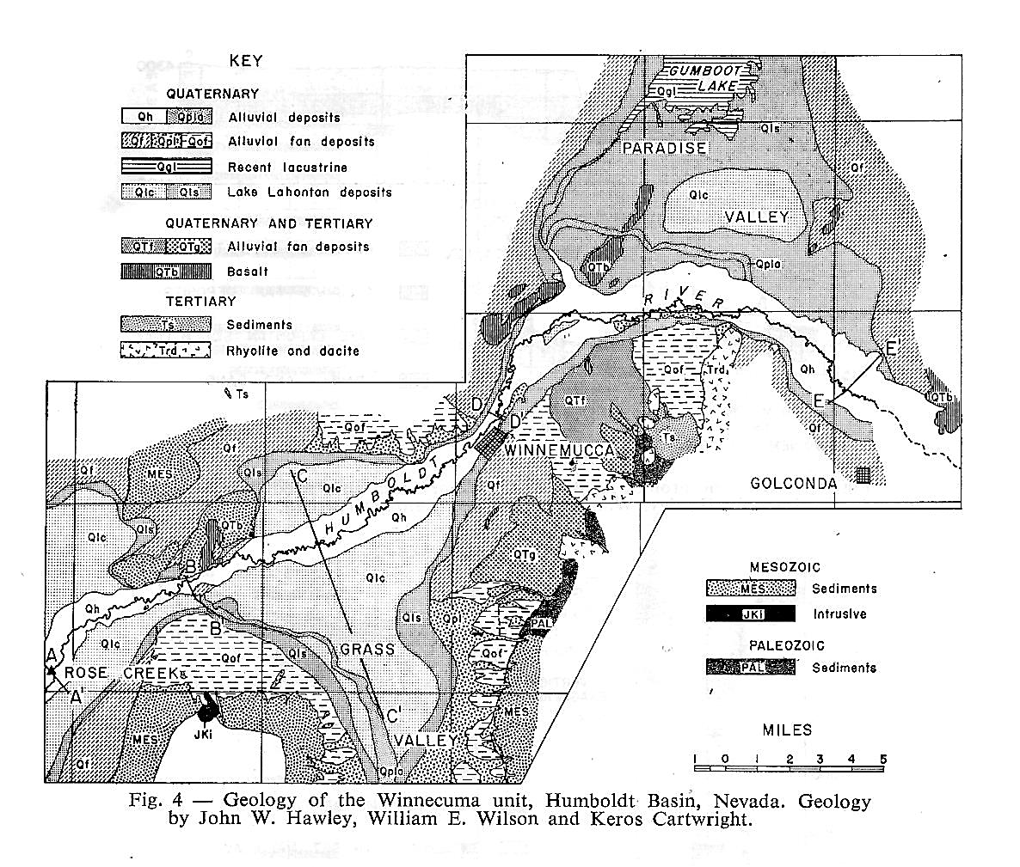
Figure A1-1. (Maxey and Shamberger 1961, Fig. 4) Prototype hydrogeologic map of the Winnemucca segment of the western Humboldt River Valley, Nevada—northern Great Basin section-B&R physiographic province (cf. Hawley et al. 1961, Hawley and Wilson 1965).
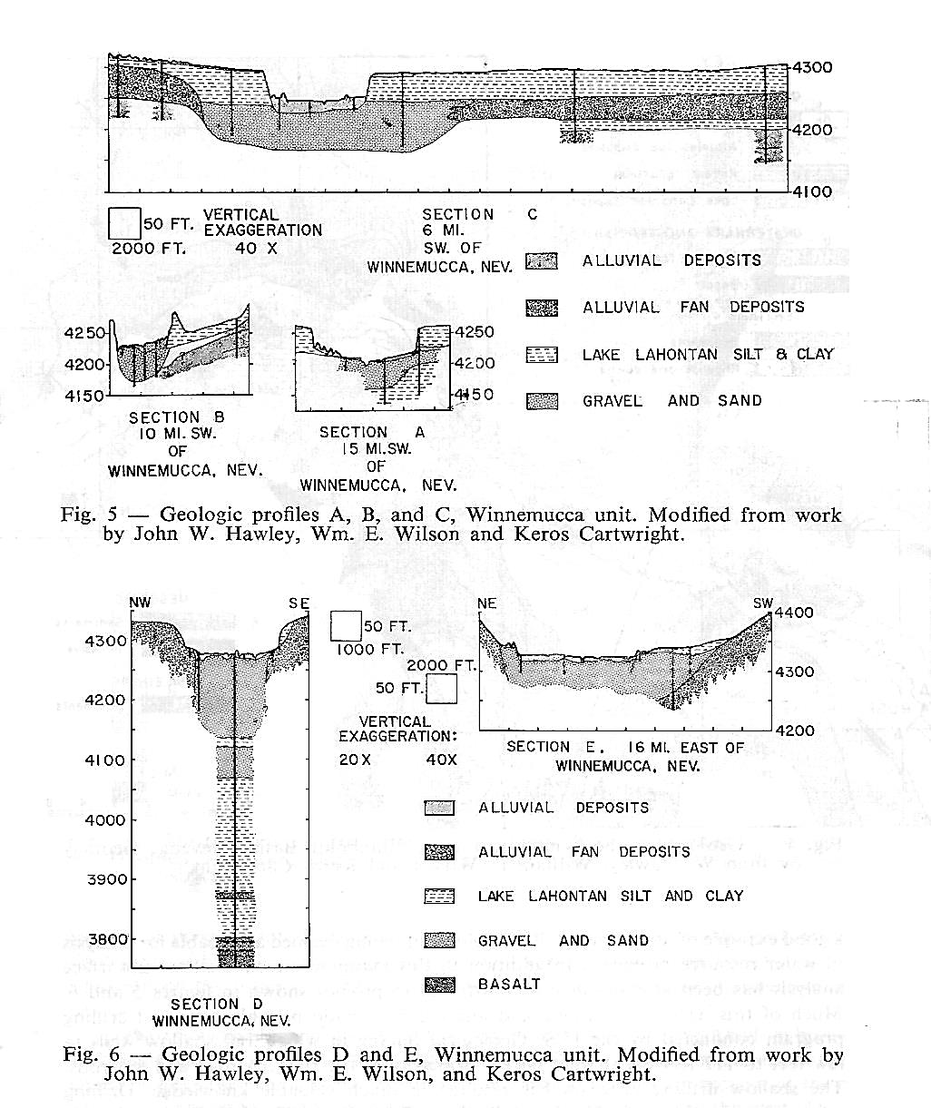
Figures A1-2a and A1-2b. (Maxey and Shamberger 1961, Figs. 5 and 6) Prototype hydrogeologic cross-sections of the Winnemucca segment of the western Humboldt River Valley, Nevada—northern Great Basin section-Basin and Range province (cf. Hawley et al. 1961, Hawley and Wilson 1965).

A1.2. Early stages of hydrogeologic-framework model development in the Mexican Highland Section of the B&R Province
A1.2.1. Initial development of conceptual hydrogeologic-framework models (1964-1980)
Detailed summaries of multi-agency groundwater-resource investigations in the southcentral
New Mexico Border region between 1960 and 1980 are included APPENDICES C3 and C4. The following excerpt from the introduction to an early NM WRRI report (No. 6) on the “Hydrogeology of the Rio Grande Valley and adjacent intermontane areas of southern New Mexico” illustrates the substantial contributions to the understanding of Mesilla Basin region’s hydrogeologic setting in the first five years of NM WRRI existence (W.E. King et al. 1969, p. 5):
In 1964, the Water Resources Research Act was passed by the United States Congress, and the Water Resources Research Institute of New Mexico, under the direction of H. R. Stucky, was established soon thereafter. The present investigation was among the first to be funded by the institute. The field and laboratory work was begun in February 1965 and [ended] in August 1968.
The principal investigator, W. E. King, professor of geology at New Mexico State University, spent one quarter of his time through each academic year and three full months each summer on the investigation. He was responsible for supervision of the investigation and is accountable for many of the conclusions. Andrew M. Taylor [Taylor 1967] served as a graduate assistant on the project from its inception through August 1967 and did much of the well logging and surface geology. Richard P. Wilson spent one year as a student assistant and is largely responsible for the drafting as well as much of the thought expressed in the water-table contour map (Pl. 1).
John W. Hawley, areal geologist with the Soil Conservation Service, of the U.S. Department of Agriculture, suggested the investigation and cooperated in the study throughout.
Figures A1-3 to A1-7 are facsimile copies of Figures 1 to 3 and 5 in Hawley and others (1969), and Figure 5 in King and others (1971). They illustrate early stage development of conceptual models of the regional hydrogeologic framework. Interpretations are based on reconnaissance geologic studies by Kottlowski (1958), Hawley (1965), Hawley and Kottlowski (1969); and on more detailed hydrogeologic work by Leggat and others (1962), Cliett (1969), and King and others (1969).
Figure A1-3 is an index map of the South-Central New Mexico Border Region (Hawley et al. 1969, Fig. 1). “MESILLA BOLSON” is the Mesilla GW Basin (MeB) in this report; and most of the “CLOSED BASIN AREA” that includes “EL BARRIAL [BARREAL]” was the site of pluvial Lake Palomas during its Late Pleistocene high stages between 29,000 to 12,000 yrs. ago (29-12 ka BP). Ancestral Rio Grande (ARG) deposits are referred to as “UPPER SANTA FE GROUP”-“FLUVIAL FACIES” in these reports (cf. Figs. A1-4 to A1-7).
Figure A1-4 (modified from Hawley 1975, Fig. 2) shows the general area occupied by the distributive drainage network of the Ancestral Rio Grande (ARG) during much of Pliocene and Early Pleistocene time (cf. Connell et al. 2005, Fig. 11). The network’s apex was located near the present site of Caballo Dam about 20 mi (32 km) NW of Rincon; and it terminated in the paleo-Lake Cabeza de Vaca (LCdV) basin complex in the Mesilla-Los Muertos and Tularosa-Hueco structural depressions of the southern RG-rift region (Strain 1966, 1971). Four of the five large-river systems that discharged to the Los Muertos Basin section of LCdV remain as major components of the fluvial landscape: Rios Casas Grandes, Santa Maria and Carmen, and the Mimbres River. Figures A1-5 and A1-6 are schematic hydrogeologic cross-sections of the Mesilla Basin/Valley area near Las Cruces. Figure A1-7 is a correlation diagram of major hydrostratigraphic, lithostratigraphic, and basin-fill lithofacies-assemblage (LFA) units in the South-Central New Mexico Border Region (Hawley et al. 1969, Fig. 5). Hydrogeologic concepts are based on the then available knowledge base on RG-rift structure and radiometric-ages of rift-basin-fill deposits in the South-Central New Mexico Border Region.
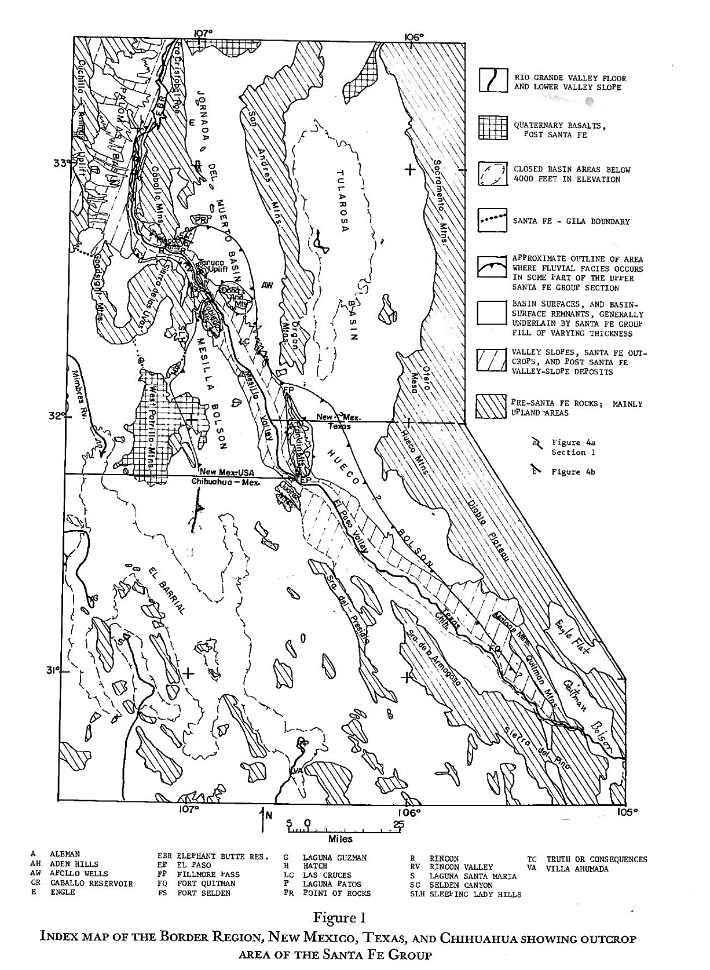
Figure A1-3. (Hawley et al. 1969, Fig. 1) Index map of the South-Central New Mexico Border Region. “MESILLA BOLSON” is the Mesilla GW Basin (MeB) in this report; and most of the “CLOSED BASIN AREA” that includes “EL BARRIAL [BARREAL]” was the site of pluvial Lake Palomas during its Late Pleistocene high stages. Ancestral Rio Grande (ARG) deposits are referred to as “UPPER SANTA FE GROUP”-“FLUVIAL FACIES” in these early reports (cf. Figs. A1-4 to A1-7).
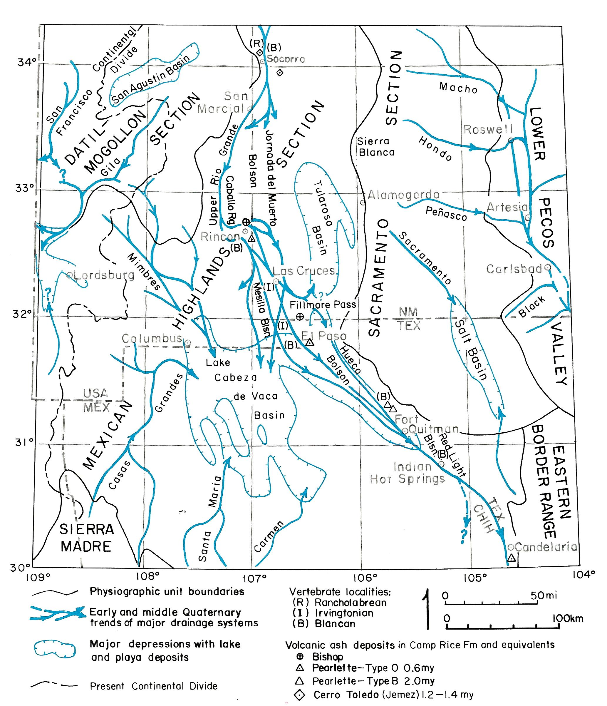
Figure A1-4. (modified from Hawley 1975, Fig. 2) Schematic depiction of the general area occupied by the distributive drainage network of the Ancestral Rio Grande (ARG) during much of Pliocene and Early Pleistocene time (cf. Connell et al. 2005, Fig. 11b and 11c). The network’s apex was located near the present site of Caballo Dam about 20 mi (32 km) NW of Rincon; and it terminated in the paleo-Lake Cabeza de Vaca (LCdV) basin complex in the Mesilla-El Parabién-Los Muertos and Tularosa-Hueco structural depressions of the southern RG-rift region (Strain 1966, 1971). Four of the five large-river systems that discharged to the Los Muertos Basin section of LCdV remain as major components of the fluvial landscape: Rios Casas Grandes, Santa Maria and Carmen, and Mimbres River (cf. Fig. A1-6).
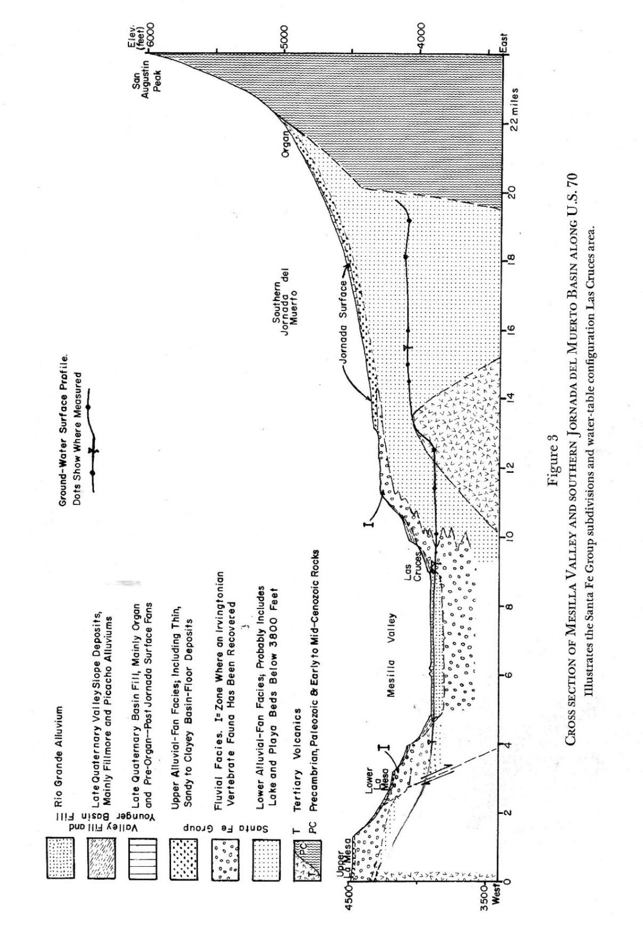
Figure A1-5. (Hawley et al. 1969, Fig. 3) Schematic hydrogeologic cross-section of the northern Mesilla and Southern Jornada Basins, which are separated by the shallowly buried Tortugas Uplift. US-70—Section DD′ alignment (Rpt. PL. 5d; cf. Figure A1-6).
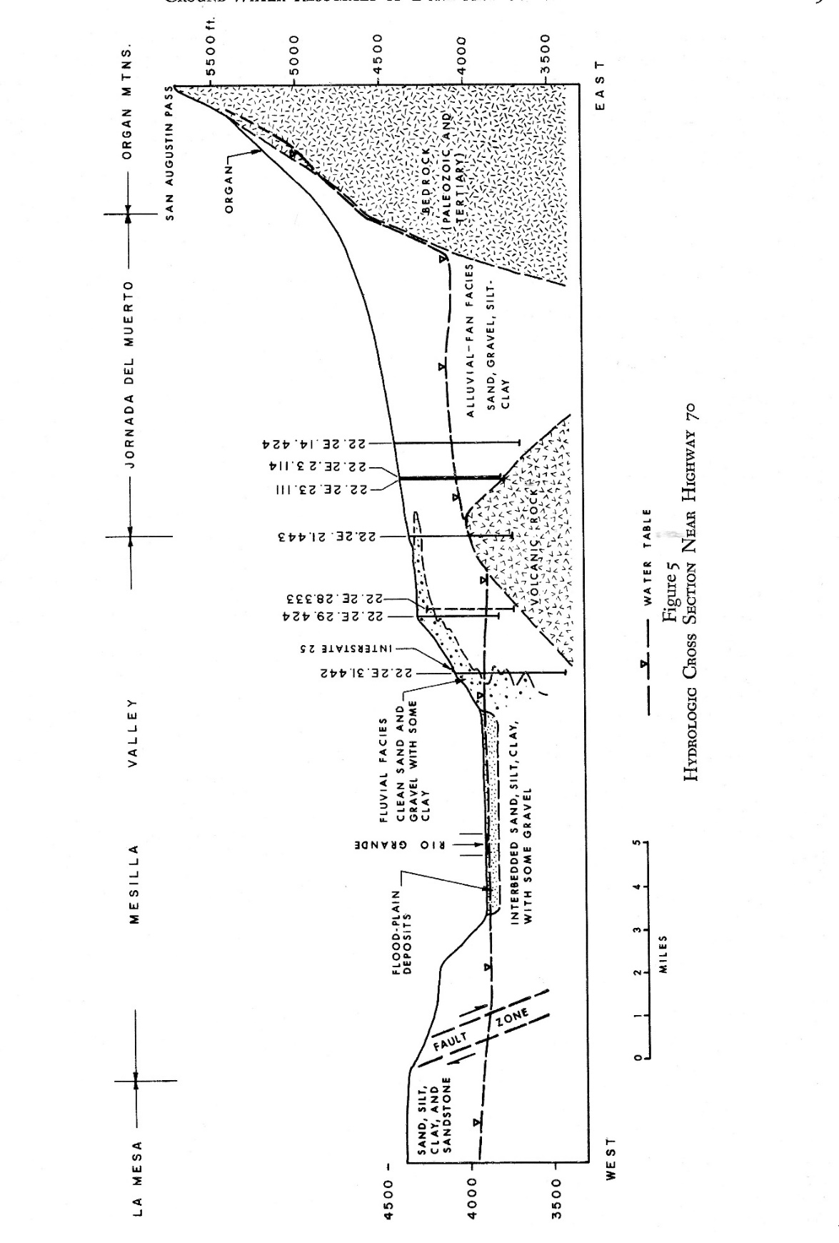
Figure A1-6. (King et al., 1971 FIG. 5) Schematic hydrogeologic cross-section of the northern
Mesilla and Southern Jornada Basins, which are separated by the shallowly buried Tortugas Uplift. US-70—Section DD′ alignment (Rpt. PL. 5d). The approximate water-table profile is shown with a dashed line; cf. Figs. A1-4 and A1-5).
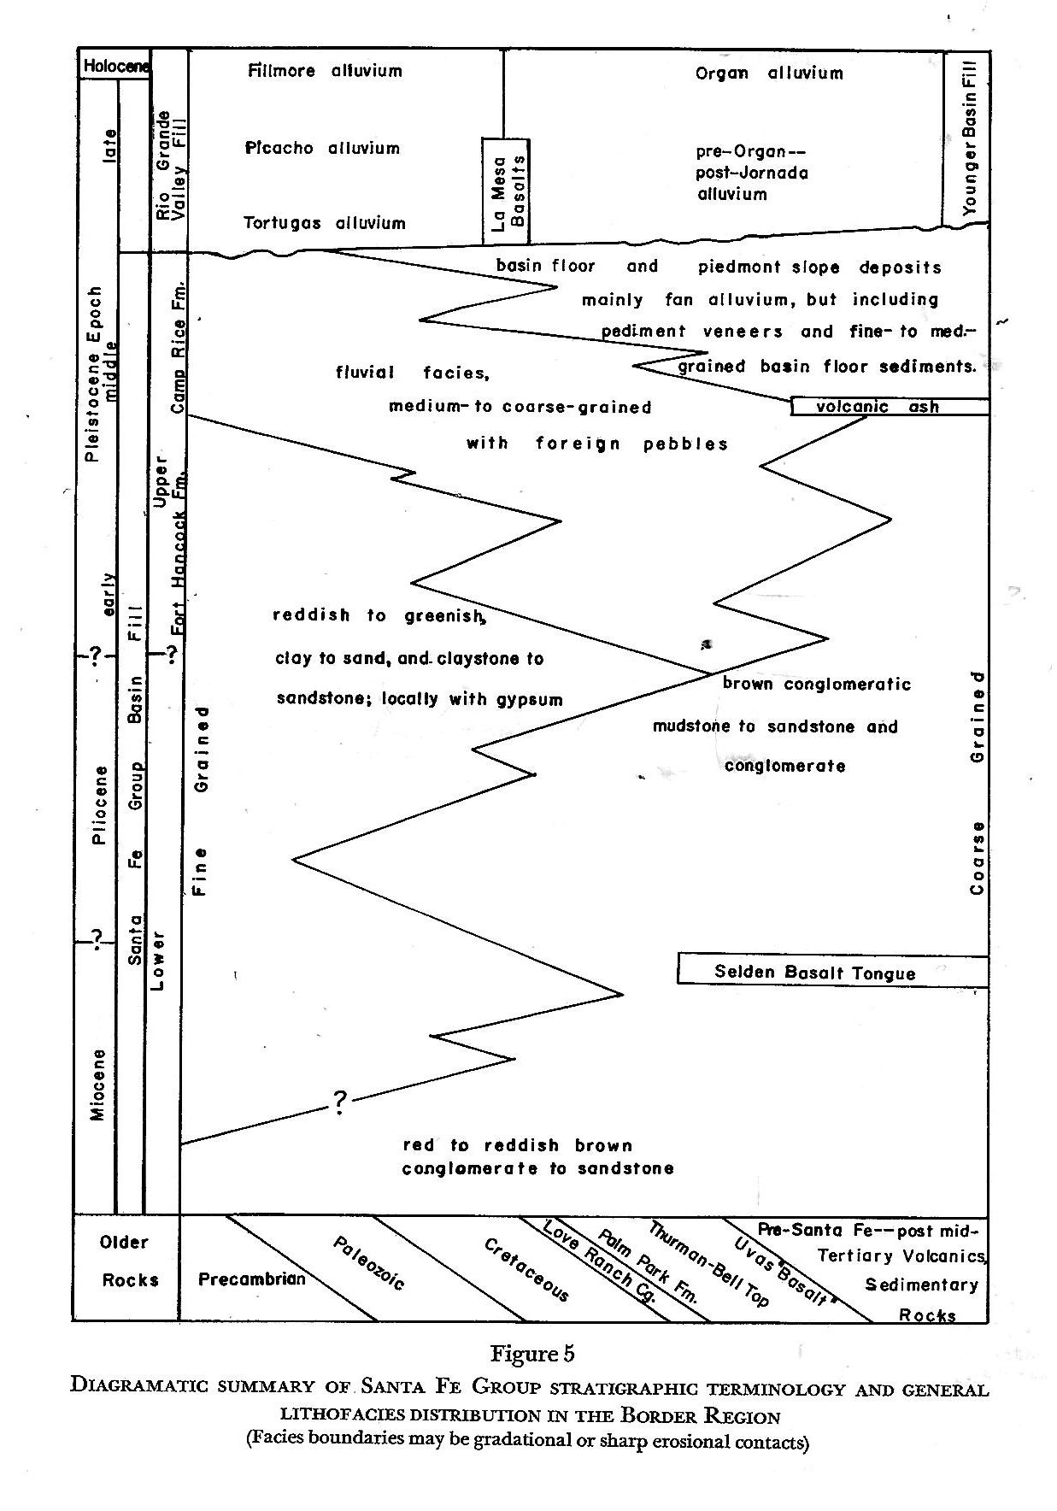
Figure A1-7. (Hawley et al. 1969, Fig. 5) Early correlation diagram of major hydrostratigraphic, lithostratigraphic, and basin-fill lithofacies-assemblage (LFA) mapping units in the South-Central New Mexico Border Region. The radiometric age of the “Selden Basalt Tongue” is about 9.5 million yrs. (9.5 Ma). The “volcanic ash” beds in Ancestral Rio Grande (ARG) “Fluvial Facies” of Pliocene to Early Pleistocene Age have now been determined to range from about 4.5 to 0.65 Ma. The age of the base of SFG is now estimated to be between 25 and 30 Ma (cf. Fig; A2-3).

A1.2.2. Note on Contributions by Clyde Wilson-USGS (1932-1980)
It is sad and quite ironic to note that much of the PI’s productive hydrogeologic work in the Mesilla Basin region since 1977 relates directly to the seminal contributions of close friend and professional colleague, Clyde A. Wilson (1932-1980). His work in the Mesilla Basin region between 1971 and 1980 is described in detail in APPENDIX C-Parts C4 and C7. Clyde and the PI first met in Lubbock, Texas in 1971, when they were both pushing 40 and often chose to ride the bus rather than drive to our respective offices. He then headed a branch office of the USGS Water Resources Division, and the PI had just started a field study of soil-geomorphic relationships in the Llano Estacado region for SCS Soil Survey Investigations Division. We both had a shared passion for Southern High Plains-Ogallala Aquifer studies and anything else of a hydrogeologic nature. Clyde was soon transferred to Doña Ana County to initiate a USGS Southern Rio Grande basin study, but we always stayed in professional contact, especially after the PI was asked to establish an Environmental Geology Program at the N.M. Bureau of Mines & Mineral Resources in 1977.
A1.2.3. Introduction of the Lithofacies Assemblage Classification System to Conceptual Hydrogeologic-Framework Models (1981-1985)
Lithofacies-Assemblage (LFA) classes were first incorporated in hydrogeologic-framework models as part of collaborative studies of RG-rift aquifer systems in the mid-1980s by the following entities: the NM Bureau of Mines and Mineral Resources (NMBM&MR) and NM Tech Geoscience Department; the NM Office of State Engineer (NM OSE); the NM Water Resources Research Institute (NM WRRI); El Paso Water Utilities (EPWU, Tom Cliett), and the U.S. Geological Survey Water Resources Division (USGS-WRD, Michael Kernodle and Kenneth Stevens). Initiation of this study phase was in great part an unforeseen consequence of the unexpected death in October 1980 of Hydrologist Clyde A. Wilson, Southern Rio Grande Project Leader for the USGS (Part A3 and APNDX. C3). This tragic event had a profound effect on Hawley’s subsequent professional career, which up to that time was marked by increasing involvement in applied areas of geology more related to the NMBMMR Environmental Geology program that he had been asked to organize in 1974. By sad coincidence, Dr. Lynn Gelhar, then head of NM Tech Geoscience Department-Hydrology Group, had just asked the PI to design a simplified classification of basin-fill lithofacies-assemblages (LFAs) that could be used in a new generation of 3-D groundwater-flow models that he and his research associates were developing (e.g., Gelhar 1993; Gelhar et al. 1979, 1983, 1992; cf. Molz 2015). A provisional ten-component classification of LFAs was first applied by Peterson and others (1984) in the NM WRRI TCR 178 on “Quasi three-dimensional modeling of groundwater flow in the Mesilla Bolson;” cf. Hawley 1984, APNDX. A1.3).
LFA system design was based on observations by cognitive psychologist George Armitage Miller (1920-2012) in his 1956 paper in the Psychological Review: “The magical number seven, plus or minus two: Some limits to our capacity of processing information.” In his account of the lives of Israeli psychologists Daniel Kahneman and Amos Tversky – “The Undoing Project - A friendship that changed our minds” – Michael Lewis describes a typical Kahneman instruction method that was based on Miller’s work (2016, p. 139):
Danny [Kahneman]* was also training [Israeli] Air Force flight instructors to train fighter pilots. . . . How did you get fighter pilots to memorize a series of instructions? "We started making a long list," recalled [former student] Zur Shapira. "Danny says no. He tells us about 'The Magical Number Seven.''' "The Magical Number Seven, Plus or Minus Two: Some Limits on Our Capacity for Processing Information" was a [1956 Psychological Review] paper, written by Harvard psychologist George Miller, which showed that people had the ability to hold in their short-term memory seven items, more or less. Any attempt to get them to hold more was futile. Miller half-jokingly suggested that the seven deadly sins, the seven seas, the seven days of the week, the seven primary colors, the Seven Wonders of the World, and several other famous sevens had their origins in this mental truth.
At any rate, the most effective way to teach people longer strings of information was to feed the information into their minds in smaller chunks. To this, Shapira recalled, Danny added his own twist. "He says you only tell them a few things-and get them to sing it.". . . In his statistics classes he had actually asked his students to sing the formulas. . . [cf. Siegel 2008, Siegel and Hinchey 2019].
*Elected member of the US National Academy of Science in 2001; and 2002 Nobel Prize recipient "for having integrated insights from psychological research into economic science, especially concerning human judgment and decision-making under uncertainty (cf. Kahneman and Tversky 19746 and 1996)."
The history of lithofacies classification-system development and its early application in hydrogeologic-framework characterization throughout the RG-rift region is covered in detail in PART A2 (cf. Khaleel et al. 1983, Peterson et al. 1984, Hawley and Lozinsky 1992, Hawley and Kernodle 2000, Hawley et al. 2001). It is introduced here with an extended quote and illustration from Hawley (1984, p.1-2, Pl. 5 [Fig. A1-8]):
The purpose of this phase of research on numerical modeling of groundwater flow in the lower Rio Grande basin of New Mexico (Khaleel et al. 1983; in progress) is to illustrate the hydrogeologic framework of the Mesilla Bolson utilizing all available surface and subsurface information. Emphasis is on physical properties of the intermontane-basin fill related to storage and transmission of ground water, and on the structural and lithologic properties of rock units forming basin boundaries. Information is presented in a combined surface-map and cross-section format (Plates 1 to 16) in order to provide 3-dimensional hydrogeologic models that interface directly with numerical models developed for the hydrologic phase of the study. . . .
Any valid characterization of bolson hydrogeology must be based on the best possible understanding of the local geologic framework, particularly in the context of relatively recent geologic history, since the major water-bearing units are fills of intermontane structural basins of late Cenozoic age. The bulk of these units, and associated confining beds, are components of the Santa Fe Group and include deposits of the ancestral Rio Grande. Recent mapping (summarized by Seager et al., in press [1987]) of exposed geologic units and structures is of excellent quality. However, hydrologic investigations focus on basin- and valley-fill units that are rarely well exposed; and in much of the area, subsurface data from drill holes and geophysical surveys are not available. Therefore, portrayals of bolson hydrogeology (e.g. King et al. 1971; King and Hawley 1975; Wilson et al. 1981; [Hawley 1984]), including materials in this report, should be regarded only as reasonable state-of-the-art models that will be subject to . . revision. . . .
Plates 1 to 16 illustrate the major hydrogeologic features of the Mesilla Bolson and the format used for presenting hydrogeologic information in this ongoing study. Plate 1 is a topographic map view of the area showing location of 1) major basin-range boundary faults, 2) well-control points, and 3) sixteen cross sections that form the basis for the hydrogeologic model [Plates 2 to 16, Fig. A1-8 (Pl. 5)]. . . . The base line of all sections is mean sea level, and geologic information to that depth is given wherever possible. . . .
General distribution patterns of 10 hydrogeologic subclasses of valley and basin fills are shown on plates 2 to 16 (sections with 10:1 [and 1:1] vertical exaggeration). These deposits [Lithofacies Assemblages (LFAs)] of late Oligocene to Holocene age (<25 million years) are listed in order of decreasing aquifer potential and include six subdivisions that form important aquifers in the Mesilla Bolson area (Plate 1). Units I to IV [1-4]* form the major aquifers of the region and include deposits of a large fluvial-fan system constructed by the ancestral Rio Grande in Pliocene to middle Pleistocene time (5 to 0.5 million years ago). Clean sand or gravelly sand zones are extensive and thick, and have relatively large hydraulic conductivities. Estimated transmissivities commonly exceed 10,000 ft²/day and water quality is good (tds usually <1,000 mg/L). Units V and VI [5 and 6] form thinner and less extensive aquifers that are locally important water sources, particularly in the southern Jornada del Muerto Basin. These piedmont-slope and basin-floor alluvial deposits include elongate sand and gravel lenses that are in part transitional to more extensive deposits of the ancestral Rio Grande. Transmissivities locally may be as high as 10,000 ft²/day. Units VII to X [7 to 10] rarely form aquifers and include fine-grained basin fill (playa and lake beds) and indurated fan-piedmont deposits. Hydraulic conductivities are very low and water quality is usually poor.
*Lithofacies Assemblage (LFA) code symbols were changed from Roman- to Arabic-numerals in the late 1990s to facilitate their use in contemporary digital geohydrologic models (e.g. Hawley and Kernodle 2000; Hawley et al. 2000, 2001).
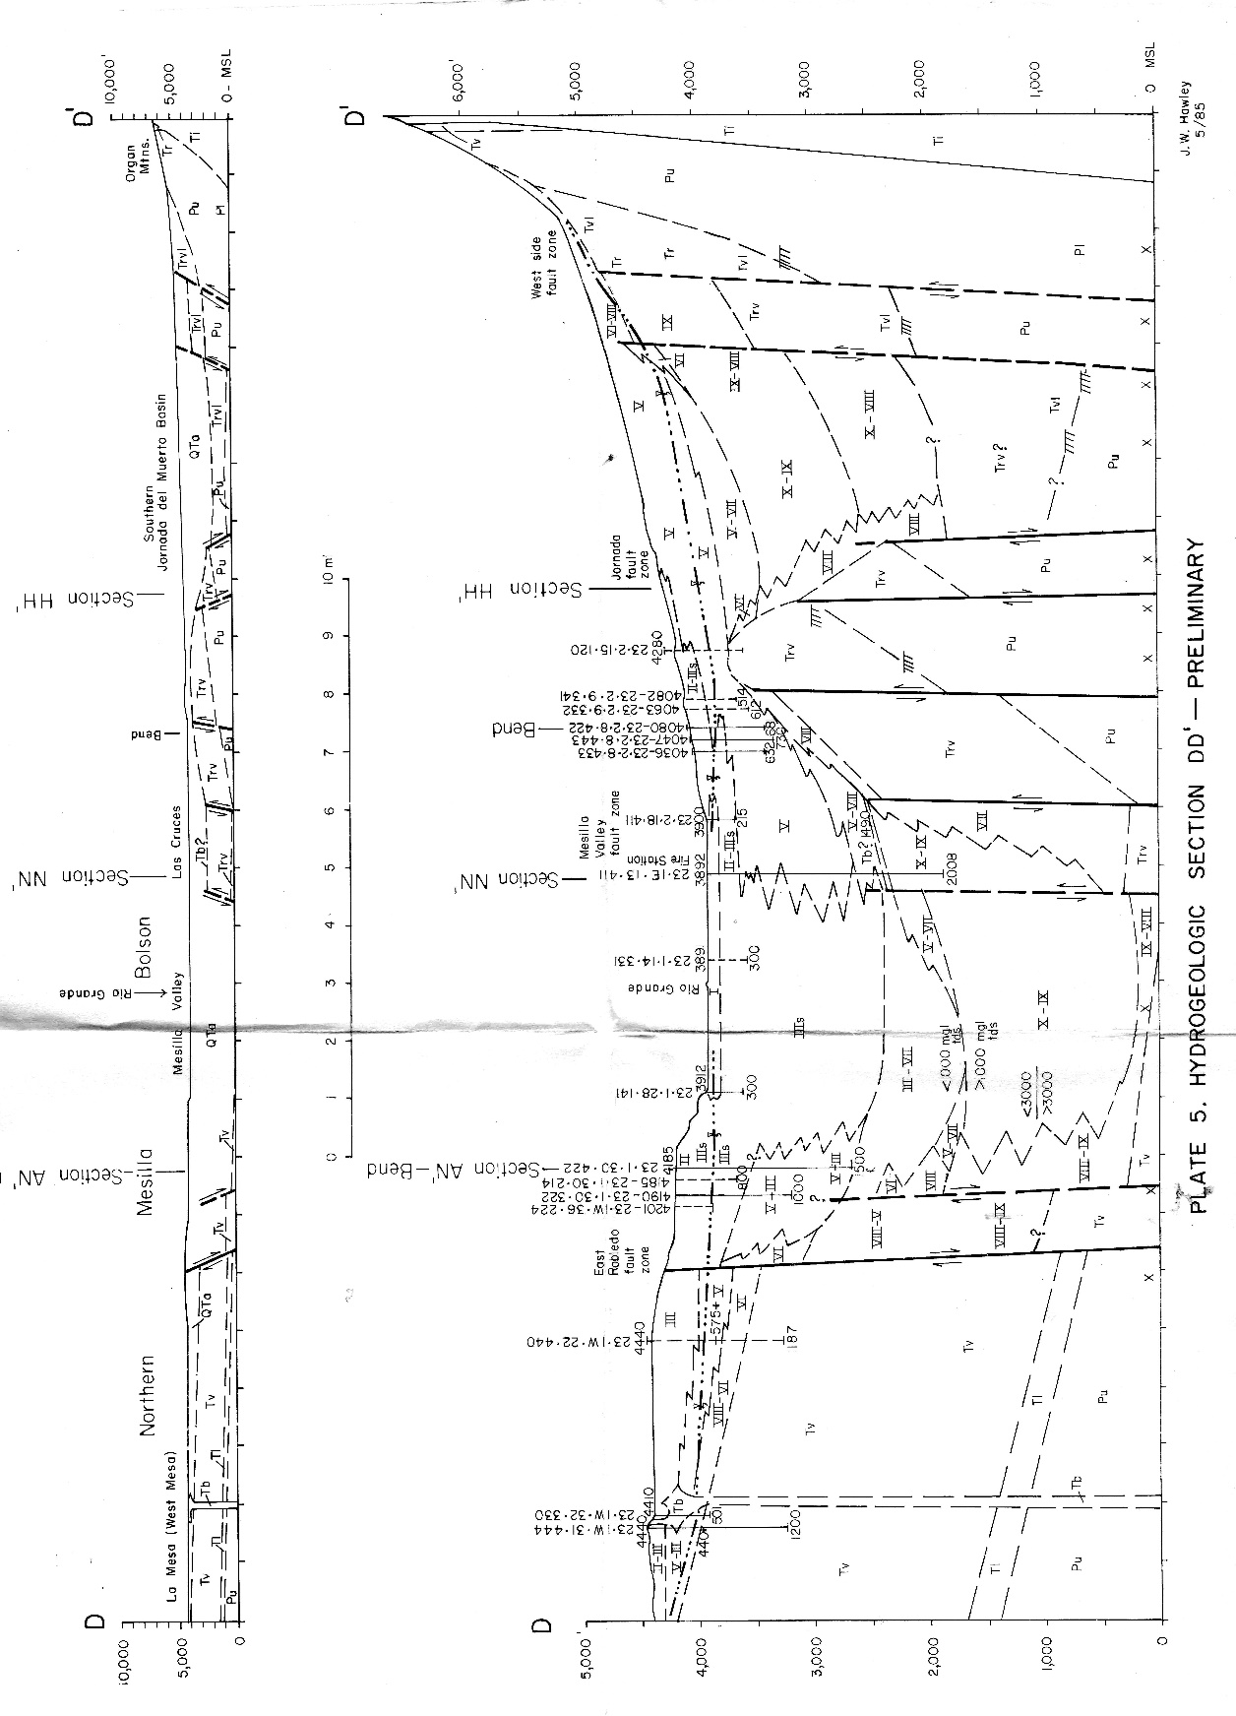
Figure A1-8.* (Hawley 1984, Pl. 5) Schematic hydrogeologic cross-section of the northern Mesilla and Southern Jornada Basins, which are separated by the Tortugas Uplift. US-70—Section DD′ alignment (PL. 5d). Representative early use of Lithofacies Assemblage Notations (LFAs I to X) in characterization of Rio Grande-rift basin fill deposits (i.e., undivided SFG, *cf. Figs. A1-5, A1-6 and A1-9).
Figure A1-9 is a schematic hydrogeologic section that was modified from Figure A1-8 by Frenzel and Kaehler 1992 (their Fig. 11). It extends ENE across the northern Mesilla and Southern Jornada GW Basins (MeB and SJB) west of the Organ Mountain Uplift. The shallowly buried northern part of the Tortugas Uplift (“Jornada Horst” of Woodward and Myers, 1997) separates the MeB-Mesilla Valley (MeV) from the SJB. The black arrows show the “possible path of underflow” contributions to the northern MeB from 1) the SJB through gaps in the buried Tortugas Uplift to the east, and 2 bedrock and thin SFG deposits west of the “EAST ROBLEDO FAULT ZONE.” Predevelopment interbasin underflow-discharge terminated in the MeB below the eastern edge of the Mesilla Valley; however, much of this flow in now captured by pumping for suburban-domestic use. Frenzel and Kaehler (1992, Fig. 18), for example, estimate that the combined “mountain-front” recharge component to the northeastern MeB from the Organ Mountains and adjacent parts of the SJB is about 3,767 ac-ft/yr.
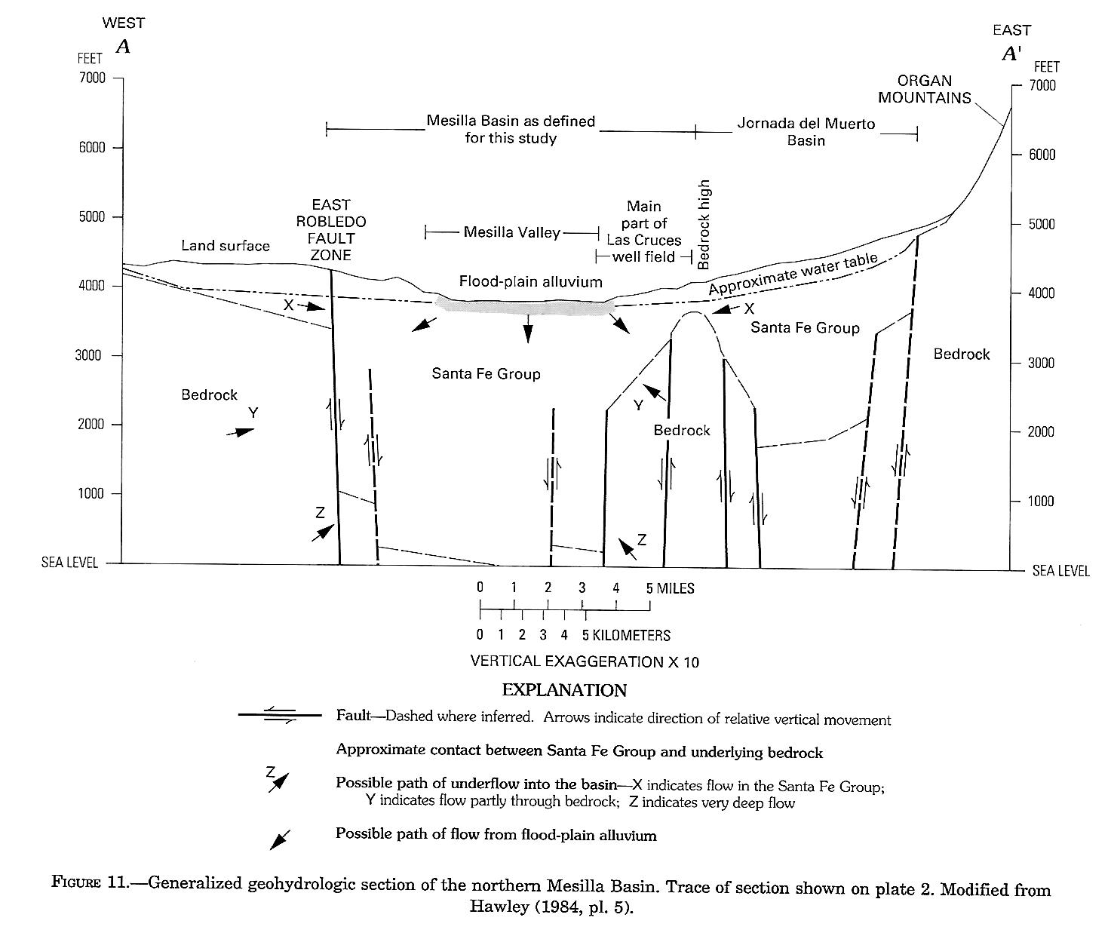
Figure A1-9. (Frenzel and Kaehler 1992, Fig. 11; modified from Hawley 1984 [pl. 5]) Schematic hydrogeologic section, in the approximate position of Report PLATE 5e, which extends ENE across the northern Mesilla and Southern Jornada GW Basins (MeB and SJB) west of the Organ Mountain Uplift. The shallowly buried northern part of the Tortugas Uplift* separates the MeB-Mesilla Valley (MeV) from the SJB (*“Jornada Horst” of Woodward and Myers, 1997 [Figs. 5g and 5l]).
A2. HYDROGEOLOGIC-FRAMEWORK-MODEL DEVELOPMENT AND APPLICATION (1986-2010)
A2.1. Initial Stages of digital framework-model development and application (1986-1996; cf. A5)
A2.1.1. Hydrostratigraphic Units (HSUs)
George Burke Maxey (1964, p. 126) originally defined a hydrostratigraphic unit (HSU) as “a body of rock having considerable lateral extent and composing a geologic framework for a reasonably distinct hydrologic system.” As initially applied in the Study Area: “A hydrostratigraphic unit may represent an entire [litho-] stratigraphic unit, a portion of a stratigraphic unit, or a combination of adjacent stratigraphic units with consistent hydraulic properties” (Giles and Pearson 1998, p. 322). In this report, HSUs are used as the chief mechanism for hydrogeologic mapping of RG-rift basin-fill deposits on the basis on distinctive LFA composition and well-defined lithostratigraphic-sequence positions (Rpt. Fig. 3-6; cf. Fig. A2-3, Hawley and Kernodle 2000, Hawley and Kennedy 2004).
A2.1.2. Development of an Integrated LFA and HSU Classification System
The first step in organizing hydrogeologic information on basin-fill stratigraphy and sedimentology involved development of a provisional hydrostratigraphic classification system that is applicable throughout the eastern B&R and RG-rift provinces (Rpt. Fig. 3-6). Even-numbered alphanumeric codes (e.g., HSU’s USF 2 and MSF 2) designate units composed of basin-floor lithofacies assemblages (LFA’s 1-3, 9-10); and odd-numbered codes) denote units comprising piedmont-slope LFA’s (5-9; e.g., USF 1, MSF 1). Refinement in HSU definitions is an ongoing process, with updates occurring during each study phase. Informal Upper, Middle, and Lower Santa Fe HSUs (USF, MSF, LSF) form the major basin-fill aquifer zones in the Mesilla Basin region, and they correspond roughly to the Camp Rice, Fort Hancock, Rincon Valley, and Hayner Ranch lithostratigraphic subdivisions of the Santa Fe Group (SFG; Rpt. Fig. 3-6, Part 3.7.2b). Proper identification and correlation of these lithostratigraphic units in the deeper subsurface, however, remains a significant problem in parts of most administratively closed-GW basins; hence the informal status of this hydrostratigraphic classification system.
The labor-intensive initial processes involved in lithofacies-assemblage (LFA) and hydrostratigraphic-unit (HSU) classification-system development and provisional application in representative RG-rift basins required acquisition and interpretive review of available relevant information on basin-fill hydrogeologic units in the USGS Southwest Alluvial Basins-Regional Aquifer-Systems (SWAB-RASA) study area of New Mexico and Trans-Pecos Texas (APPENDIX C4; Wilkins 1998). In the Mesilla Basin region, much of the basic hydrogeologic information had already been compiled for early-stage numerical modeling studies at New Mexico Tech. Initial work was funded primarily by the NM WRRI and the NM Bureau of Mines and Mineral Resources (NMBMMR, and it was based in great part on the 1971-1980 investigations headed by Clyde A. Wilson* of the USGS-WRD (cf. W.E. King 1973, King et al. 1971, King and Hawley 1975, Wilson et al. 1981, Hawley 1984, and Wilson and White 1984). This selection from the “Introduction” to NMBMMR Open-File Report 323, “Hydrogeologic framework of the Mesilla Basin in New Mexico and western Texas (Hawley and Lozinsky 1992, p. 37-38)” illustrates the already advanced state of conceptual-model development by 1990:
This report describes the results of a hydrogeologic study by the New Mexico Bureau of Mines and Mineral Resources (NMBMMR) in the Mesilla Basin between Las Cruces, New Mexico and the International Boundary west of EI Paso, Texas. The two major study objectives were (1) to develop a detailed conceptual model of the basin's hydrogeologic framework that is based on a synthesis of all available geological, geophysical, and geochemical data, and (2) to present that information in a format suitable for use by the U.S. Geological Survey, Water Resources Division (USGS-WRD) in developing numerical models of the ground-water flow system. These modelling efforts will, in turn, provide a much more quantitative base for management decisions on future strategies for water-resource development and conservation. Predictive models are particularly important because of the potential for water quality degradation and land subsidence due to excessive ground-water withdrawals that have been proposed in some parts of the Mesilla Basin.
Funding for the initial phase of data compilation and model development in 1987 was jointly provided by the NMBMMR and the U.S. Geological Survey, Water Resources Division (USGS-WRD, contract no. 14-08-D001-G-726), and subsequent support has been furnished by the NMBMMR. Work was done in cooperation with personnel of the USGS- WRD Albuquerque, Las Cruces, and EI Paso offices, New Mexico State Engineer Office, and EI Paso Water Utilities Department.
In its simplest form, the conceptual model of a basin's hydrogeologic framework is a graphic portrayal of (1) the lithologic character, geometry, and geologic history of basin-fill deposits; and (2) the bedrock units and structural features that form the basin boundaries and influence intrabasinal depositional environments. When firmly based on adequate (geological and geophysical) data on subsurface conditions, the model characterizes the basic "architecture" of mapable subdivisions of basin deposits that can be defined in terms of their aquifer properties.
The fill of the Mesilla Basin has two basic hydrologic components: Santa Fe Group basin fill and Rio Grande Valley fill. In terms of volume and areal extent, the Santa Fe Group forms the bulk of basin-filling deposits. It comprises a very thick sequence of alluvial, eolian, and lacustrine sediments deposited in intermontane basins of the Rio Grande rift structural province during an interval of about 25 million years starting in late Oligocene time. Widespread filling of several structural subbasins, which in aggregate form the Mesilla Basin, ended about 700,000 years ago (early Middle Pleistocene time) with the onset of Rio Grande (Mesilla) Valley incision.
Post-Santa Fe Group valley fills include (1) inset deposits of the ancestral Rio Grande and tributary-arroyo systems that form terraces bordering the modern floodplain, and (2) river and arroyo alluvium of the inner valley area that has been deposited since the last major episode of Rio Grande Valley incision in late Pleistocene time (about 15,000 to 25,000 years ago).
The three basic hydrogeologic components of the Mesilla Basin model comprise
[cf. Rpt. Part 4.2]:
- Structural and bedrock features. They include basin-boundary mountain uplifts, bedrock units beneath the basin fill, fault zones within and at the edges of basin that influence sediment thickness and composition, and rocks that penetrate or are interbedded with basin deposits.
- Hydrostratigraphic units. These mapable bodies of basin and valley fill are grouped on the basis of origin and position in a stratigraphic sequence. Genetic classes include ancestral-river, present river-valley, basin-floor playa, and piedmont alluvial fan deposits. Time-stratigraphic classes include units deposited during early, middle and late stages of rift-basin filling (i.e. lower, middle and upper Santa Fe Group), and post-Santa Fe valley fills (e.g. channel and floodplain deposits of the Rio Grande, and fan alluvium of tributary arroyos [Tbl. A2-1, Hawley and Lozinsky Tbl. 1; cf. Fig. A2-1].
- Lithofacies [Assemblage-LFA] subdivisions. These units are the basic building blocks of the model. In this study, basin deposits are subdivided into ten lithofacies (I through X) that are mapable bodies defined on the basis of grain-size distribution, mineralogy, sedimentary structures, and degree of post-depositional alteration. They have distinctive geophysical, geochemical, and hydrologic attributes [Tbl. A2-3, Hawley and Lozinsky Tbl. 3; cf. Fig. A2-1 to A2-3].
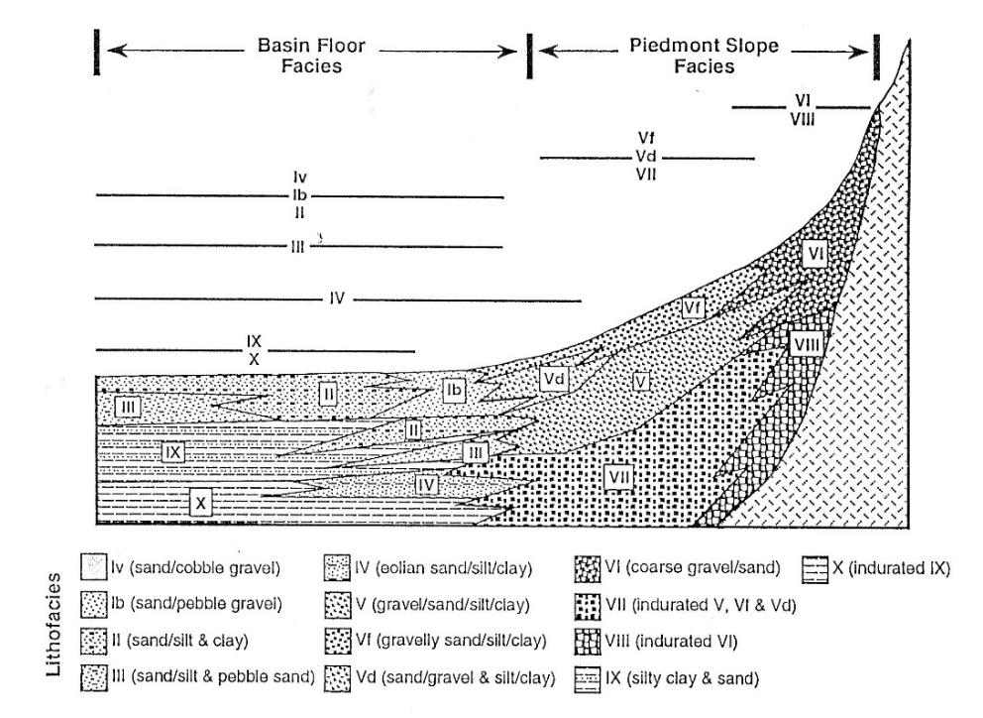
Figure A2-1. (Hawley and Haase 1992, Fig. III-6) Original schematic representation of distribution pattern of major lithofacies assemblages (LFAs) in Santa Fe Group basin-fill deposits of the Rio Grande rift province. Modified from. See Table A2-1 and Rpt. Figure 4-3.
The following selections from the “Methods and Techniques” section of Hawley and Lozinsky (1992) are also included (with some supplemental editorial comments) to facilitate access to additional information on the initial stages of digital hydrogeologic-framework characterization between 1986 and 1992:
Data Collection and Analysis [Hawley and Lozinsky (1992, p. 8)]
Key sources of borehole data were identified and located on available geologic maps of the Mesilla Basin (scales 1:24,000 and 1:100,000) for use as control points. These sources included borehole geophysical and sample logs, geothermal data, and geochemical analyses [for 56 key well in the NM (42) and TX parts of the study area]. Six new test wells drilled by the USGS-WRD and EPWU provided supplemental information. The Afton, Lanark, La Union, and Noria test wells were drilled in the basin area west of Mesilla Valley (MT 1 to 4; 25.1E.6.333, 27.1E.4.121, 27.2E.13.331, 28.1E.34.414 [Rpt. TBL. 1, nos. 178, 239, 247, 257]). The other two wells (CWF1D, CWF4D; JL-49-04-481, 469 [TBL. 1, nos. 344, 342]) are located in the Canutillo Well Field area on the Rio Grande floodplain west of Vinton, Texas (Nickerson 1986, 1989; Nickerson and Myers 1993). Subsurface data were supplemented by detailed seismic reflection profiles made at two sites near the Canutillo Well Field (C.B. Reynolds and Associates 1986, 1987). This database also included water analyses from one or more sampling intervals in most of the key wells (Table 4; Appendix—Tables A3, A4).
Tools needed to properly describe the sand-size fraction of basin-fill deposits included a binocular microscope for preliminary drill-cutting descriptions, a petrographic (light) microscope for rock and grain thin-section analyses, and x-ray equipment and the scanning electron microscope for characterization of ultra-fine-scale features (e.g., grain surface features, cementing agents, and porosity). Only the binocular and petrographic microscopes were used in the 1986-1992 study to analyze the sand-size fraction from selected sets of drill cuttings and outcrop samples. Color, grain size, and other major characteristics of the sediments were noted on the geologic logs. Cuttings were analyzed in approximate 10 ft (3 m) internals. Geophysical and driller logs greatly facilitated drill-cutting interpretations.
Table A2-1. (Hawley and Lozinsky 1992, Table 1-part 1; cf. Fig. A1-3)

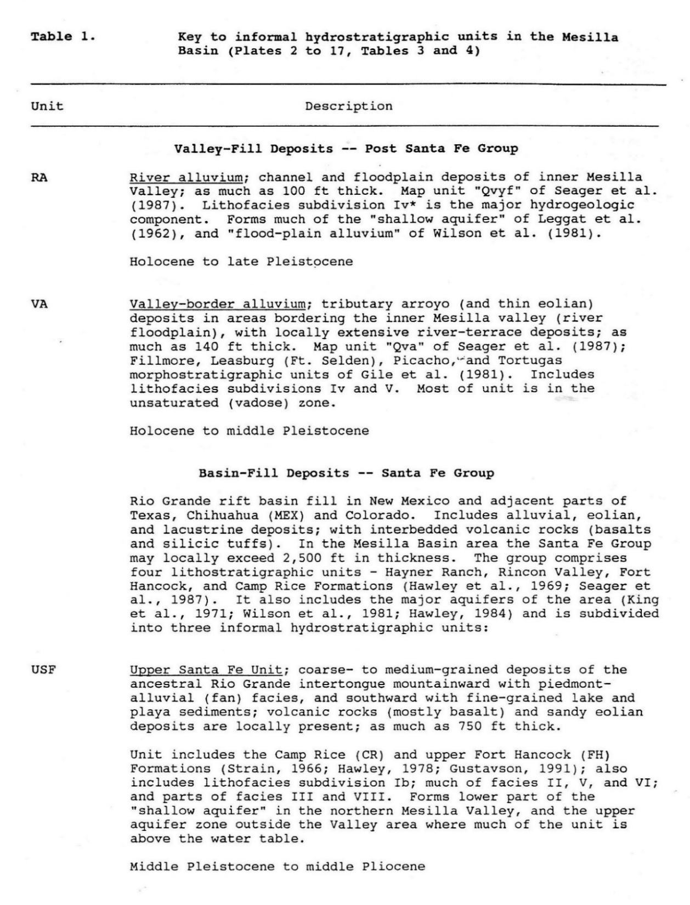

Table A2-1 concluded. (Hawley and Lozinsky 1992, Table 1-part 1; cf. Fig. A1-3)

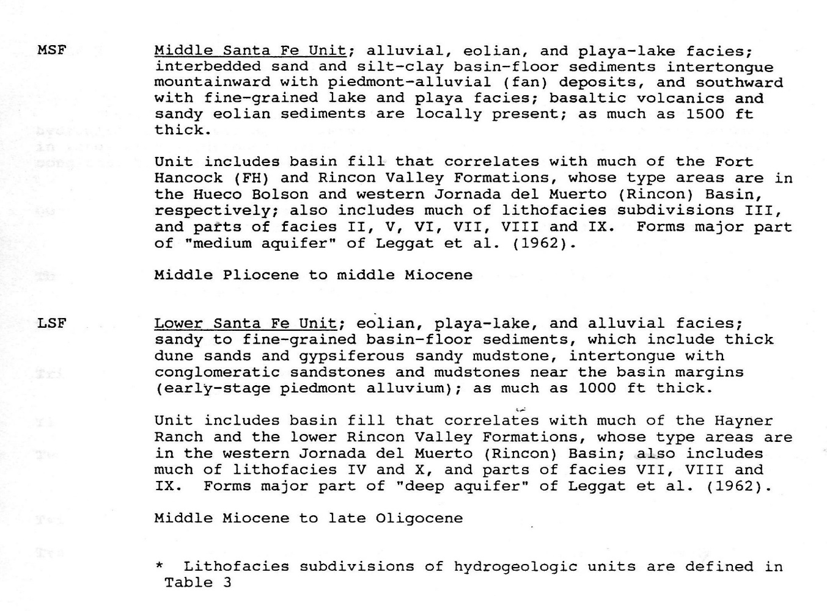
Drill Cutting and Thin Section Analysis [Hawley and Lozinsky (1992, p. 8 and 9)]
Cuttings from the Afton, Lanark, La Union, and Noria test wells (MT 1 to 4) were initially analyzed with a binocular microscope in order to construct a geologic log for each well and to determine sample intervals for thin section work. No preliminary cutting analysis was performed on samples from the Canutillo Field (CWF1D and CWF4D) because these wells were drilled very late in the study. Color, grain size, and other major characteristics of the sediments were noted on the geologic logs. Cuttings were analyzed in approximate 10 ft (3 m) intervals. Geophysical and driller logs aided in the initial examination of the cuttings.
Based on the cutting analysis, samples for thin section study were collected at approximately 100 ft (30 m) intervals from representative sand beds in the Afton, Lanark, La Union, and Noria test wells (MT 1 to 4). Samples were also collected from sandy intervals within the CWF1D and CWF4D wells, and from Santa Fe Group outcrops in the area. Locations of sampled wells and outcrops are shown on Plate 1. Forty-six thin sections were analyzed using criteria described by Dickinson (1970) in order to determine detrital modes and provenance. Thin-section petrographic data and interpretations are presented in Report Section III and Appendix A. Four hundred framework grains per thin section were point counted using a petrographic microscope. Ternary diagrams were constructed based on the point counts and data were also plotted on the geologic-petrographic logs of the Afton, Lanark, La Union, and Noria Test Wells (Plates 12-15).
Digitizing Borehole Geophysical Logs [Hawley and Lozinsky (1992, p. 9)]
Concurrently with the cutting and petrographic analysis, borehole geophysical data from selected key wells were digitized and then plotted onto computer-generated worksheets with a basin cross-section format. The borehole data were plotted to an altitude datum of 4,500 ft (1372 m) above MSL (vertical scale 1 in = 100 ft, 1 cm = 12.2 m). Digitizing of geophysical logs and plotting of cross-section worksheets was done at the USGS-WRD District Office (now NM Water Science Center) in Albuquerque. The computer-generated graphics system utilized in this study for integrating geophysical, geologic and hydrologic data (Plates 2-15) was developed by Hydrologist Kenneth Stevens, formerly with that office.
Hydrostratigraphic Unit Correlation and Hydrogeologic Framework [Hawley and Lozinsky (1992, p. 9)]
The basic approach of this investigation was the correlation of borehole-electric (resistivity), geologic-petrographic, and driller logs. Plates 12-15 summarize this information for the four test wells (MT 1 to 4) drilled as part of this study in representative areas of the central and southern parts of the basin. After detailed review of geophysical and geologic-petrologic data, and supplemental geothermal and geochemical information (Tables 4 to 6), initial correlations were made between these key boreholes and other wells in the basin (Plate 1). Kenneth Stevens of the USGS-WRD and Francis West of the NM-OSE collaborated in this phase of the study. Preliminary cross-section plots based on analyses of these data were prepared and reviewed prior to preparation of ten representative hydrogeologic sections of the basin. These sections, with selected borehole geophysical and hydrochemical data, are illustrated in Plates 2 and 11 [reproduced in APPENDIX A as Plates A2 to A7 on the CD-ROM included with the 2005 Addendum to Hawley and Kennedy 2004].* Plates 1, 16 and 17, with supporting data in Tables 1 to 3, integrate the above information into a conceptual model of the basin's hydrogeologic framework. The model's base elevation is 1,000 ft (305 m) above mean sea level.
*The hydrogeologic map and cross-section from Hawley and Kennedy (2004, APNDX. A [CD-ROM]) is reproduced here in Part AA1.1 (Plate AA1).

Table A2-2a. (Hawley and Lozinsky 1992, Table 3-part 1; cf. Tables A2-1 and A2-3)

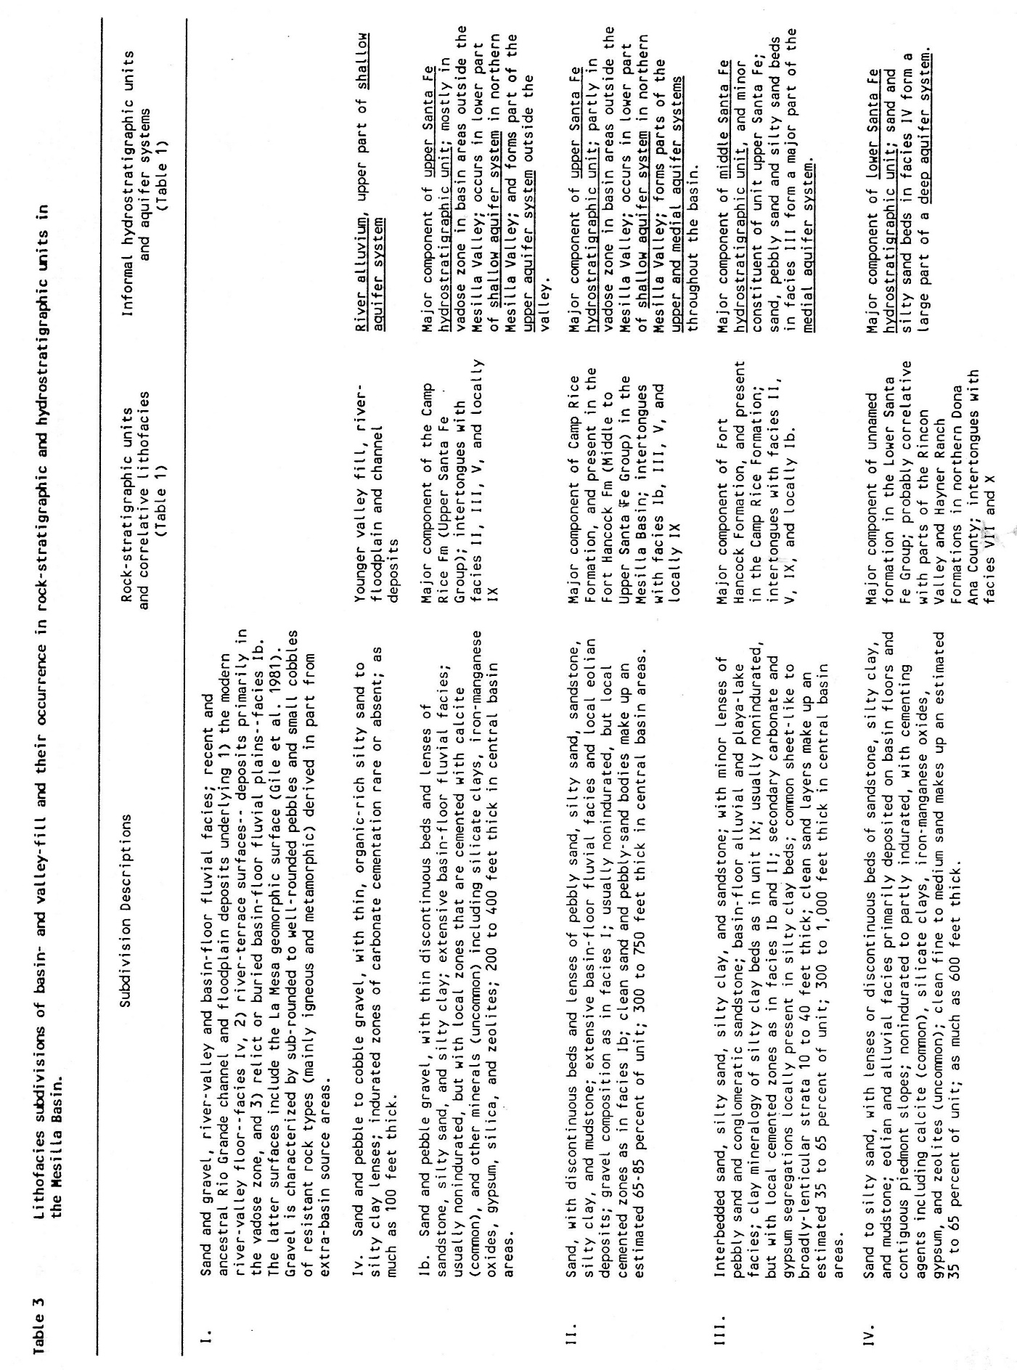
Table A2-2b. (Hawley and Lozinsky 1992, Table 3-part 2; cf. Tables A2-1 and A2-2)

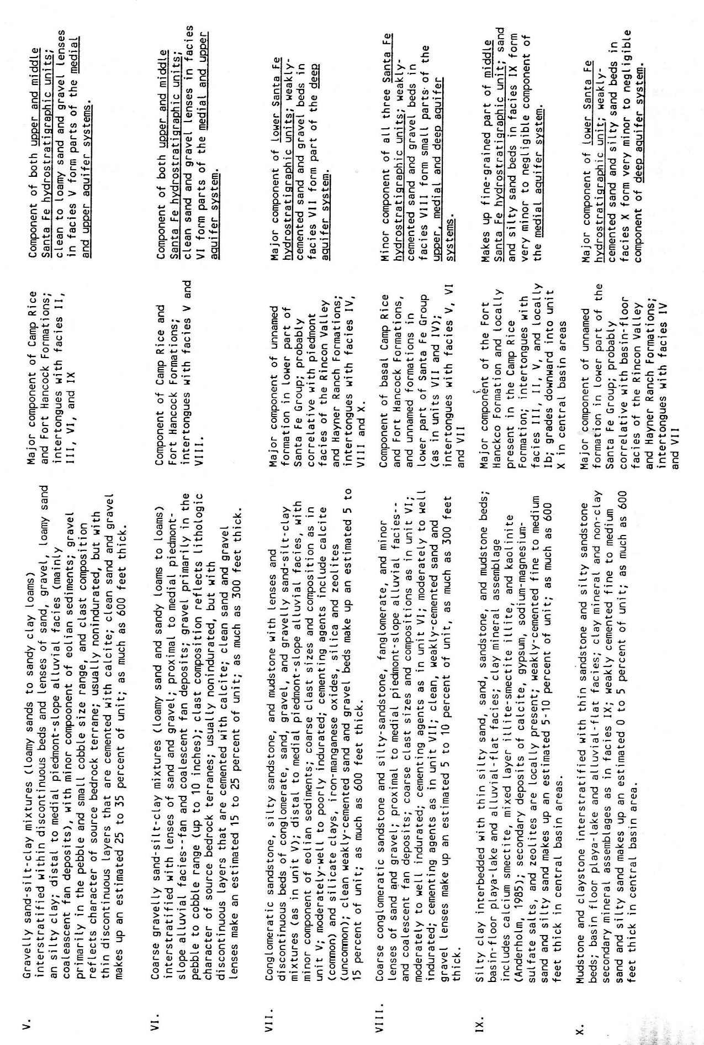
The HSU and LFA classification scheme in its present form was initially designed for use in a numerical model of the Mesilla Basin groundwater-flow system being developed for ongoing USGS-WRD, RASA-SWAB investigations (APPENDIX C-4; Frenzel and Kaehler 1960, and Kernodle 1992b). Pressing need for an updated hydrogeologic-framework characterization of the northern Albuquerque Basin, however, led to the HSU/LFA classification system’s initial application in GW-flow models being developed in that area (Hawley and Haase 1992, Thorn et al. 1993, Kernodle et al. 1995, Kernodle 1996). Section III in Hawley and Haase (1992) introduces the “Conceptual Hydrogeologic Model and its Hydrostratigraphic, Lithofacies, Structural, and Bedrock Boundary Components (Hawley, p. III-1 to III-14; Fig. III-6, p. III-10 [Fig. A-6]).” Section VI describes the primary geohydrologic functions of Lithofacies-Assemblage units (as portrayed on basin-scale hydrogeologic maps and cross sections) in Estimation of Hydrologic Parameters (Haase and Lozinsky, 1992, p. VI-1 to VI-3, Table VI-I
[Table A2-1]):
Introduction
Measurements of specific hydrologic properties of the Santa Fe group, such as hydraulic conductivity and transmissivity, have been obtained from pumping tests on individual wells (e.g., John W. Shomaker, Inc., 1990; 1991) throughout the Albuquerque area. The generalized distribution of such properties and of the water producing potential of the various Santa Fe Group lithofacies, however, has not been determined. In the remainder of this section four geological parameters, sand/clay ratio, bedding thickness, bedding configuration, and bedding continuity, will be assessed for the various Santa Fe Group lithofacies, and estimates of the permeability and water productivity of the lithofacies will be made. Results of the assessment are presented in Table VI-I [Table A2-3, a reformatted version of Table 3 in Thorn et al. 1993].
Geological Parameters
Sand + gravel/silt + clay ratio. As discussed in Section III of this report (see Table III-2), the 10 lithofacies and sub-lithofacies have variable amounts of sand-, gravel-, silt-, and clay-sized material. Such grain-size differences exert a major influence on the hydraulic conductivity of a particular lithofacies, with the more coarse-grained sediment typically exhibiting higher hydraulic conductivity than finer-grained sediments (Domenico and Schwartz, 1990): In Table VI-I [Tbl. A2-3], sand + gravel/silt + clay ratios are categorized as high (>2), moderate (0.5 to 2), and low <0.5).
Bedding thickness. Bedding thickness is a measure of the vertical extent of an individual bed. Thickness of individual beds influences both the hydraulic conductivity and the water productivity of a lithofacies. In general, the thicker the bedding within a sedimentary unit, the higher the expected water productivity (Fetter, 1988) from the unit. Bedding thickness for the Santa Fe Group lithofacies is summarized in in three categories, <1 ft thick, 1 to 5 ft thick, and >5 ft thick (Table VI-I [Tbl. A2-3]). See also Section III, Table III-2; . . .
Bedding configuration. Beds of the Santa Fe Group, typical of alluvial-fan and fluvial depositional systems Fetter, 1988), can be described as elongate (length to width ratios >5), planar (length to width ratios 1 to 5), and lobate (asymmetrical or incomplete planar beds). Bed configuration can influence water productivity through the impact of bed boundaries acting as hydraulic barriers to ground-water movement (Fetter, 1988). In the analysis described in this section, planar- or elongate-bedded lithofacies are assumed to have higher ground-water productivity. Bedding configurations for the lithofacies of the Santa Fe Group are summarized in Table VI-I [Tbl. A2-3].

Table A2-3. Summary of parameters that influence aquifer-production potential of Santa Fe Group Lithofacies Assemblage (LFA) classes. A reformatted version of Haase and Lozinsky (1992) Table VI-1 in Thorn, McAda, and Kernodle (1993, Tbl. 3). See Figure A2-1

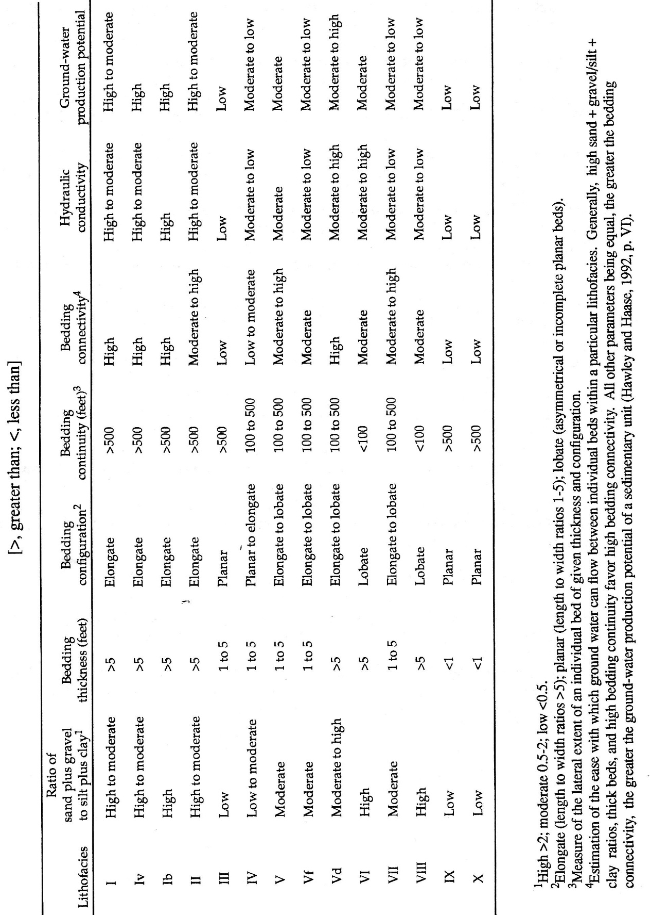
Bedding continuity. Bedding continuity is a measure of the lateral extent of an individual bed of given thickness and configuration. Bedding continuity influences the ability of ground water to flow through a bed and between different beds (Fetter, 1988). All other parameters being equal, greater bedding continuity favors increased ground water productivity. Bedding continuity for
the Santa Fe Group can be divided (see Chapter III, Table III-l) into >500 ft, between 100 and 500 ft, and <100 ft, and are summarized in Table VI-I [Tbl. A2-3].
Estimated parameters
Bed connectivity. This parameter is an estimation of the ease with which ground water can flow between individual beds within a particular lithofacies. In general, high sand + gravel/silt + clay ratios, thick beds, and high bedding continuity favor high bedding connectivity. All other parameters being equal, the greater the bedding connectivity, the greater the ground water productivity of a sedimentary unit (Fetter, 1988). Estimated bedding connectivities for the Santa Fe Group are summarized in Table VI-I [Tbl. A2-3].
Hydraulic conductivity. This parameter was estimated principally from the sand + gravel/silt + clay ratio. High ratios were taken to correspond to high hydraulic conductivities. Additionally, the parameters of bedding continuity and bedding connectivity were considered to a lesser degree. High values for both of these parameters correspond to high hydraulic conductivity values. For the lithofacies of the Santa Fe Group, hydraulic conductivity values are categorized in Table VI-I [Tbl. A2-3]. as high (>30 ft/day), moderate (0.3 to 30 ft/day), and low <0.3 ft/day).
Ground-water [aquifer-production] potential. This is a qualitative indicator of the suitability or desirability of a particular lithofacies for development of ground-water resources Table VI-I
[Tbl. A2-3].
Discussion
The parameters summarized in Table VI-l suggest that lithofacies I, Iv, Ib, II, and Vd have the highest potential as ground-water sources. Lithofacies I, Iv, Ib, and II were deposited in a fluvial setting. Lithofacies Vd was deposited as a major distributary channel within a large alluvial fan (see Section III) and, therefore, under conditions similar to those in a fluvial setting. Because of the high sand + gravel/silt + clay ratio of the material deposited, and the laterally extensive, thick, and connected nature of the bedforms, fluvial systems resulted in sediments with the highest potential for ground-water production within the Santa Fe Group.
A2.2. First digital compilations of hydrogeologic-framework information on the Mesilla
and Southern Jornada Basins, and adjacent bedrock uplands (1997-2010)
A2.2.1. Introduction
The above-described hydrostratigraphic unit (HSU) and lithofacies-assemblage (LFA) classification system was designed for use in basin-fill groundwater-flow models throughout the RG-rift region; and it has provided a template for organization of a variety hydrogeologic databases (Tables A2-1 to A2-3; Hawley and Haase 1992, Hawley and Lozinsky, 1992, Hawley et al. 1995; cf. Hawley and Kernodle 2000). Figures A2-2 and A2-3, and Tables A2-4 and A2-5 illustrate the progress made in development of a hydrogeologic-framework classification system that has already proven to be valuable component of aquifer-assessment efforts in the eastern Basin and Range province (e.g., Peterson et al. 1984, Thorn et al. 1992, Kernodle et al. 1995, Hawley and Kernodle 2000, Hawley et al. 2000, Kennedy et al. 2000, McAda and Barrow 2002, Plummer et al. 2004).
The most significant change from the 1992-1995 LFA class-ID system involved substitution of Arabic class-code numbers: 1 to 10 for the Roman numerals (I to X), which were clearly unsuited for digital-data processing (Figs. A2-2 and A2-3, Tbls. A2-4 and A2-5L). The other important changes in LFA-class organization were (1) the restriction of Arabic-code numbers to the ten primary Lithofacies-Assemblage components of the HSU-USF/MSF/LSF (SFG basin-fill) sequence, and (2) creation of separate alphanumeric system for categorizing LFA subdivisions of RG-Valley alluvial and intermontane-basin deposits of post-SFG age (Figs. A2-2 and A2-3, Tbls. A2-4 and A2-5R).
Major advances in hydrogeologic-framework characterization between 1997 and 2010 were mainly associated with geology and geophysics-based investigations for the “Trans-International Boundary Aquifer Project (TIBAP).” The studies were funded primarily by the U.S. Environmental Protection Agency (Region VI) and administered by the NM WRRI (APPENDIX H; Hibbs et al. 1997, 1999, 2000; Hawley et al. 2000, 2001; Kennedy et al. 2000; Creel and Hawley 2001; Granados Olivas et al. 2001, 2006, 2012; Hawley and Kennedy 2004). NM WRRI Associate Director, Dr. Bobby J. Creel (cf. Part A2.2.3) played the key role in insuring the implementation and ultimate success of this and closely related water-resource investigations throughout the southwestern New Mexico region. His visionary establishment of the NM WRRI GIS Laboratory and supporting main-frame computer facility in the mid-1990s is of special note in this respect (Creel 2010, Creel and Hawley 2001, Creel et al. 2006; Granados et al. 2006, 2012; Hawley et al. 2000, 2001, 2010; Hibbs et al. 1997).
The initial-TIBAP task required conversion of large and complex lithologic, stratigraphic, and structural databases into digital cartographic products (mainly hydrogeologic maps and cross-sections) to formats designed specifically for use in contemporary numerical models of the MBR’s groundwater-flow and hydrochemical systems (e.g., Hawley et al. 2000, Hawley and Kennedy 2004, Witcher et al. 2004, Hawley et al. 2009; cf. Hawley and Kernodle 2000, Kennedy et al. 2000).
The concluding section of this Appendix (Part AA1) includes summaries of hydrostratigraphic interpretations of geophysical and sample logs for boreholes and cross sections shown on Plates AA1 to AA9 (Table A2-7).
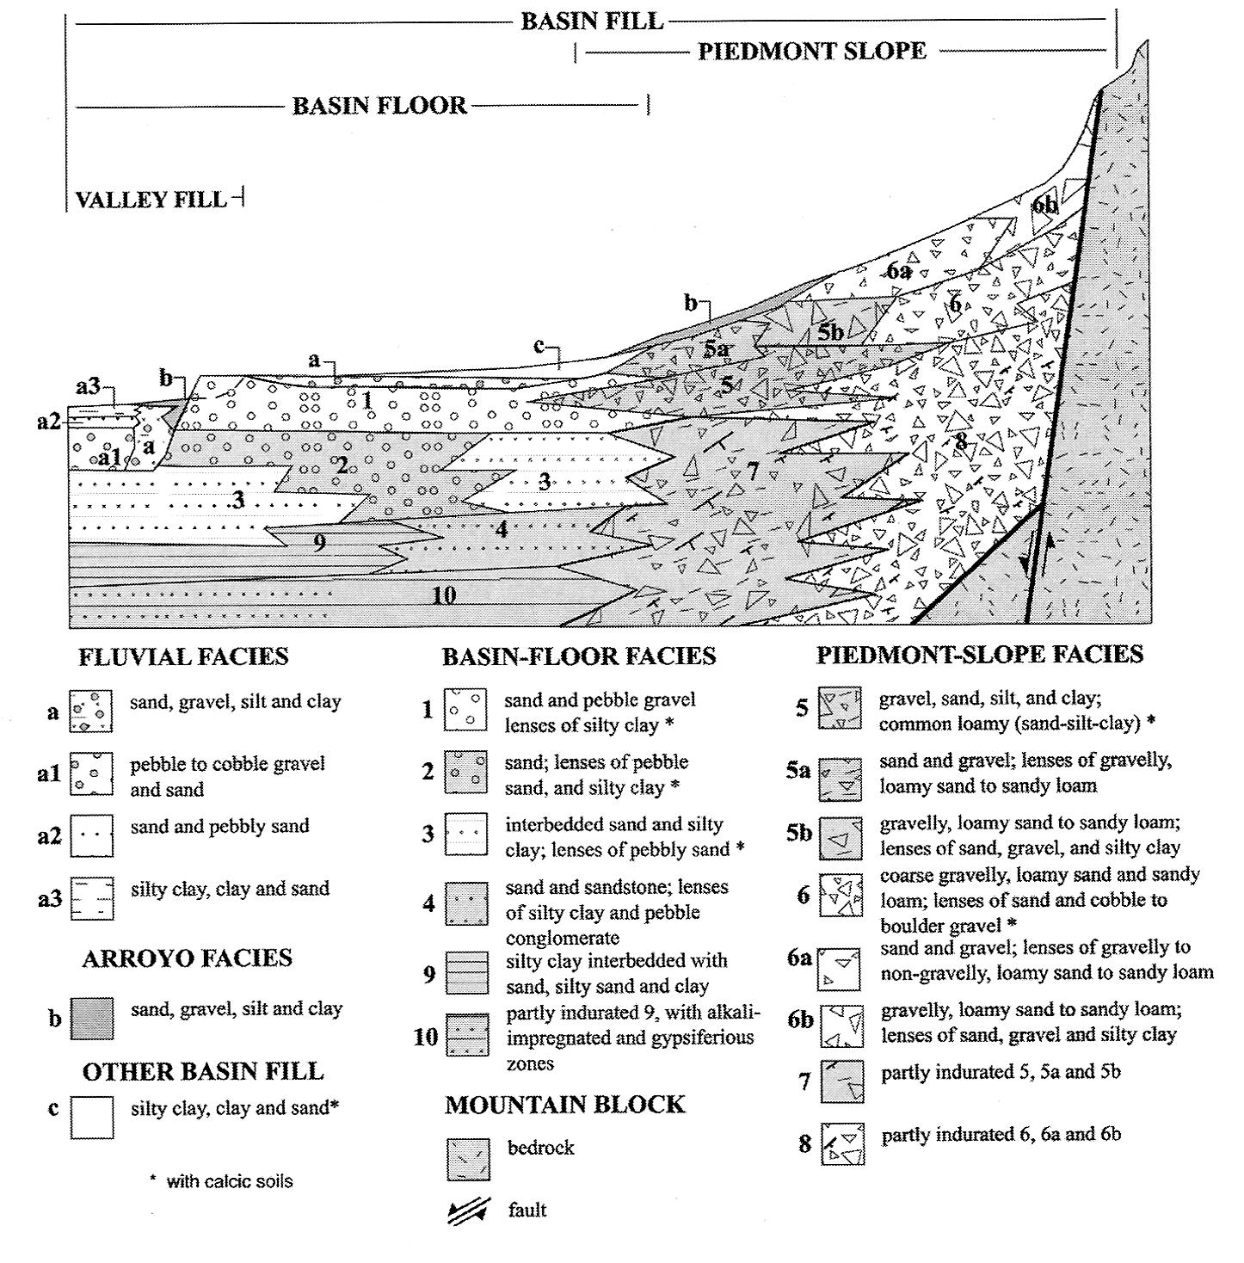
Figure A2-2. (Kennedy et al. 2000, Fig. 4) Schematic distribution pattern of major lithofacies assemblages (LFAs) in intermontane-basin (1 to 10 [USF/MSF/LSF]) and river-valley (a and b [RA and VA]) fills in a Rio Grande rift/eastern Basin and Range provincial setting. Modified from Hawley and others (2000, Fig. 3.6). See Figure A2-1, Table A2-3, and Report Figure 4-3a.
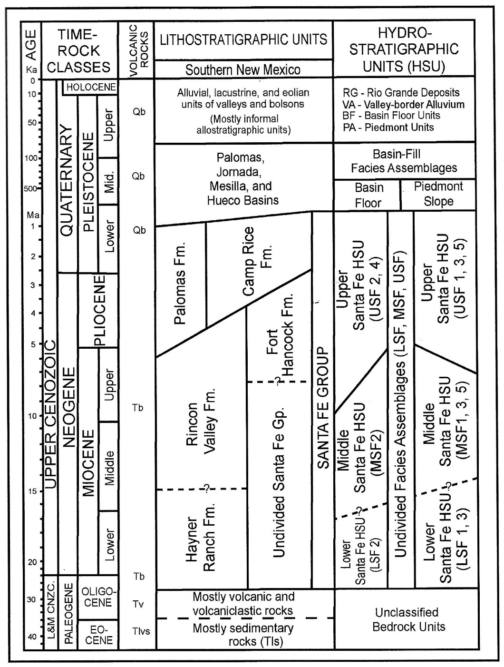
Figure A2-3. Correlation diagram of major chronologic, lithostratigraphic, and hydrostratigraphic units in southern New Mexico, western Trans-Pecos Texas, and northern Chihuahua, Mexico. Rock-unit symbols: Qb–Quaternary basalt, Tb–Tertiary mafic volcanics, Tv–older Tertiary intermediate and silicic volcanics, and associated plutonic-igneous and sedimentary rocks (adapted from Hawley and others (2009), with Neogene/Quaternary (Pleistocene) boundary-age from Walker and Geissman (2009).

Table A2-4. (Kennedy et al. 2000, Tbl. 2) Summary of depositional setting and dominant textures of major lithofacies assemblages (LFAs) in Santa Fe Group basin fill (1 to 10) and Rio
Grande Valley fill (a to c) in the intermontane basins of the Rio Grande rift tectonic province.
Modified from Hawley and Haase (1992, Tbl. III-2).

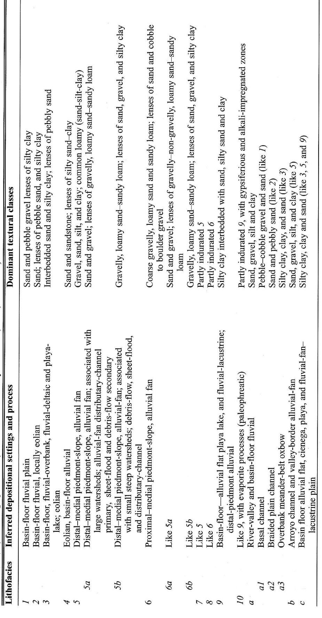
Table A2-5a. (Kennedy et al. 2000, Table 3L) Summary of major sedimentological properties that influence groundwater-flow and aquifer-production potential of LFAs 1 to 10 in Santa Fe Group basin fill (modified from Haase and Lozinsky (1992, Tbl. VI-1).

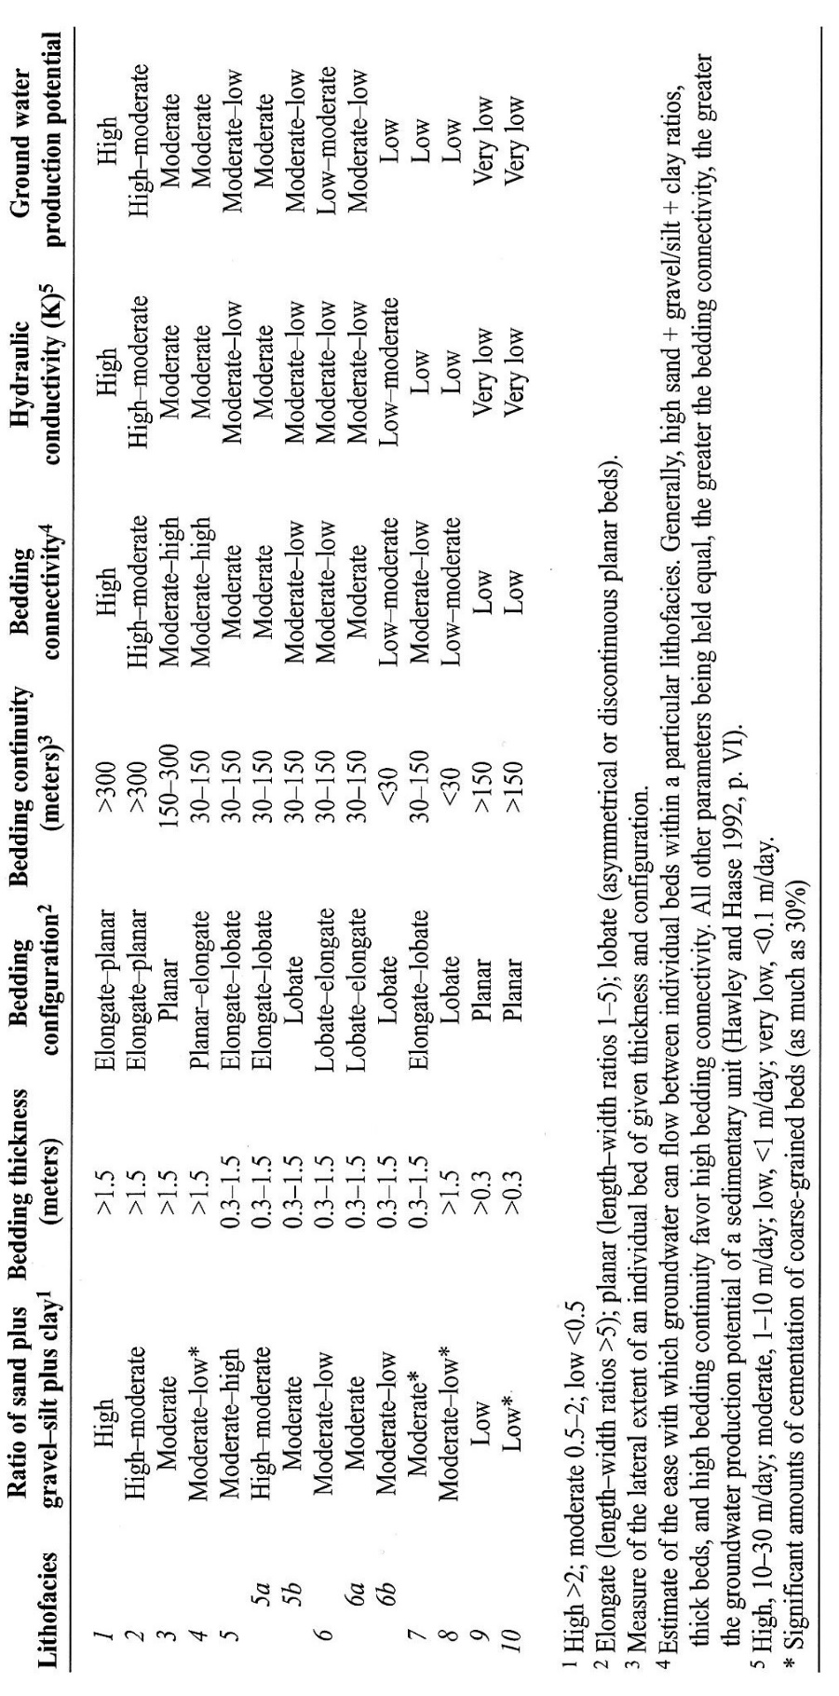
Table A2-5b. (Kennedy et al. 2000, Table 3R) Summary of major sedimentological properties that influence groundwater-flow and aquifer-production potential of LFAs a to c in river-valley and basin fills of post-Santa Fe Group age (modified from Hawley and others, 2000, Tbl. 3).

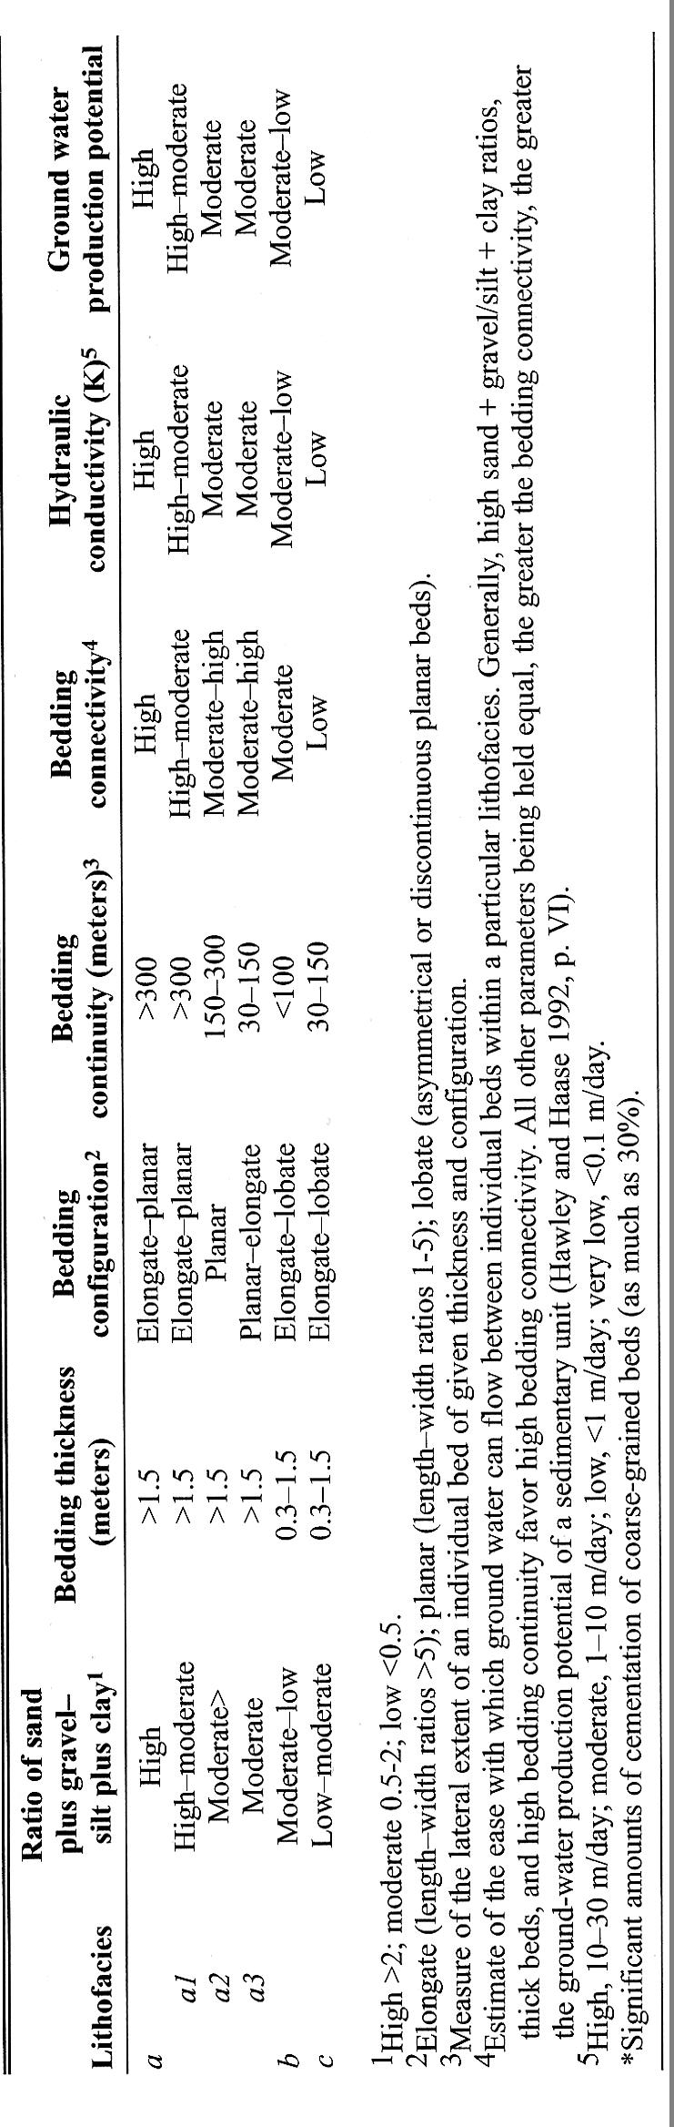
A2.2.2. Early HAWLEY GEOMATTERS Collaborations (1998-2009)
Following his retirement from NM Tech in 1997, John Hawley formed a sole-proprietorship consulting firm, HAWLEY GEOMATTERS, that specialized in environmental and groundwater geology of the New Mexico region. Emphasis of private consulting and pro bono public service was on assessing and mitigating impacts of water- and mineral-resource exploitation, and waste disposal in fragile arid and semiarid environments. Since groundwater-supply sustainability was of special concern, development of hydrogeologic-framework models that supported sound groundwater-resource conservation practices remained a major professional endeavor throughout the 20 years of the firm’s operation. Activities that relate specifically to groundwater investigations in the binational Mesilla Basin region, and their sources of funding and administrative support are listed in two major categories in Table A2-6: Public-institutional program activities, and private consultation dba HAWLEY GEOMATTERS. While almost all project outcomes to date have arrived at a common perspective on basin-scale hydrogeologic-framework composition, this is definitely not the case for the myriad interrelated water-resource management issues (interstate and international) that have yet to be resolved (cf. APNDX. H).
Increased funding support from the combined public and private sources listed in Table A2-6 allowed a significant expansion in the scope of NM WRRI-sponsored hydrogeologic investigations in the Mesilla Basin region after 1999. This is illustrated by the cartographic products, well-control databases, and the broad professional expertise and binational representation of the authors of NM WRRI-TCRs 330, 332, and 349 (Witcher et al. 2004, Hawley and Kennedy 2004, and Hawley et al. 2009; cf. Hawley et al. 2000, 2001; Granados Olivas et al. 2001, 2006; Hibbs et al. 2003; Creel et al. 2006; Druhan et al. 2008; Eastoe et al. 2008; Hutchison and Hibbs 2008). The most notable advances involved: (1) Updating the lithofacies (LFA) classification system and creating new digital versions of most of the hydrogeologic cross-sections of the Mesilla Basin area that were initially developed by Hawley and Lozinsky (1992, Pls. 1-11, 16, and 17; cf. Hawley and Kennedy 2004, Pls. A1 to A9 on CD-ROM). The original Hawley and Kennedy digital compilation of surface and subsurface information is reproduced in pdf format at the end of this Appendix (Tbl. A2-7; see AA1.1: Pls. A1-A9). Included are summaries of provisional interpretations of geophysical and sample logs with respect to hydrogeologic-framework position at each of 51 borehole sites. Final development of shape-files and metadata for hydrogeologic map and cross-sections is reviewed in Part A3 (cf. Tbl. A2-7). (2) Expansion of basin-scale framework characterization into the following areas: Rincon Valley southern Palomas Basin and the western Hueco Bolson (Hawley et al, 2005 and 2009).
Funding support from the NM Interstate-Stream Commission (ISC), the Lower Rio Grande Water Users Organization (LRGWUO), and El Paso Water Utilities (EPWU) also enabled compilation of the first generation of structure-contour maps that portray the base of the Santa Fe Group (SFG) basin-fill aquifer system in the area between Caballo Dam and El Paso del Norte at a scale of 1:100,000. Figures A2-4 and A2-5 exemplify the timely support from the NM-ISC, and illustrate basic hydrogeologic-framework controls on the groundwater-flow regime and its hydrochemical constituents in Lower Mesilla Valley-El Paso del Norte section of the Rio Grande Valley system (cf. Hawley and Kennedy 2004, Figs. 5-2 and 5-3).
Figures A2-6 and A2-7 (Hawley et al. 2009, Figs. 9 and 10) illustrate the major elements of hydrogeologic system evolution in the Mesilla Basin region (MGR) from a Pliocene-Quaternary (5 ma) geologic-time perspective (Fig. A2-3). These schematic-cartographic products exemplify collaborative investigations in the MBR that were initiated in the western Hueco Bolson in 2001 by Dr. Barry Hibbs of California State University at Los Angeles (CASULA) and Dr. Alfredo Granados Olivas of the Universidad Autónoma de Ciudad Juárez (UACJ). See APPENDICES B to D and H, Hawley (2020), and Hawley and Swanson (2022).
Table A2-6. Special studies in hydrogeologic-framework development (1998-2011).

- Public Institution Sponsored Programs, NM Water Resources Research Institute (NM WRRI): Visiting Senior Hydrogeologist (1998 - )
- Co-Principal Investigator: Trans-International Boundary Aquifers in Southwestern New Mexico. EPA Assistance ID # X-996350-01-3 (NM WRRI Contractor). Hydrogeologic framework of aquifer systems in the southwestern New Mexico region (1997-2000)
- Co-Principal Investigator: Digital hydrogeologic-framework model of the Mesilla and southern Jornada del Muerto Basins. Lower Rio Grande Water Users Organization—Account #01-4-23987b (2001-2003)
- Co-Principal Investigator: Sources of salinity in Rio Grande and Mesilla Basin aquifers. OSE/ISC-NMSU/WRRI Joint Powers Agreement #1-4-23960 (1999-2001)
- Co-Principal Investigator: Salinity sources of the Hueco Bolson. NM WRRI, with NSF Grant (SAHRA Glue Grant Supplement) to CEA-CREST (9/2001 – 8/2005)
- Co-Principal Investigator: Transboundary Aquifer Assessment Act Project. NM WRRI and TAMU/WRRI-USGS Cooperative Agreement 20090356-GR0002387 (2008-2011). See APPENDIX B and APPENDIX H
2. Private Consulting Activities dba HAWLEY GEOMATTERS (2008-2018)
- TetraTech-EMI (NMISC subcontract: REF: TTI Proj. No. S.1315.002; Subcontract # 02SR-S0052—2002-2003). “Hydrogeologic reports on borehole-sample and geophysical; logs of monitoring wells [ISC-MWs 1 - 3] near Anthony and Vinton—Lower Mesilla Valley, Doña Ana County, New Mexico.”
- TetraTech-EMI (NMISC subcontract: REF: TTI Proj. No. S.1315.002; Subcontract # 04SR-S0052—2004). “Prepare structure contour map (scale 1:100,000) of the base of Santa Fe Gp basin fill in the Mesilla Basin for the NM ISC.”
- TetraTech-EMI (NMISC subcontract: REF: TTI Proj. No. S.1315.002; Subcontract # 04SR-S0052—2004). Hydrogeologic consulting activities related to “proposed ISC-MW sites 4-7 in the Sunland Park area of the Lower Mesilla Valley.”
- El Paso Water Utilities (Lower Mesilla Valley–2006-2007). “Pursuant to Contract No. MCHAWLEY1 and the letter of agreement of March 14, 2006, HAWLEY GEOMATTERS prepared: (1) final versions of basic-data tables related to hydrostratigraphic-unit distribution in 175 wells in the Canutillo well-field area and adjacent parts of the Mesilla groundwater basin; and (2) structure-contour maps (scale 1:100,000) of interfaces between the Upper and Middle, and Middle and Lower Santa Fe Group basin-fill aquifer systems in that area.” These revisions and updates to the study area hydrogeologic model were submitted to the EPWU Hydrogeology and GIS staff on 1/10/07 (Tables) and 3/2/07 (Maps).
- CH2M-Hill Project No. 408366 (sources of Rio Grande salinity-USACE subcontract–2010-2011)

Table A2-7. Initial Digital-Format Compilation of Information on the Hydrogeologic Framework of the Mesilla Basin and Adjacent Upland Areas (Hawley and Kennedy 2004, Pls. A1 to A9). See Part AA1.1 Hydrogeologic Basemap and Cross-Sections* of the Mesilla Basin and Valley Area.
*Includes hydrogeologic interpretations of geophysical and sample logs for boreholes and cross sections shown on PLATE AA1.

Plate AA1. Hydrogeologic map of the Mesilla Basin region, south-central New Mexico, and adjacent parts of Texas and Chihuahua, Mexico, from Hawley and Kennedy (2004, Appendix A2 on CD-ROM). Includes locations of key wells and hydrogeologic cross sections. Compiled and modified from Seager and others (1982, 1987), Seager (1995).
Plates AA2 to AA7. Hydrogeologic-index cross-sections, with borehole geophysical and geochemical data*, and interpretations of lithofacies assemblages (LFAs) and hydrostratigraphic units (HSUs). Section locations shown on Plate AA1; base elevation 1,500 ft amsl, with irregular horizontal scale. Selected data and interpretations for on 51 key wells, from Hawley and Kennedy (2004).
* The short- and long-normal resistivity traces in the electric logs are in red and blue, respectively. Chemical analyses of water samples and provisional hydrostratigraphic correlations for 56 key wells (NM-42, TX-14) summarized in Hawley and Kennedy 2004, Appendix A.
Plate AA2. Afton Test Well (MT 1) to Mesquite. Modified from Hawley and Lozinsky (1992, Pl. 3).
Plate AA3. Aden-Afton volcanic field to Anthony-La Tuna area, including Lanark (MT 2) and Union (MT 3) Test Wells. Modified from Hawley and Lozinsky (1992, Pl. 4).
Plate AA4e. Hydrogeologic section Noria Test to Mesa Boulevard, with borehole geophysical data. Modified from Hawley and Lozinsky (1992, Pl. 6).
Plate AA4w. Hydrogeologic section Potrillo Mountains to Noria Test, with borehole geophysical data. Modified from Hawley and Lozinsky (1992, Pl. 7).
Plate AA5. Las Cruces West Mesa to Santa Teresa, including Afton (MT 1) and Lanark (MT 2) Test Wells. Modified from Hawley and Lozinsky (1992, Pl. 9).
Plate AA6. Las Cruces Fire Station to Vado. Modified from Hawley and Lozinsky (1992, Pl. 10).
Plate AA7. Vado to Lizard Siding (SPRR). Modified from Hawley and Lozinsky (1992, Pl. 11).
Plates AA8 and AA9. Schematic hydrogeologic sections of the Mesilla Basin between Las Cruces and El Paso, showing inferred distribution of major lithofacies assemblages (LFAs), hydrostratigraphic units (HSUs) and fault zones. Section locations shown on Plate 1, with the same horizontal scale; base elevation 1,000ft asl and 10x vertical exaggeration. Compiled by Hawley and Kennedy 2004; modified from Hawley and Lozinsky (1992, Pls. 16 and 17).
Plate AA8. West to east sections
Plate AA8a. West Mesa-Fairgrounds to Mesilla Valley-Las Cruces Fire Station.
Plate AA8b. Afton Test Well (MT 1) to Mesquite (Plate 2 alignment).
Plate AA8c. Aden-Afton volcanic field to Anthony-La Tuna area (Plate 3 and Figure
2.7b alignment).
Plate AA8d. West Mesa-La Union Test Well to Mesilla Valley-Vinton.
Plate AA8e. East Potrillo Mountains to Mesa Boulevard, El Paso (Plate 4 alignment).
Plate AA9. North to south sections
Plate AA9a. Inner Mesilla Valley—Las Cruces Fire Station to Lizard Siding, via Vado (Plates AA6 and 7 alignment).
Plate AA9b. Las Cruces West Mesa to Santa Teresa (Plate 5 alignment).
Plate AA9c. Western basin area—Afton Test Well to Noria, via Lanark Test Well.

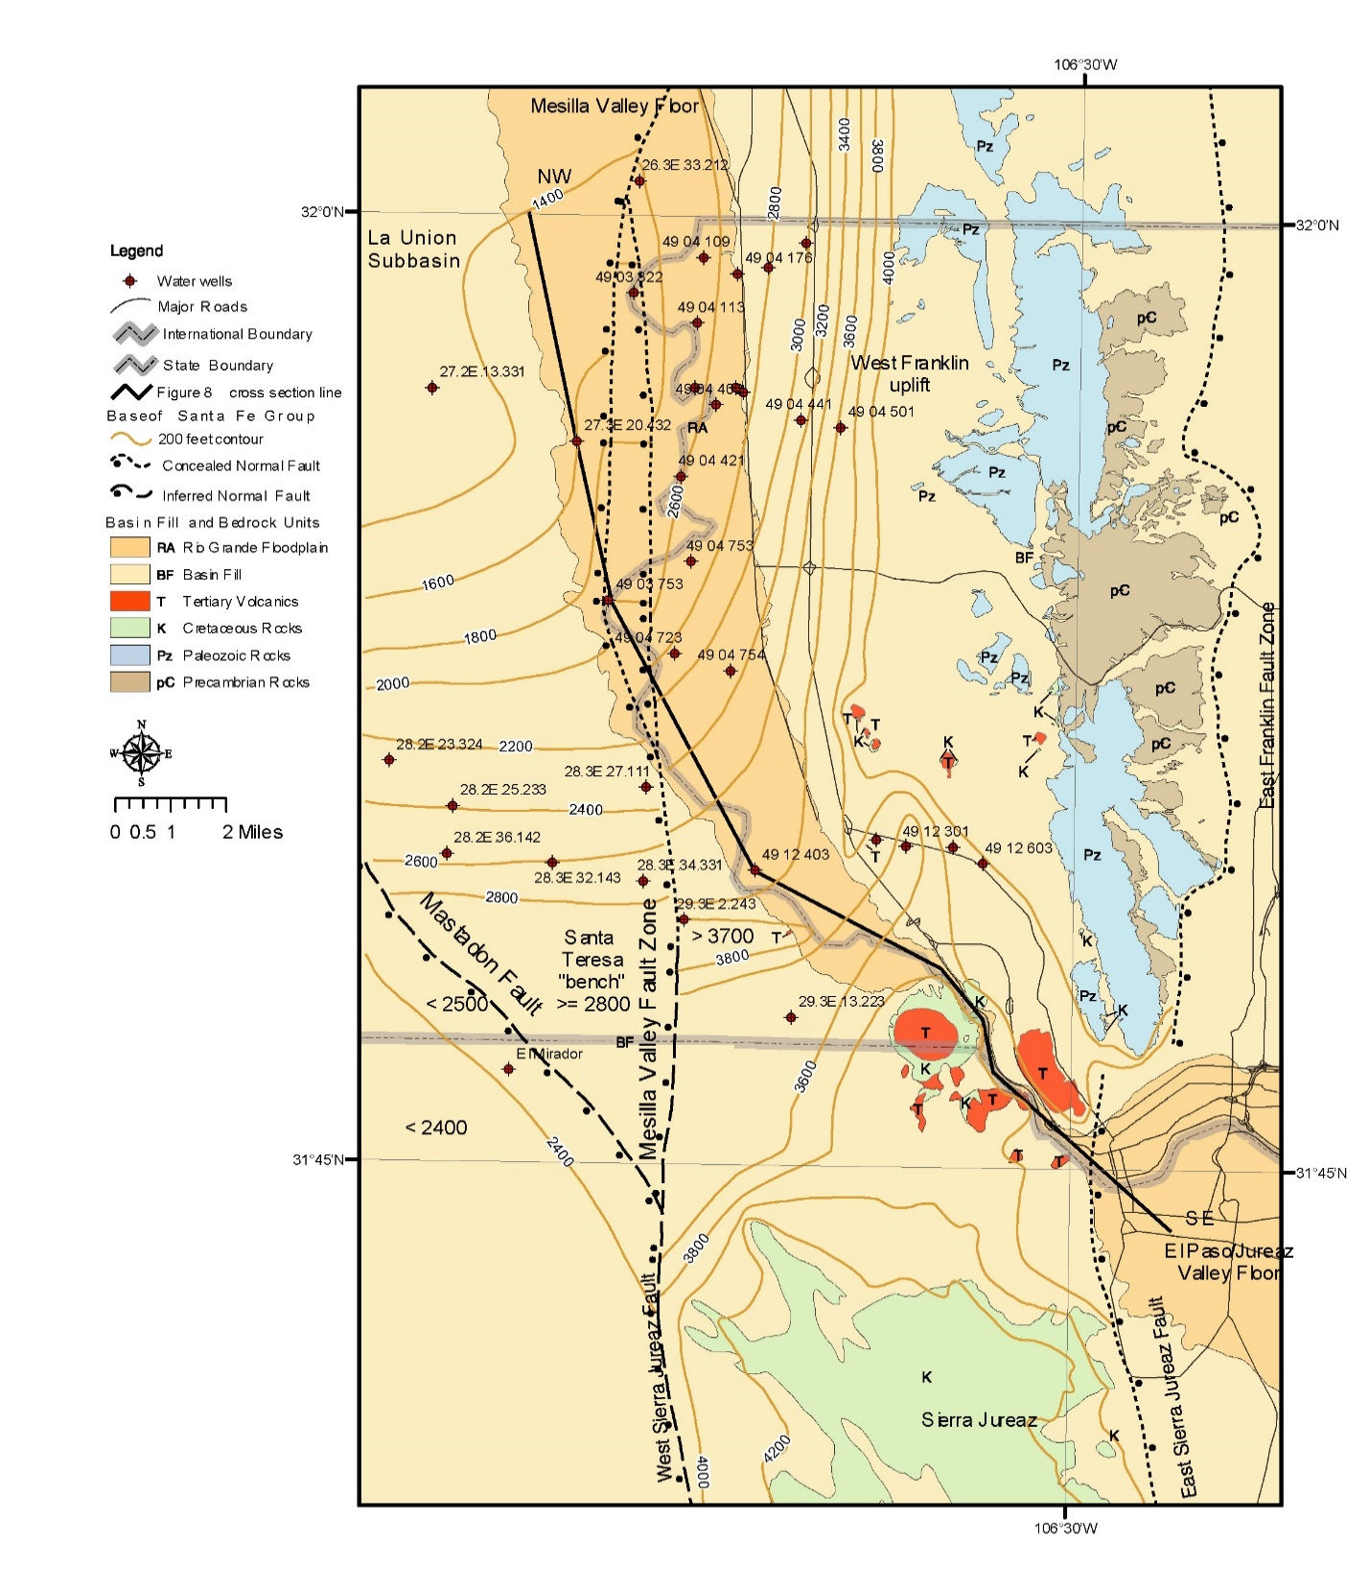
Figure A2-4. (Hawley and Kennedy 2004, Fig. 5-2; Hawley et al. 2009, Fig. 7) Index map of the Lower Mesilla Valley-El Paso del Norte-El Paso/Juárez section of the Rio Grande/Bravo Valley/Canyon system. 200-ft (60 m)-interval structure contours schematically portray the elevation (amsl) of the base of Santa Fe Gp (RG-rift) basin fill. NW—SE (solid-black) line shows location of hydrogeologic cross-section (Fig. A2-5). Note: “West Sierra Juárez fault” is designated El Vergel fault zone (EVfz, Rpt. Tbl. 1-5).
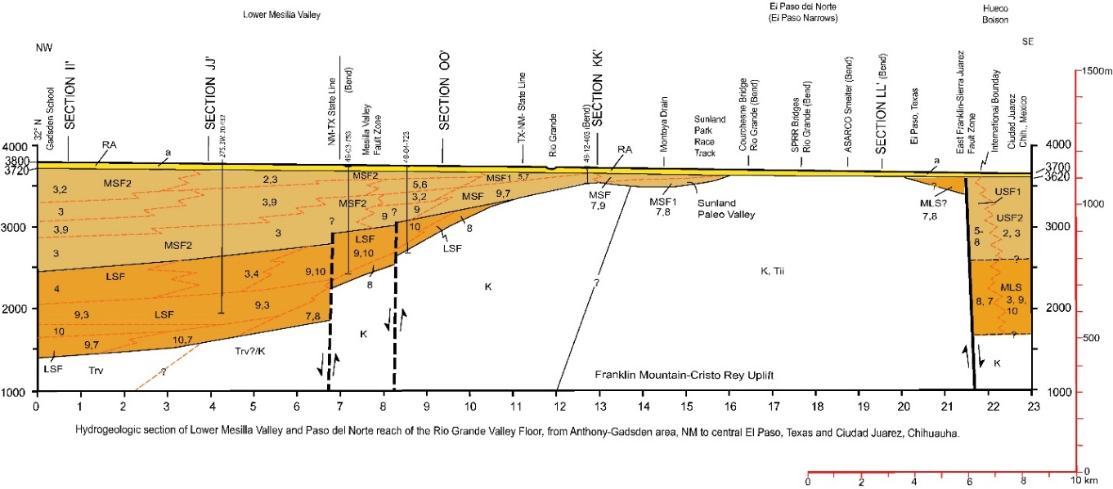

Figure A2-5. (Hawley and Kennedy 2004, Fig. 5-3; Hawley et al. 2009, Fig. 7) Hydrogeologic cross-section of the Lower Mesilla Valley-El Paso del Norte-El Paso/Juárez reach of the Rio Grande/Bravo Valley system (location on Fig. A2-4). Schematically illustrates the primary hydrogeologic-framework features that control the groundwater-flow regime and its hydrochemistry up and down the hydraulic gradient from El Paso del Norte (EP Narrows).
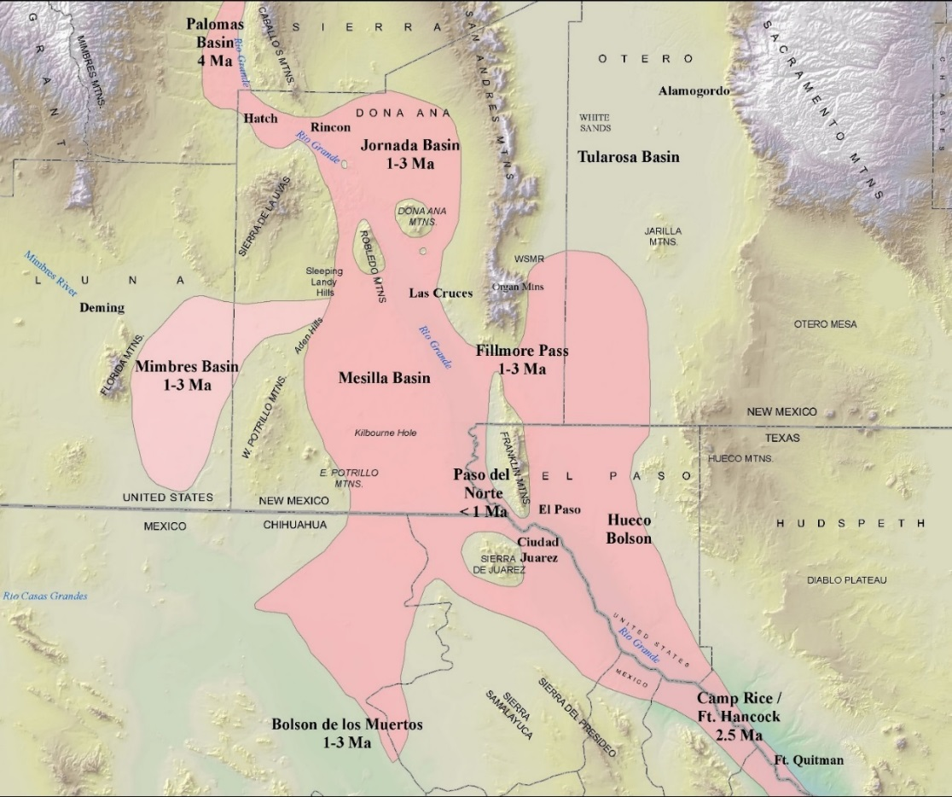

Figure A2-6. (Hawley et al. 2009, Fig. 9; cf. Fig. A1-4) Schematic depiction of the approximate area where fluvial and fluvial-deltaic deposits of the Ancestral Rio Grande (ARG) form the dominant Upper SFG basin-fill component. The primary distributary-channel network that spread out from an apex at the end of a trunk ARG channel-belt in the Palomas Basin NW of Hatch is in pink. Million-yr (Ma) age ranges of major distributary channel-belts are based on geochronologic information available in 2008. The network terminated in fluvial-deltaic transition zones that bordered the paleo-Lake Cabeza de Vaca (LCdV) system of Strain (1966; cf. Rpt. Part 3.7.2). The latter occupied basin-floor areas below a present altitude of about 4,050 ft (1,235 m) in the Tularosa Basin, Hueco Bolson, and Bolsón de Los Muertos (Strain 1971, Gustavson 1991). ARG fluvial-plain remnants preserved in the present landscape comprise parts of the “La Mesa geomorphic surface” (Hawley et al. 1969, Gile et. al. 1981). USGS DEM-base.
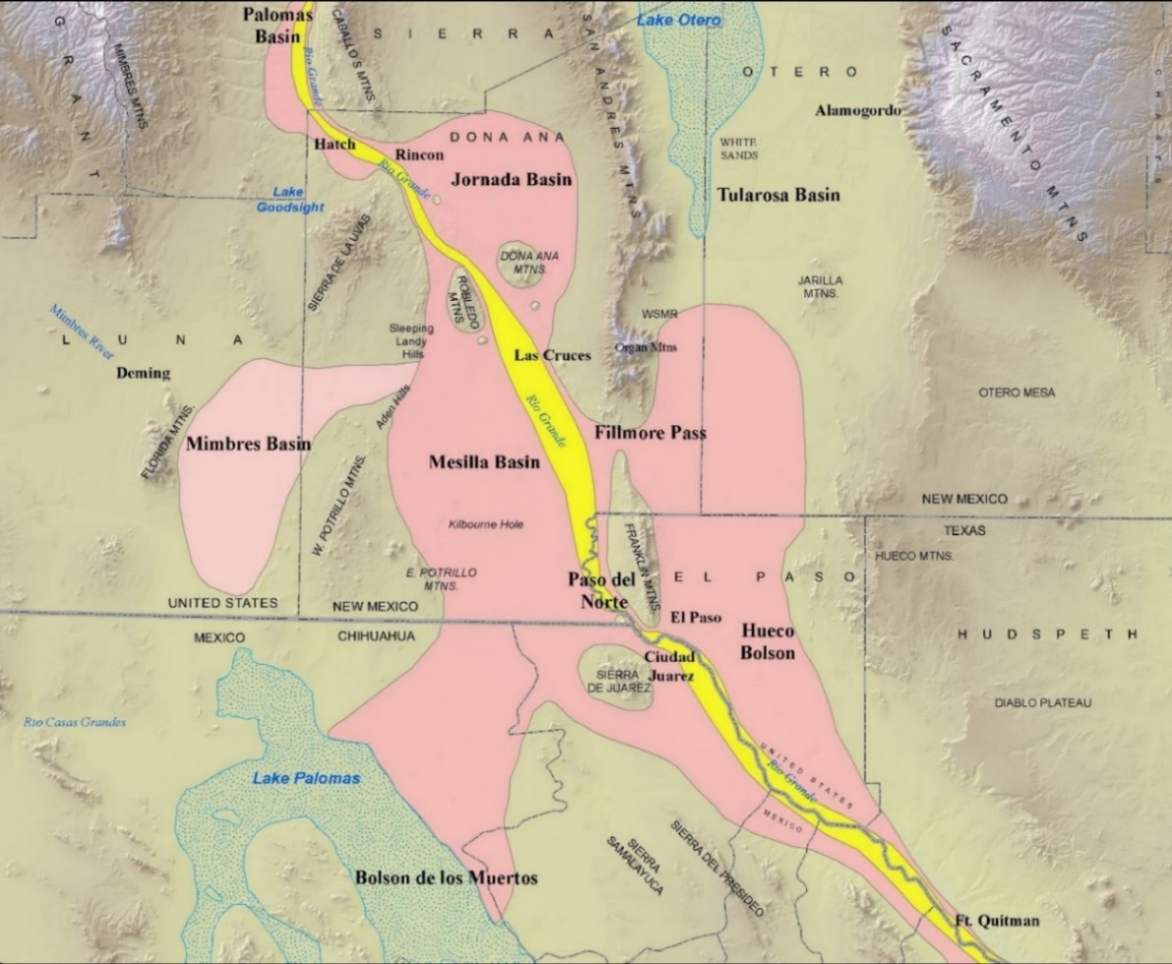
Figure A2-7. (Hawley et al. 2009, Fig. 10; cf. Fig. A2-6) Schematic depiction of major Quaternary-landscape features of the Mesilla Basin region. The approximate area covered by the Ancestral Rio Grande (ARG) distributary drainage network that spread out from a trunk-ARG channel system in the Palomas Basin is in pink. The deeply entrenched Rio Grande/Bravo Valley and Canyon system is in yellow. The stipple pattern covers the basin-floor areas occupied by deepest Late Pleistocene stages of two large pluvial lakes: Palomas (NW Chihuahua) and Otero (Tularosa Basin). Remnants of the Early Pleistocene ARG fluvial-deltaic plain comprise parts of the “La Mesa geomorphic surface (Hawley and Kottlowski 1969).” USGS-DEM base.
A2.2.3. Commemorative Remarks by John W. Hawley at Dr. Bobby J. Creel’s Celebration of Life, February 19, 2010: “Some Memories of Bobby Joe Creel (1943-2010; Fig. A2-8)”
Everyone’s life is multifaceted. Some facets refract inward to private places best left unvisited. Here, I choose to recall those that reflect the sunlight of a very special life and sparkle with the vigor of great accomplishments. In the case of my long-time friend and professional associate Bobby J. Creel, his all-too-short lifetime is a wonderful but still heart-wrenching place to visit. Bobby’s physical absence today is such an unexpected event and devastating blow that the best my wife and I can do under the circumstances is offer our heartfelt condolences to his immediate family and loved ones. The following comments are limited to a few observations of Bobby’s seminal contributions to water resources research based on about thirty years of personal acquaintance . . .
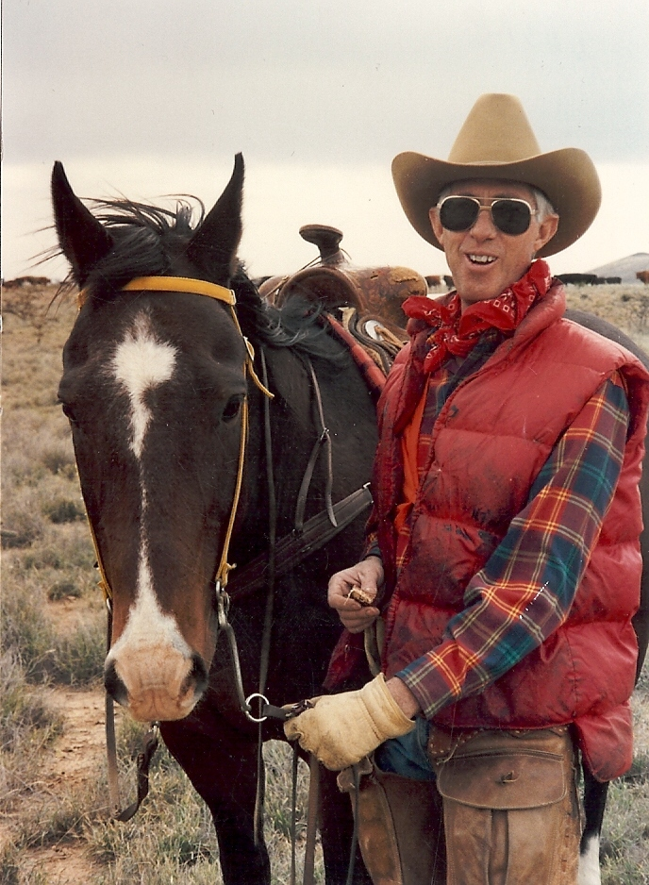
Figure A2-8. Bobby Creel taking a break from professional life at his Tularosa Basin Ranch (1990s).
During most of the 1980s, I was one of several NM Tech representatives on the multi-institutional panel that evaluated proposals for water-research projects administered by the NM Water Resources Research Institute. In those days quite a lot of public funds and matching support was still available, mostly in the form of “seed” grants for water-related graduate research programs throughout the state-university system. In his position as Assistant (and Acting) Director of the Institute and an astute natural-resource economist, Bobby Creel was always there to ensure that public funds were appropriately distributed and utilized in the most cost-effective manner. As the “cash-cow” got leaner in subsequent years, he was still able to turn challenges into opportunities and never stopped growing in intellect and professional stature.
I’m just one example of the many lives that Bobby Creel has enriched. Fortunately, most were his students and peers, and not old folks like me. In 1997 he reignited the spark in my professional life by inviting me to work at least part time at the WRRI after my retirement from the NM Bureau of Mines at NM Tech. At the time, I was a semi-burned-out 65-year-old with no particular plans other than doing some consulting in environmental geology. Bobby actually believed that I could recover some useful information from earlier (1960s) work with the USDA-SCS and apply it to building more robust hydrogeologic models of transboundary aquifers of the southwestern New Mexico region [APNDX. H]. Thanks to him I’m still a viable geologist with passable computer skills, and even reasonably effective in terms of communication with GIS specialists and groundwater-flow modelers.
I still haven’t figured out why such an eminent natural-resource economist, scientist, and research administrator would attempt to resurrect an eccentric old geologist with an obsessive compulsion to treat earth science as some sort of religious experience. This is even more mystifying because GIS, automotive mechanics, animal husbandry, and farm/ranch operations were also part of Bobby’s skill set. However, our common bonds definitely included love of the binational American West, its natural resources and culture; as well as stubborn desire to get things “right.” Family, co-workers, and friends would probably like to forget our “infamous” work binges (e.g., all-nighters and weekenders) when project-completion reports had to meet research contract deadlines.
In closing, I choose to remember and honor Bobby Creel as one who left a very positive and healing mark on this part of our wounded planet. He could and did “think outside the box.” But Bobby was most of all an effective consensus builder, who instinctively knew the location of and how to respect all boundaries dictated by scientific rationale and “common sense” (the ability not to repeat a mistake more than twice [cf. Creel 2010].” He was the epitome of an effective public servant who lived by a motto attributed to James Cash Penney: “There’s no limit to the good a man can do if he doesn’t care who gets the credit.”*
*Figure A2-8. See Creel and Hawley (2001); Creel and others (2006); Granados and others (2006 and 2012); Hawley and others (2000, 2001, 2009 and 2012); and Hibbs and others (1997).
A3. ADVANCES IN HYDROGEOLOGIC-FRAMEWORK CHARACTERIZATION
(2010-PRESENT)
A3.1. Background on the Transboundary Aquifer Assessment Program (TAAP)
The transboundary character of this study required that special emphasis be placed on hydrogeologic features of significant binational and interstate concern. Research, therefore, has been closely linked with previous and concurrent studies of multi-institutional and multi-disciplinary nature, some of which continue to have sensitive binational-political and/or interstate-compact implications (e.g., APNDX. H; Granados Olivas, ed., 2022). Programs of note include the Southwest Alluvial Basin Regional Aquifer-System Analysis (SWAB-USGS) and EPA-La Paz—Border XXI projects, and the ongoing Transboundary Aquifer Assessment Program (TAAP) (Wilkins 1986, Frenzel and Kaehler 1992, Kernodle 1992, Nickerson and Myers 1993, Hibbs et al. 1997, Wilkins 1998, Hawley et al. 2000 and 2009, Hawley and Kennedy 2004, Creel et al. 2006, Granados-Olivas et al. 2009 and 2012, Sheng et al. 2013, Sweetkind 2017 and 2018, Sweetkind et al. 2017, Teeple 2017, Hanson et al. 2018, Hawley and Swanson 2022).
Most hydrogeologic investigations in the MBR since 2009 have been designed to integrate with related water-resources research activities into appropriate parts of the Transboundary Aquifer Assessment Program (TAAP, Alley 2013). The TAAP originated in U.S. Public Law 109-448, which was signed by President George W. Bush on December 22, 2006 as the United States-Mexico Transboundary Aquifer Assessment Act (US-MX TAA, 2006). The act (S.214-1) authorizes: “The Secretary of the Interior to cooperate with the States on the border with Mexico and other appropriate entities in conducting a hydrogeologic characterization, mapping, and modeling program for priority transboundary aquifers, and for other purposes.”
The NM WRRI was selected as the lead institution in three major TAAP activities: Task 1 - Water-resource economics, with Dr. Bobby Creel as co-PI; Task 2 - Binational bibliography compilation (APNDX. B); and Task 4 - Hydrogeologic-framework characterization. The scope of work described in Report Part 1.3 conforms to Sections 1 and 3 of the “Act,” which specifically involves the process of “systematically assessing priority transboundary aquifers” in the “Hueco Bolson and Mesilla aquifers underlying parts of Texas, New Mexico, and Mexico; ….” From a hydrogeologic perspective, the primary NM WRRI SOW objectives are outlined in Tasks 2 and 4 in the “Updated U.S. Joint Work Plan for Mesilla Basin/Conejos Médanos (11/30/2010, p. 3-6).” The range of interdisciplinary and multi-institutional involvement in TAAP activity is illustrated in APPENDIX H, Table H6-1.
Task 2 involves the identification, review, and evaluation of previous hydrogeologic studies in the binational parts of the Mesilla Basin and Hueco Bolson region. This ongoing effort exemplifies the basic TAAP theme of water-resource database sharing, and involves compilation of published information, in an annotated-bibliographic format, on Transboundary aquifer systems in a large region that extends beyond the NM WRRI Study Area into surrounding parts of Chihuahua, New Mexico and Trans-Pecos Texas (e.g., APNDX B). Task 4 requires updating the initial basin-scale hydrogeologic-framework model of Hawley and Kennedy (2004, Tbl. 2-7) to better “define aquifer characteristics and further support development of scientifically sound groundwater-flow models (Part A2.2.2).” Transboundary-aquifer characteristics and hydrogeologic-boundary conditions in contiguous parts of the Mesilla GW Basin (MeB) and the “Acuífero Conejos-Médanos” section of the “Zona Hidrogeológica de Conejos Médanos” have received special attention (cf. Hawley and Swanson (2022). The substantial progress made in Task 4 completion is covered in detail in Report CHAPTERS 3 to 7 (e.g., the TBL. 1, Key-well database, and the hydrogeologic maps and cross-sections displayed in PLS. 2, 5 and 7).
Substantial progress in TAAP research was made prior to the 2010 death of NM WRRI Associate Director Dr. Bobby Creel. However, loss of his seasoned and dynamic leadership in both statewide and in regional water-resources research programs coincided with an unanticipated curtailment of federal and state funding support for TAAP activities. The resultant interruptions in GIS laboratory-service availability led to major delays in completion of the hydrogeologic investigations that were originally designed to be an integral part of ongoing numerical-modeling efforts at Regional USGS Water Science Centers. Nonetheless, even without adequate funding support, TAAP-related studies have led to many very productive collaborations (cf. Eastoe et al. 2008, Granados Olivas et al. 2009 and 2012, Hawley et al. 2012, Alley 2013, Hibbs et al. 2015, Sweetkind 2017, Sweetkind et al. 2017, Teeple 2017, Hanson et al. 2018, Hawley 2020, Kubicki et al. 2021, Hawley and Swanson 2022).
A3.2. Background of Recent Advances in Hydrogeologic-Framework Characterization
Substantial advances since 2010 in the cartographic portrayals of basic hydrogeologic-framework components are illustrated in the present generation of maps, cross sections, and schematic diagrams of the NM WRRI Study Area (Fig. A3-1; e.g., PLS. 1B, 1C, and 5a-s).
As stated in Report Parts 2.3.1 and 2.3.2:
Preparation of the Report’s maps (8), cross-sections (19), and block diagrams (2) has been a mind-expanding, . . . process that involves merging art with geoscience (e.g., PLS. 1 to 9). It has required the scientific and technical input of dozens of individuals, including skilled cartographers and GIS specialists, over a period of more 50 years. Concepts and assumptions in map, cross-section, and derivative block-diagram preparation are derived from the large body of public-domain information, most of which is adequate for basin-scale hydrogeologic-framework characterization (here ~1:100,000). Major components of this cartographic database include information on (1) surficial geomorphic and geologic relationships, (2) subsurface stratigraphy and structure, and (3) geophysical and hydrochemical conditions. With respect to the interpretation of geomorphic processes and landscape features alone, the current generation of Google Earth® and space-platform imagery have played an essential role in map preparation, particularly in the part of the Study Area in Mexico. . . .
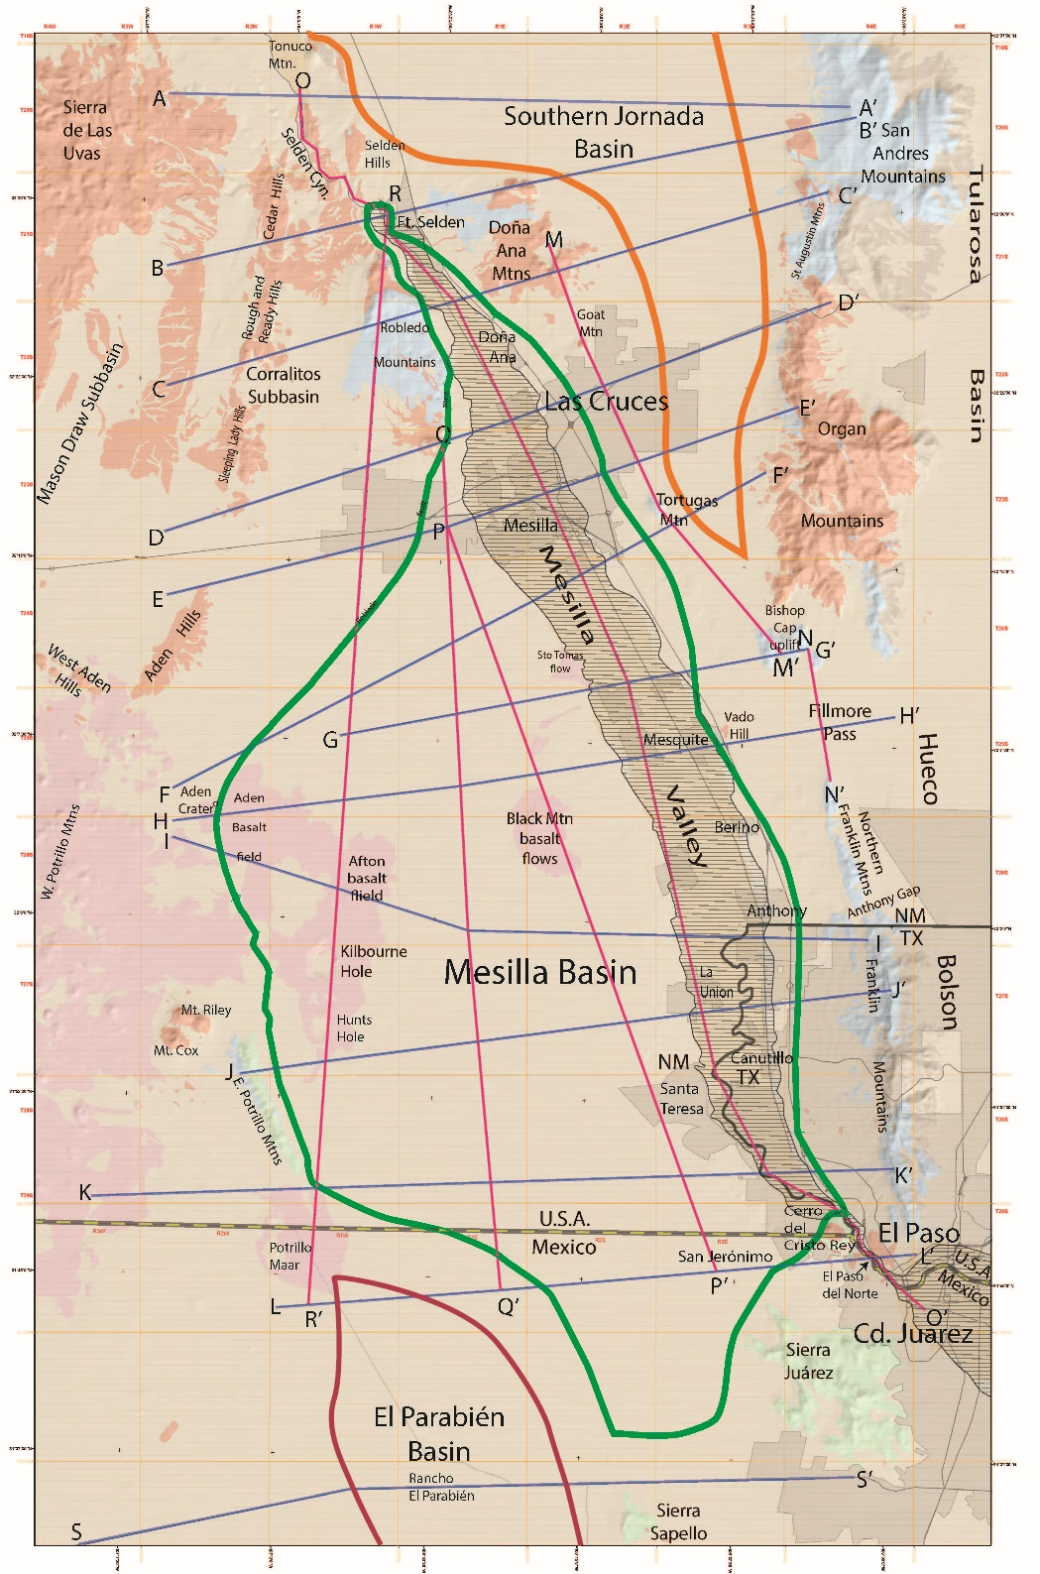
Figure A3-1. Index map for the 3,350-mi² (8,675-km²) NM WRRI Study Area on a Hydrogeologic Map base that shows distribution of major bedrock units and terrain features, including the Mesilla Valley of the Rio Grande. The Mesilla, Southern Jornada, and El Parabién groundwater (GW) basins (MeB, SJB and EPB) are outlined in green, orange and dark red, respectively. Locations of Hydrogeologic Cross-Sections A-A' to S-S' (PLS. 5a-5s) shown with blue and red lines. USGS DEM base.

Because it is designed for continued refinement as additional subsurface information is acquired, the updated hydrogeologic-framework template represents an important advance over previous work. Nevertheless, it is essential to recognize that all hydrogeology-based modeling efforts remain “works in progress” simply because of the limits imposed by the uneven distribution and inconsistent quality of information on the earth’s subsurface environment. It is also important to note that the innovations in framework characterization outlined herein have not required significant changes in the basic definitions of lithofacies, hydrostratigraphic, and basin-boundary components that were initially developed for geohydrologic modeling throughout the area of “Southwest Alluvial Basins Regional Aquifer-System” studies (Report Part 2.3.1)
A3.3. Hydrogeologic Mapping of the Study Area in a Southern RG-Rift Basin Context
As noted in Report Part 1.6.2: “The inherent complexity and deep-seated nature of the major structural components of Rio Grande rift basins and their bordering bedrock uplifts required that hydrogeologic characterization of basin-fill deposits and rift-structural boundaries be based on a wide variety of direct and indirect methods of surface and subsurface investigation (e.g., detailed mapping, borehole-sample logging, and geophysical and geochemical surveys).”
Figures A3-2 to A3-4 illustrate the iterative process involved in converting the relatively complex portrayal of the Mesilla Basin’s hydrogeologic-framework in Hawley and Kennedy (2004, Pls. A1-A9; Part AA1.1) to a simplified, but still-representative format that better fits the requirements of contemporary GW-flow and hydrochemical modeling platforms. Figure A3-2 (page-size PL. 1) was completed in December 2012, and represents an intermediate stage of map compilation.
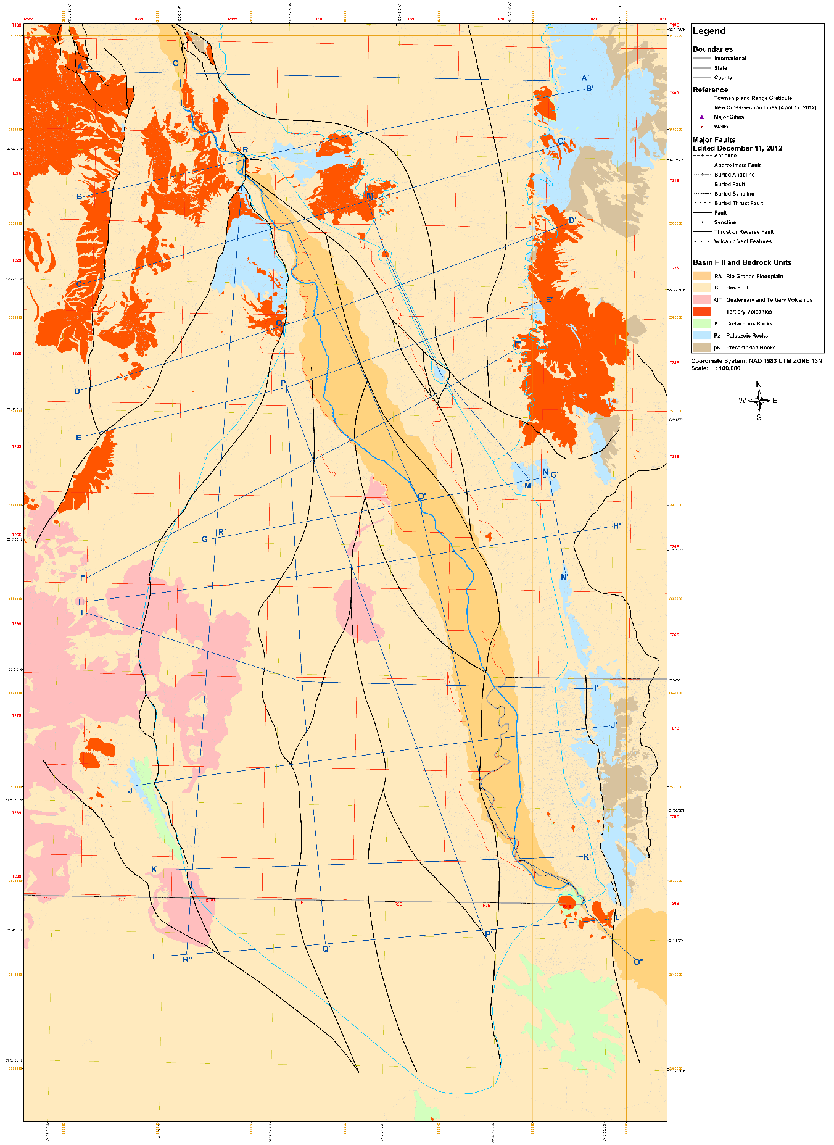
Figure A3-2. Intermediate-stage (12-11-2012) compilation of the hydrogeologic basemap for the WRRI hydrogeologic Study Area.
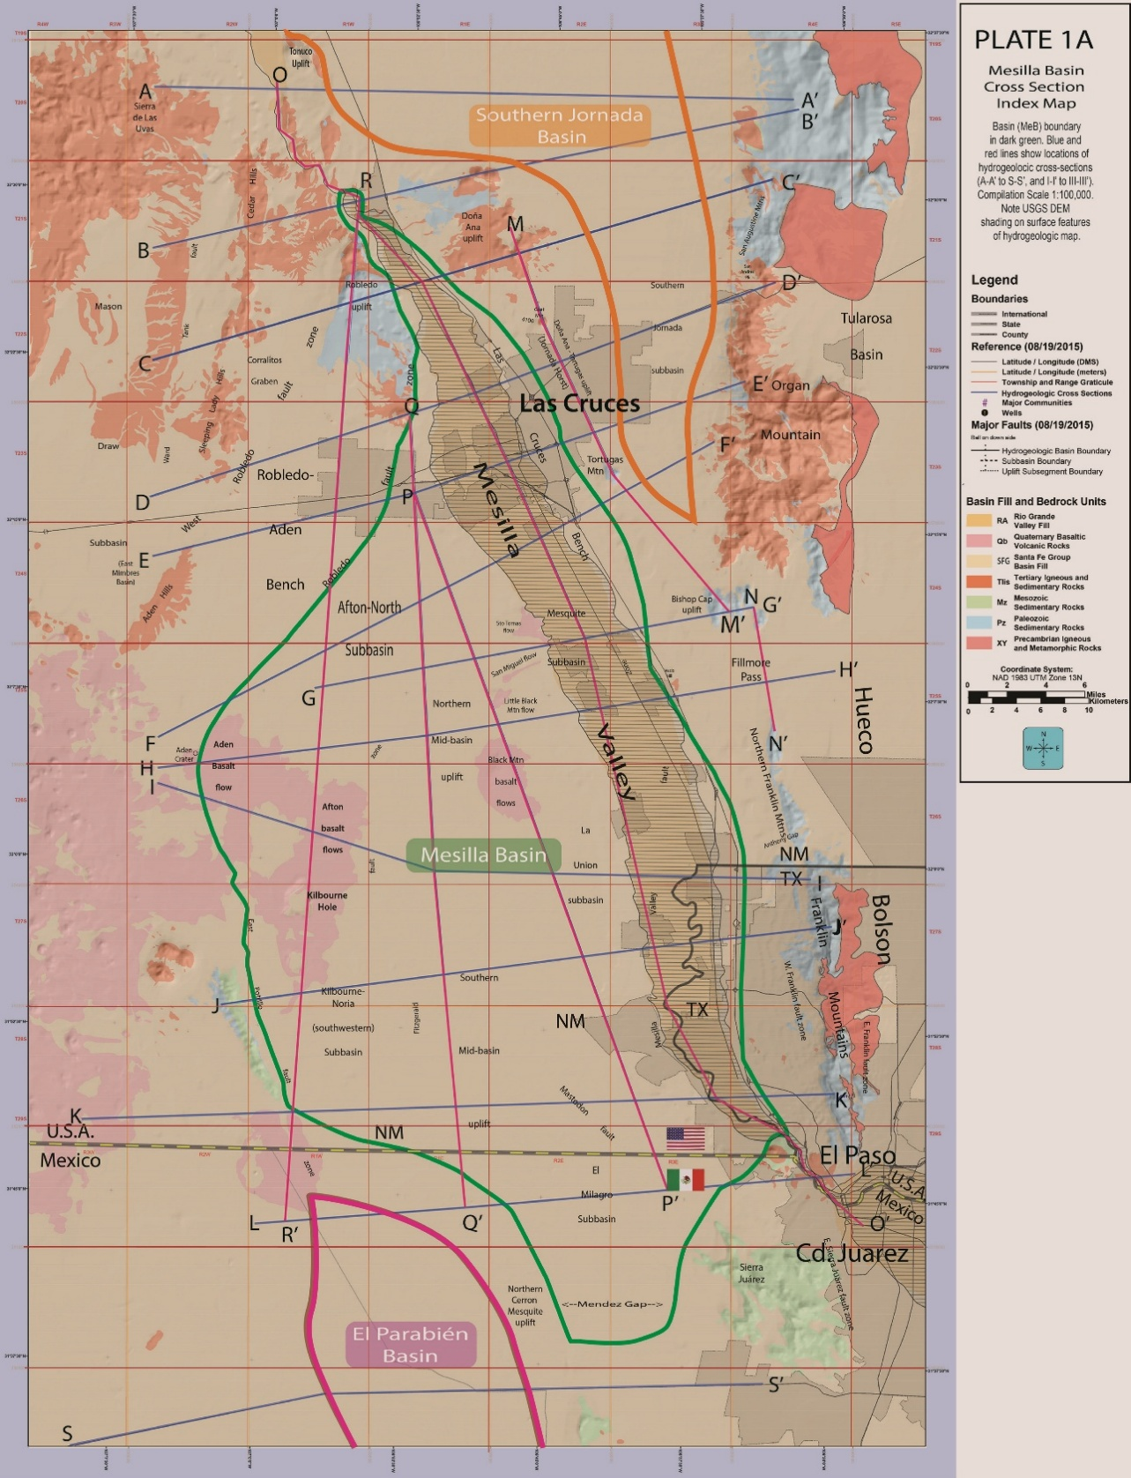
Figure A3-3. (page-size PLATE 1A) Study Area index map showing locations of the Mesilla, Southern Jornada, and El Parabién groundwater (GW) basins (MeB, SJB and EPB; outlined in green, orange and red, respectively). Also shown are the locations of hydrogeologic cross-section A-A′ to S-S′ (Report PLATES 5a to 5s), major terrain features (incl. the Mesilla Valley, Selden Canyon and El Paso del Norte of the Rio Grande), and the Las Cruces and El Paso/Ciudad Juárez metropolitan centers. USGS DEM base, with UTM-NAD83 SI-system and latitude/longitude coordinates.
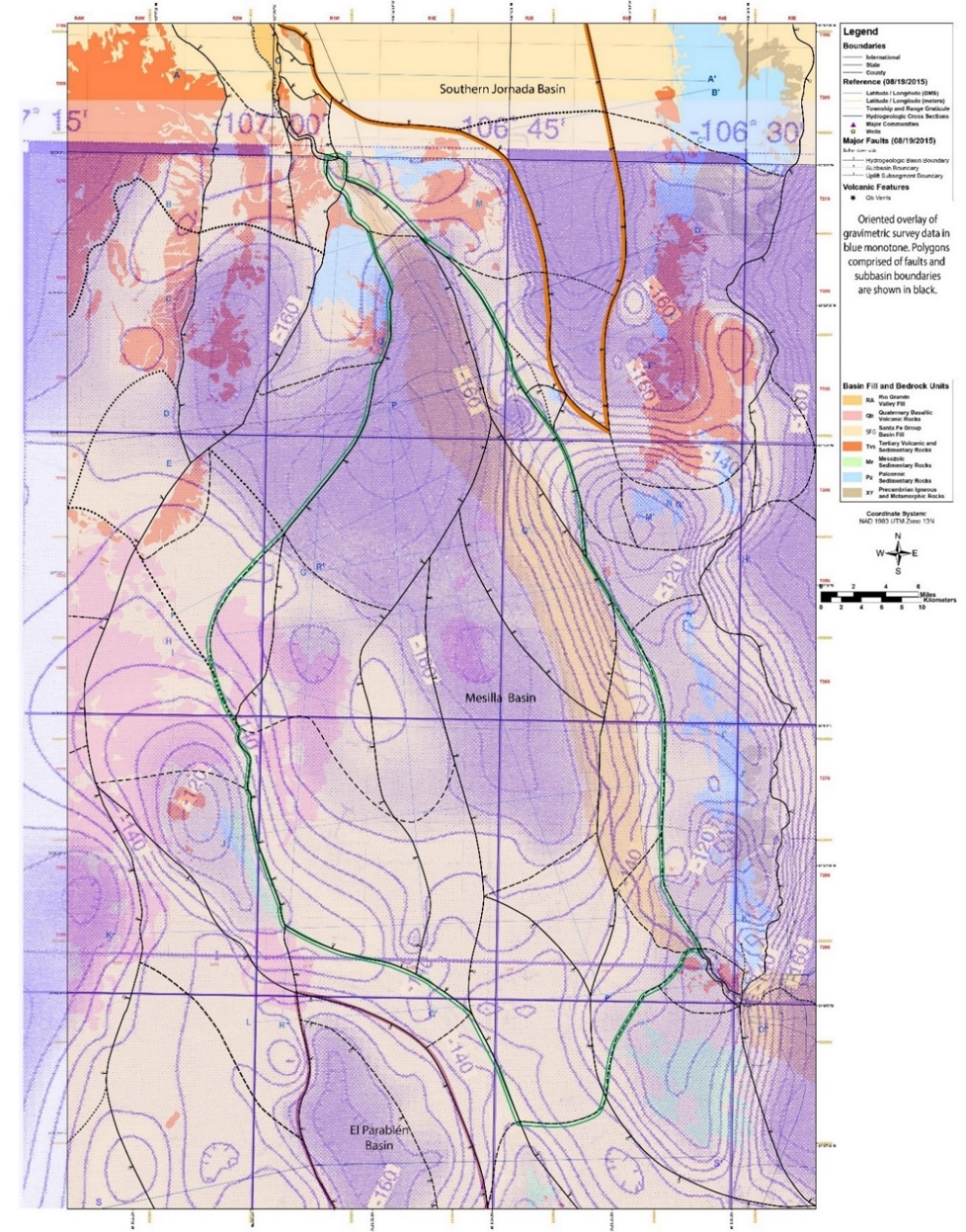
Figure A3-4. (page-size PLATE 1A) Second-stage (2215) in Study-Area basemap development for the current (2022) hydrogeologic-framework model. Overlay of groundwater-basin subdivision and bed-rock unit boundaries from the PLATE 1 hydrogeologic-basemap onto parts of the Bouguer isostatic-residual gravity map of Jiménez and Keller (2000, Fig. 4; 4 milligal contour interval). Southern Jornada, Mesilla and El Parabién GW Basins outlined in orange, green, and dark red, respectively. Hydrogeologic-subdivision boundaries (Fig. A3-3) shown with black solid and dashed lines.
A4. BACKGROUND ON GIS-SHAPEFILE AND METADATA COMPILATIONS,
WITH EXAMPLES IN PART A6B PART A4. CITED REFERENCES; AND APPENDIX B TOPIC/CATEGORY CODES (P. 54)
Cliett, T., 1969, Groundwater occurrence of the El Paso area and its related geology: New Mexico Geological Society Guidebook 20, p. 209-214. (F2, H1)
Collins, E.W., and Raney, J.A., 2000, Geologic map of west Hueco Bolson, El Paso region, Texas: The University of Texas at Austin, Bureau of Economic Geology, Miscellaneous Map No. 40, scale 1:100,000. (C2b, F1)
Connell, S.D., Hawley, J.W., and Love, D.W., 2005, Late Cenozoic drainage development in the southeastern Basin and Range of New Mexico, southeasternmost Arizona and western Texas, in Lucas, S.G., Morgan, G., and Zeigler, K.E., eds., 2005, New Mexico’s Ice Ages: New Mexico Museum of Natural History & Science Bulletin No. 28, p. 125-150. (C2b, I1, I3)
Creel, B.J., 2010, Research needs in the U.S. portion of the Rio Grande watershed: Journal of Transboundary Water Resources, v. 1, p. 31-41. www.wrri.nmsu.edu (C1, E2, E3)
Creel, B.J., and Hawley, J.W., 2001, Water resources of the Border Region of New Mexico, in Bloom, G., report coordinator, New Mexico’s border with Mexico: Creating a viable agenda for growth: Albuquerque, New Mexico First 27th Town Hall Background Report, p. 60-79. http://www.nmfirst.org (F1)
Creel, B.J., Hawley, J.W., Kennedy, J.F., and Granados Olivas, A., 2006, Groundwater resources of the New Mexico-Texas-Chihuahua border region, in Anderson, K.S.J., ed., Science on the Border: N.M. Journal of Science, v. 44. p. 11-29. (F1, H1)
Dickinson, W.R., 1970, Interpreting detrital modes of greywacke and arkose: Journal of Sedimentary Petrology, v. 40, p. 695-707. (D1)
Domenico, P.A., and Schwartz, F.W., 1990, Physical and chemical hydrogeology: New York, NY, John Wiley & Sons, 824 p. (D1)
Druhan, J.L., Hogan, J.F., Eastoe C.J., Hibbs, B.J., and Hutchison, W.R., 2008, Hydrogeologic controls on groundwater recharge and salinization: a geochemical analysis of the northern Hueco Bolson aquifer, Texas, USA: Hydrogeology Journal, v. 16, no. 2, p. 281-296. (D2, H1, H2)
Eastoe, C.J., Hibbs, B.J., Granados Olivas, A., Hogan, J.F., Hawley, J., and Hutchison, W.R., 2008, Isotopes in the Hueco Bolson aquifer, Texas (USA) and Chihuahua (Mexico): Local and general implications for recharge sources in alluvial basins: Hydrogeology Journal, v. 16, no. 4, p. 737-747. (H1, H2)
Fetter, C.W., 1988, Applied hydrogeology: Columbus, OH, Merrill Publishing Co., 592 p. (D1)
Frenzel, P.F., and Kaehler, C.A., 1990, Geohydrology and simulation of ground-water flow in the Mesilla Basin, Doña Ana County, New Mexico and El Paso County, Texas; with a section on Water quality and geochemistry by S.K. Anderholm: U.S. Geological Survey Open-file Report 88-305, 179 p. (F2, H2, H3)
Gelhar, L.W., 1993, Stochastic subsurface hydrology, 1st edition: Englewood Cliffs, NJ, Prentice-Hall Engineering, Science, and Mathematics, 390 p. (D1)
Gelhar, L.W., and Axness, C.L., 1983, Three-dimensional stochastic analysis of macro-dispersion in aquifers: Water Resources Research, v. 19, no. 1, p. 161-180. (D1) See Molz, 2015.
Gelhar, L.W., Gutjahr, A.L, and Naff, R.L., 1979, Stochastic analysis of macro-dispersion in a stratified aquifer: Water Resources Research, v. 15, no. 6, p. 1387-1397. (D1) See Molz, 2015.
Gelhar, L.W., Welty, C., and Rehfeldt, K.R., 1992, A critical review of data on field-scale dispersion in aquifers: Water Resources Research, v. 21, no. 7, p. 1955-1974. (D1) See Molz, 2015.
Gile, L.H., Hawley, J.W., and Grossman, R.B., 1981, Soils and geomorphology in the Basin Range area of southern New Mexico – Guidebook to the Desert Project: New Mexico Bureau of Mines and Mineral Resources, Memoir 39, 222 p. https://geoinfo.nmt.edu/publications/monographs/memoirs/39/ (C2a, C3)
Giles, G.C., and Pearson, J.W., 1998, Characterization of hydrostratigraphy and groundwater flow on the southwestern San Andres Mountains pediment, NASA-JSC White Sands Test Facility: New Mexico Geological Society Guidebook 49, p. 317-325. (H1, H3)
Granados Olivas, A., coordinador, 2022, Los recursos hidrológicos en cuencas transfronterizas entre México y Estados Unidos: El Paso del Norte y la gobernanza binacional del agua: Universidad Autónoma de Chihuahua y Universidad Autónoma de Ciudad Juárez, 324 p. ISBN 978-607-536 (A2, B3, F1)
Granados Olivas, A., Creel, B., Kennedy, J., and Aldouri, R., 2001, Water planning GIS for the Paso del Norte region, in Aldama, A., Aparicio, F.J., and Equihua, R., eds. First International Symposium on Transboundary Waters Management, Proceedings: Asociación Mexicana de Hidráulica, Avances en Hidráulica 10, p.147-154. (E1, F1)
Granados Olivas, A., Creel, B., Sánchez-Flores, E., Chávez, J., and Hawley, J.W., 2012, Thirty years of groundwater evolution – Challenges and opportunities for binational planning and sustainable management of the Paso del Norte watersheds, in Lee, E., and Ganster, P., The U.S.–Mexican border environment: Progress and challenges for sustainability: Southwest Consortium for Environmental Research and Policy, SCERP Monograph Series, no. 16, San Diego State University Press, p. 201-217. (E2, F1)
Granados Olivas, A., Brown, C., Greenlee, J., Creel, B., Hawley, J.W., Kennedy, J., Dena-Ornelas, O., and Hurd, B., 2006, Geographic information systems at the Paso del Norte region. The academic accomplishments and challenges for a Transboundary water resources GIS cooperation, in Anderson, K.S.J., ed., Science on the Border: New Mexico Journal of Science, v. 46, p. 45-56. (E1, F1)
Gustavson, T.C., 1991a, Arid basin depositional systems and paleosols: Fort Hancock and Camp Rice Formations (Pliocene-Pleistocene) Hueco Bolson, West Texas and adjacent Mexico: The University of Texas at Austin, Bureau of Economic Geology, Report of Investigations No. 198, 49 p. (C2b, C3, I3)
Haase, C.S., and Lozinsky, R.P., 1992, Estimation of hydrologic parameters, in Hawley, J.W., and Haase, C.S., compilers, Hydrogeologic framework of the northern Albuquerque Basin: New Mexico Bureau of Mines and Mineral Resources, Open File Report 387, p. VI-1 to VI-3. (D1)
Hawley, J.W., 1962, Late Pleistocene and recent geology of the Winnemucca segment of the Humboldt River Valley, Nevada: University of Illinois at Urbana-Champaign, doctoral dissertation, 220 p. (D1)
Hawley, J.W., 1965, Geomorphic surfaces along the Rio Grande Valley from El Paso, Texas to Caballo Reservoir, New Mexico: New Mexico Geological Society, Guidebook 16, p. 188-198. (C2a)
Hawley, J.W., 1969a, Geology and its relation to the hydrologic system, in King, W. E., Hawley, J. W., Taylor, A. M. and Wilson, R. P., Hydrogeology of the Rio Grande Valley and adjacent intermontane areas of southern New Mexico: New Mexico Water Resources Research Institute, WRRI Report 6, p. 19-47. (H1)
Hawley, J.W., 1969a, Geology and its relation to the hydrologic system, in King, W.E., Hawley, J.W., Taylor, A.M. and Wilson, R.P., Hydrogeology of the Rio Grande Valley and adjacent intermontane areas of southern New Mexico: New Mexico Water Resources Research Institute, WRRI Report 6, p. 19-47; cf. King, W.E., and others, Geology and ground-water resources of central and western Doña Ana County, New Mexico: New Mexico Bureau of Mines and Mineral Resources, Hydrologic Report 1, p. 9-24, 61-62. (C2a, H1)
Hawley, J.W., compiler, 1970, Cenozoic stratigraphy of the Rio Grande Valley area, Doña Ana County, New Mexico: El Paso Geological Society, Guidebook 4, 49 p. (C2a, F2)
Hawley, J.W., 1984, Hydrogeologic cross sections of the Mesilla Bolson, New Mexico and Texas: New Mexico Bureau of Mines and Minerals Resources, Open-file Report 190, 10 p. Appendix in Peterson, D.M., Khaleel, R., and Hawley, J.W., 1984 (H1)
Hawley, J.W., 2020, A Hydrogeologic perspective on groundwater conservation in the northern Rio Grande basin, New Mexico, Texas, and Chihuahua—2014 Albert E. Utton Memorial Lecture, in Sheely, M., ed. Proceedings, 59th Annual New Mexico Water Conference, Santa Fe, NM., p. 59-84, with 28 pptx-slide pdf on CD-ROM. (D1, F1, H1)
Hawley, J.W., and Gile, L.H., 1966, Landscape evolution and soil genesis in the Rio Grande region, southern New Mexico: Friends of the Pleistocene, Rocky Mountain Section, Guidebook 11th Field Conference; La Cruces, NM State University Agronomy Department, Special Publication, 74 p. (C2a, C3)
Hawley, J.W., and Haase, C.S., 1992, compilers, Hydrogeologic framework of the northern Albuquerque Basin: New Mexico Bureau of Mines and Mineral Resources, Open-file Report OF-387, 74 p., 8 Appendices, Glossary. (D1)
Hawley, J.W., and Kennedy, J.F., 2004, Creation of a digital hydrogeologic framework model of the Mesilla Basin and southern Jornada del Muerto Basin: N.M. Water Resources Research Institute, New Mexico State University; prepared for Lower Rio Grande Water Users Organization; Technical Completion Report 332, 105 p., with plates and appendix on CD ROM. Access at: http://wrri.nmsu.edu/publish/techrpt/tr332/downl.html (H1, F1)
Hawley, J.W., and Kernodle, J.M., 2000, Overview of the hydrogeology and geohydrology of the northern Rio Grande basin—Colorado, New Mexico, and Texas, in Ortega-Klett, C.T., ed., Proceedings of the 44th Annual New Mexico Water Conference: New Mexico Water Resources Research Institute Report 312, p.79-102. http://wrri.nmsu.edu/publish/watcon/proc/proc44/contents.html (D1)
Hawley, J.W., and Kottlowski, F.E., 1969, Quaternary geology of the south-central New Mexico border region, in Border Stratigraphy Symposium: New Mexico Bureau of Mines and Mineral Resources, Circular 104, p. 89-115. (C2a)
Hawley, J.W., and Lozinsky, R.P., 1992, Hydrogeologic framework of the Mesilla Basin in New Mexico and western Texas: New Mexico Bureau of Mines and Mineral Resources, Open-File Report 323, 55 p. (H1)
Hawley, J.W., and Swanson, B.H., 2022, Conservation of shared groundwater resources in the binational Mesilla Basin-El Paso Del Norte Region—A Hydrogeological Perspective, in Granados Olivas, A., coordinador, Los Recursos Hidrológicos en Cuencas Transfronterizas entre México y los Estados Unidos: El Paso del Norte y la Gobernanza Binacional de Agua [Hydrological Resources in Transboundary Basins between Mexico and the United States: El Paso del Norte and the Binational Water Governance]: Universidad Autónoma de Ciudad Juárez y Universidad Autónoma de Chihuahua, p. 202-223. ISBN 978-607-536 (F1, H1)
Hawley, J.W., and Wilson, W.E. III, 1965, Quaternary geology of the Winnemucca area, Nevada: Desert Research Institute at Reno, Technical Report No. 5, 66 p. (D1)
Hawley, J.W., Granados Olivas, A., and Creel, B.J., 2012, Progress report on development of an annotated bibliography for transboundary aquifer systems of the Mesilla Basin-Paso del Norte area, New Mexico, Texas, and Chihuahua—Poster Presentation Abstract for 57th Annual New Mexico Water Conference: Hard Choices: Adapting Policy and Management to Water Scarcity (8/28/12), New Mexico Water Resources Research Institute, NMSU-Las Cruces. http://2012.wrri.nmsu.edu/webcast; http://kunm.org/post/new-mexicos-hard-choices (A1, F1)
Hawley, J.W., Haase, C.S., and Lozinsky, R.P., 1995, An underground view of the Albuquerque Basin, New Mexico, in Ortega-Klett, C.T., ed., Proceedings of the 39th Annual New Mexico Water Conference, New Mexico Water Resource Research Institute Report 290, p. 37-55. http://wrri.nmsu.edu/publish/watcon/proc39/contents.html (D1)

Hawley, J.W., Kambhammettu, B.V.N.P., and Creel, B.J., 2010, Digital hydrogeologic-framework model of the San Francisco River basin, west-central New Mexico and east-central Arizona: New Mexico Water Resources Research Institute, New Mexico State University, Technical Completion Report No 354, 51 p., 7 tables and 5 figures, with 3 plates and Appendix on CD ROM. https://nmwrri.nmsu.edu/tr-354/ (D1, H1)
Hawley, J.W., Kennedy, J.F., and Creel, B.J., 2001, The Mesilla Basin aquifer system of New Mexico, West Texas and Chihuahua—an overview of its hydrogeologic framework and related aspects of groundwater flow and chemistry, in Mace, R.E., Mullican, W.F. III, and Angle, E.S., eds., Aquifers of West Texas: Texas Water Development Board Report 356, p. 76-99. http://www.twdb.state.tx.us/publications/reports/GroundWaterReports/GWReports/Individual%20Report%20htm%20files/Report%20356.htm (H1)
Hawley, J.W., Kennedy, J.F., Granados Olivas, A., and Ortiz, M.A., 2009, Hydrogeologic framework of the binational western Hueco Bolson-Paso del Norte area, Texas, New Mexico, and Chihuahua: Overview and progress report on digital model development: New Mexico Water Resources Research Institute Technical Completion Report 349, 45 p., 2 pls. Access at https://nmwrri.nmsu.edu/tr349/ (H1, F1)
Hawley, J.W., Kottlowski, F.E., Seager, W.R., King, W.E., Strain, W.S. and LeMone, D.V., 1969, The Santa Fe Group in the south-central New Mexico border region, in Border Stratigraphy Symposium: New Mexico Bureau of Mines and Mineral Resources, Circular 104, p. 52-76. (C2a, F1)
Hawley, J.W., Wilson, W.E., Cartwright, K., Swinderman, J., and Farvolden, R.N., 1961, Progress report on the geologic phase of the Humboldt River Project for Field Season 1960, in Progress Report, Humboldt River Research Project—A State-Federal Cooperative Program: Carson City, Nevada State Department of Conservation and Natural Resources, p. 26-32. (D1)
Hawley, J.W., Hibbs, B.J., Kennedy, J.F., Creel, B.J., Remmenga, M.D., Johnson, M., Lee, M.M., and Dinterman, P., 2000, Trans-International Boundary aquifers in southwestern New Mexico: New Mexico Water Resources Research Institute, prepared for U.S. Environmental Protection Agency-Region 6 and International Boundary and Water Commission; Technical Completion Report-Interagency Contract X-996350-01-3, 126 p. http://wrri.nmsu.edu/publish/otherrept/swnm/downl.html (C2b, D1, F1, I2)
Hibbs, B.J., Lee, M.M., and Hawley, J.W., 1999, Evolution of hydrochemical facies in the Mimbres Basin aquifer system: A transboundary resource, in Hydrological issues of the 21st Century: Ecology, Environment, and Human Health: American Institute of Hydrology, Hydrological Science and Technology, v. 15, no. 1-4, p. 52-65. (F1, H1, H2)
Hibbs, B.J., Lee, M.M., Hawley, J.W., and Kennedy, J.F., 2000, Some notes on the hydrogeology and ground-water quality of the Animas basin system, southwestern New Mexico: New Mexico Geological Society, Guidebook 51, p. 227-234. (F1, H1, H2)
Hibbs, B., Phillips, F., Hogan, J., Eastoe, C., Hawley, J., Granados, A., and Hutchison, B., 2003, Hydrogeologic and Isotopic Study of the Groundwater Resources of the Hueco Bolson Aquifer El Paso/Juárez Area: Hydrological Science and Technology, volume 19, no.1-4, p. 109-119. (F1, H1, H2)
Hibbs, B.J., Creel, B.J, Boghici, R., Hayes, M., Ashworth, J., Hanson, A., Samani, Z., Kennedy, J.F., Hann, P., and Stevens, K., 1997, Transboundary Aquifers of the El Paso/Ciudad Juarez/Las Cruces Region: U.S. Environmental Protection Agency, Region 6; Technical Contract Report- Interagency Contracts X-996343-01-0 and X-996350-01-0, prepared by the Texas Water Development Board and the New Mexico Water Resources Research Institute, variously paged. See TWDB, 1997, Appendix C—G.I.S. coverages, metadata descriptions, [and] groundwater data sets on CD-ROM, with Water Quality map insert on back-cover. (F1, H1, H2)
Hutchison, W.R., and Hibbs, B.J., 2008, Ground water budget analysis and cross-formational leakage in an arid basin: Ground Water, v. 46, no. 3, p. 384-395. (H1, H2, H3)
INEGI, 2012, Zona Hidrogeológica Conejos-Médanos: Instituto Nacional de Estadística y Geografía, Edificio Sede, Av. Héroe de Nacozari Sur 2301, Fraccionamiento Jardines del Parque, 20276, Aguascalientes, Aguascalientes; DR©2012, Impreso en México. www.inegi.org.mx; atencion.usuarios@inegi.org.mx (F3)
Kahneman, D., and Tversky, A., 1974, Judgement under uncertainty: Heuristics and biases: Science, v. 185, issue 4157, pp. 1124-1131. doi: 10.1126/science.185.4157.1124 (A2, D1)
Kahneman, D., and Tversky, A., 1996, On the reality of cognitive illusions: Psychological Review, v. 103, no. 3, p. 582–591. https://doi.apa.org/doi/10.1037/0033-295X.103.3.582 See Lewis (2017) (A2, D1)
Kennedy, J.F., Hawley, J.W., and Johnson, M., 2000, The hydrogeologic framework of basin-fill aquifers and associated ground-water-flow systems in southwestern New Mexico – an overview: New Mexico Geological Society Guidebook 51, p. 235-244. (F1, H1, I2)
Kernodle, J.M., 1992b, Summary of U.S. Geological Survey ground-water-flow models of basin-fill aquifers in the southwestern alluvial basins region, Colorado, New Mexico, and Texas: U.S. Geological Survey Open-file Report 90-361, 81 p. (D2, H3)
Kernodle, J.M., 1996. Simulation of Ground-water Flow in the Albuquerque Basin, Central New Mexico, 1901-95, with Projections to 2020: U.S. Geological Survey Water Resources Investigations Report 94-4251. 59 p. (D1)
Kernodle, J.M., 1996. Simulation of ground-water flow in the Albuquerque Basin, central New Mexico, 1901-95, with projections to 2020: U.S. Geological Survey Water Resources Investigations Report 94-4251. 59 p. (D1, D2)
Khaleel, R., Palumbo, M.R., Peterson, D.D., and Hawley, J.W., 1983, Numerical Modeling of groundwater flow in the lower Rio Grande Basin, New Mexico: New Mexico Water Resources Research Institute, Project No. 135465 Completion Report, 188 p. (H3)
King, W.E., 1973, Hydrogeology of La Mesa, Doña Ana County, New Mexico, in Guidebook to the geology of south-central Doña Ana County, New Mexico: El Paso Geological Society 7th Annual Field Trip, p. 56-67. (H1)
King, W.E., and Hawley, J.W., 1975, Geology and ground-water resources of the Las Cruces area: New Mexico Geological Society Guidebook 26, p. 195-204. (H1)
King, W.E., Hawley, J.W., Taylor, A.M., and Wilson, R.P., 1969, Hydrogeology of the Rio Grande Valley and adjacent intermontane areas of southern New Mexico: New Mexico Water Resources Research Institute, WRRI Report 6, 141 p. (F2, H1, H2)
King, W.E., Hawley, J.W., Taylor, A.M., and Wilson, R.P., 1971, Geology and ground-water resources of central and western Doña Ana County, New Mexico: New Mexico Bureau of Mines and Mineral Resources, Hydrologic Report 1, 64 p. (F2, H1, H2)
Kottlowski, F.E., 1958, Geologic history of the Rio Grande near El Paso: West Texas Geological Society, Guidebook 1958 Field Trip, p. 46-54. (C2a)
Leggat, E.R., Lowry, M.E., and Hood, J.W., 1962, Ground-water resources of the lower Mesilla Valley, Texas and New Mexico: Texas Water Commission, Bulletin 6203, 191 p. (F2, G2, H1, H2)
Lewis, M., 2016, The undoing project – A friendship that changed our minds: New York, W.W. Norton & Company, 362 p. ISBN 978-0-393-25459-4. See Chapter 4: Errors, and Kahneman and Tversky (1974 and 1976). (A2, D1)
Maxey, G.B., 1964, Hydrostratigraphic units: Journal of Hydrology, v. 2, no. 2, p. 124-129. (D1)
Maxey, G.B., 1968, Hydrogeology of desert basins: Ground Water, v. 6, no. 5, p. 1-22. (D1)
Maxey, G.B., and Shamberger, H.A., 1961, The Humboldt River Research Project in Nevada, in Ground water in arid zones: International Association of Scientific Hydrology, Publication No. 57, p. 437-454. (D1)
McAda, D.P., and Barrow, P., 2002, Simulation of ground-water flow in the Middle Rio Grande basin between Cochiti and San Acacia, New Mexico: U.S. Geological Survey Water-Resources Investigations Report 02-4200, 81 p. (D1)
Miller, G.A., 1956, The magical number seven, plus or minus two: Some limits to our capacity of processing information: Psychological Review, v. 63, p. 31-38. (D1)
Molz, F., 2015, Advection, dispersion, and confusion: Groundwater (Technical Commentary), v. 53, no. 3, p. 348-353. See Gelhar et al. 1992. (D1)
Nickerson, E.L., 1986, Selected geohydrologic data for the Mesilla Basin, Doña Ana County, New Mexico and El Paso County, Texas: U.S. Geological Survey Open-File Report 86-75, 59 p. (H1)
Nickerson, E.L., 1989, Aquifer tests in the flood-plain alluvium and Santa Fe Group at the Rio Grande near Canutillo, El Paso County, Texas: U.S. Geological Survey Water-Resources Investigations Report 89-4011, 29 p. (H3)
Nickerson, E.L., and Myers, R.G., 1993, Geohydrology of the Mesilla ground-water basin, Doña Ana county, New Mexico, and El Paso County, Texas: U.S. Geological Survey Water-Resources Investigations Report 92-4156, 89 p. (H1, H2)
Ortega Klett, C.T., ed., 2012, One hundred years of water wars in New Mexico: Santa Fe, Sunstone Press, 288 p. ISBN: 978-0-86524-902-5 (A2, E2, E3)
Peterson, D.M., Khaleel, R., and Hawley, J.W., 1984, Quasi three-dimensional modeling of groundwater flow in the Mesilla Bolson, New Mexico: New Mexico Water Resources Research Institute Technical Completion Report No. 178, project no. 1–3–45645, New Mexico State University, 185 p. https://nmwrri.nmsu.edu/tr178/ (H1, H3)
Plummer, L.N., Bexfield, L.M., Anderholm, S.K., Sanford, W.E., and Busenberg, E., 2004, Geochemical characterization of ground-water flow in the Santa Fe Group aquifer system, Middle Rio Grande Basin, New Mexico: U.S. Geological Survey Water-Resources Investigations Report 03-4141,369 p., with CD-ROM. (D1, D2, H3)
Reynolds, C.B. & Associates, 1986, Shallow seismic reflection survey, Canutillo area, Texas and New Mexico: Unpublished consultant's report for U.S. Geological Society by Charles B. Reynolds & Associates, 4409 San Andres Ave., NE, Albuquerque, NM 87110, 8 p., 2 figs., 12 enclosed seismic profiles. (C4)
Reynolds, C.B. & Associates, 1987, Shallow seismic reflection line CA-1, Doña Ana County, New Mexico and El Paso County, Texas: Unpublished consultant's report for U.S. Geological Society by Charles B. Reynolds & Associates, 4409 San Andres Ave., NE, Albuquerque, NM 87110,
4 p., 1 fig., 2 enclosed seismic profiles. (C4)
Richardson, G.L, Gebbard, T.G., Jr., and Brutsaert, W.F., 1972, Water-table investigation in the Mesilla Valley: Las Cruces, New Mexico State University, Engineering Experiment Station Technical Report 76, 206 p. (H3)
Seager, W.R., 1995, Geology of southwest quarter of Las Cruces and northwest El Paso 1º x 2º sheets: New Mexico Bureau of Mines and Mineral Resources, Geologic Map 60, scale 1:125,000. (C2b)
Seager, W.R., Clemons, R.E., Hawley, J.W., and Kelley, R.E., 1982, Geology of northwest part of Las Cruces 1º x 2º sheet, New Mexico: New Mexico Bureau of Mines and Mineral Resources Geologic Map, GM-53, scale 1:125,000, 3 sheets. (C2a)
Seager, W.R., Hawley, J.W., Kottlowski, F.E., and Kelley, S.A., 1987, Geologic map of east half of Las Cruces and northeast El Paso 1º x 2º sheets, New Mexico: New Mexico Bureau of Mines and Mineral Resources, Geologic Map, GM-57, scale 1:125,000, 3 sheets. (C2a)
Siegel, D., 2008, Reductionist hydrogeology: ten fundamental principles: Hydrological Processes, v. 22, p. 4967–4970—Published online 10 November 2008 in Wiley InterScience (www.interscience.wiley.com). doi: 10.1002/hyp.7139 (D1)
Siegel, D.J., and Hinchey, E.J., 2019, Big data and the curse of scale: Groundwater, v. 57, no. 4, p. 505. (D1)
Strain, W.S., 1966, Blancan mammalian fauna and Pleistocene formations, Hudspeth County, Texas: Texas Memorial Museum, Bulletin 10, 55 p. (B1, C2a)
Strain, W.S., 1971, Late Cenozoic bolson integration in the Chihuahua tectonic belt, in The geologic framework of the Chihuahua tectonic belt: West Texas Geological Society, Publication No. 71-59, p. 167-173. (C2a)
Taylor, A.M., 1967, Geohydrologic investigations in the Mesilla Valley, New Mexico: New Mexico State University, master’s thesis, 130 p. (H1, H3)
Thorn, C.R., McAda, D.P. and Kernodle, J.M., 1993, Geohydrologic framework and hydrologic conditions in the Albuquerque Basin, central New Mexico: U.S. Geological Survey, Water-Resources Investigations Report 93-4149, 106 p. (D1, D2)
Tremblay, T.A., 1999, ARCINFO data base for geologic data of the west Hueco Bolson, El Paso region, Texas: The University of Texas at Austin, Bureau of Economic Geology, open-file digital data base. (E1, F2)
Walker, J.D., and Geissman, J.W., compilers, 2009, Commentary – 2009 Geologic Time Scale: GSA Today, v. 19, no. 4/5, p. 60-61. doi: 10.1130/2009.CTS004R2C (B1)
Wilkins, D.W., 1998, Summary of the southwest alluvial basins regional aquifer-system analysis in parts of Colorado, New Mexico, and Texas: U.S. Geological Survey Professional Paper 1407–A, 49 p. [Also available at https://pubs.er.usgs.gov/publication/pp1407A] (D1, F2)
Wilson, C.A., and White, R.R., 1984, Geohydrology of the central Mesilla Valley, Doña Ana County, New Mexico: U.S. Geological Survey, Water-resources Investigations Report 82-444, 144 p. (H1, H2)
Wilson, C.A., White, R.R., Orr, B.R., and Roybal, R.G., 1981, Water resources of the Rincon and Mesilla Valleys and adjacent areas, New Mexico: New Mexico State Engineer Technical Report 43, 514 p. (H1, H2)
Witcher, J.C., King, J.P., Hawley, J.W., Kennedy, J.F., Williams, J., Cleary, M., and Bothern, L., 2004, Sources of Salinity in the Rio Grande and Mesilla Basin Groundwater: New Mexico Water Resources Research Institute Report No. 330, 168 p., with appendices and plates on CD ROM. (C2b, E2a, H1, H2)
Woodward, D.G., and Myers, R.G., 1997, Seismic investigation of the buried horst between the Jornada del Muerto and Mesilla ground-water basins near Las Cruces, Doña Ana County, New Mexico: U.S. Geological Survey Water-Resources Investigations Report 97-4147, 45 p. (C2b, C4)

Topic/Subtopic Categories, with Alphanumeric Cross-Reference Codes (Appendix B)
A. Bibliographies, Dictionaries, Glossaries, Biographies, Reviews, and News Items
A1. Bibliographies, Dictionaries, and Glossaries
A2. Biographies and Reviews
A3. News Items
B. Time: Geologic, Prehistoric, and Historic
B1. Geologic and Prehistoric Time
B2. Prehistoric Perspective: US Southwest and Northern Mexico
B3. Historic Perspective: US Southwest and Northern Mexico
C. Environmental, Physiographic, and Geologic Setting
C1. Climatic, Hydrographic, Ecologic, and Paleoenvironmental Setting
C2. Geologic and Geomorphic Setting
C2a. Geologic and Geomorphic Setting: Pre-1990
C2b. Geologic and Geomorphic Setting: Post-1989
C3. Soil-Geomorphic Relationships and Soil Surveys
C4. Geophysical/Geochemical Data and Interpretations
D. Basic Hydrogeologic Concepts
D1. Conceptual Models, Definitions, and Regional Overviews
D2. Groundwater-Flow Systems, Including Recharge
E. GIS/Remote Sensing and GW-Resource Management/Planning
E1. GIS/Remote Sensing
E2. Resource Management/Planning
E2a. Desalination
E2b. Recharge and Recovery
E2c. Groundwater-Quality Projection and Waste Management
E3. Legal and Environmental Issues and Constraints
F. Transboundary Regional Hydrogeology and Geohydrology
F1. Binational
F2. USA
F3. México
G. Early Documents on Mesilla Basin Regional Aquifer Systems (1858-1970)
G1. 1858 to 1935
G2. 1935 to 1970
H. Contemporary Documents on Mesilla Basin Regional Aquifer Systems
H1. Hydrogeology
H2. Hydrochemistry
H3. Flow Models
I. Paleohydrology: Ancestral Fluvial and Pluvial Lake Systems
I1. Regional Overviews
I2. Transboundary Region Paleohydrologic Systems
I3. Evolution of the Rio Grande Fluvial System

AA1. Digital Compilations of Information on the Hydrogeologic Framework of the Mesilla GW Basin and Adjacent Bedrock Uplands
AA1.1. Hydrogeologic Basemap and Cross-Sections* of the Mesilla Basin and Valley Area (from Hawley and Kennedy 2004, Plates A1-A9 in pdf format).
A5. HYDROGEOLOGIC MAP AND CROSS-SECTIONS* OF THE WEST MESA
AND MESILLA VALLEY AREAS OF THE MESILLA GW BASIN
(HAWLEY AND KENNEDY 2004, PLS. A1-A9)
Plate A1. Hydrogeologic map of the Mesilla Basin region, south-central New Mexico, and adjacent parts of Texas and Chihuahua, Mexico, from Hawley and Kennedy (2004, Appendix A2 on CD-ROM). Includes locations of key wells and hydrogeologic cross sections. Compiled and modified from Seager and others (1982, 1987), Seager (1995).
Plates A2 to A7. Hydrogeologic-index cross-sections, with borehole geophysical and geochemical data*, and interpretations of lithofacies assemblages (LFAs) and hydrostratigraphic units (HSUs). Section locations shown on Plate 1; base elevation 1,500 ft amsl, with irregular horizontal scale. Selected data and interpretations for on 51 key wells, from Hawley and Kennedy (2004).
*Chemical analyses of water samples and provisional hydrostratigraphic correlations for 56 key wells
(NM-42, TX-14) summarized in Hawley and Kennedy 2004, Appendix A.
Plate A2. Afton Test Well (MT 1) to Mesquite. Modified from Hawley and Lozinsky (1992, Pl. 3).
Plate A3. Aden-Afton volcanic field to Anthony-La Tuna area, including Lanark (MT 2) and Union
(MT 3) Test Wells. Modified from Hawley and Lozinsky (1992, Pl. 4).
Plate A4e. Hydrogeologic section Noria Test to Mesa Boulevard, with borehole geophysical data. Modified from Hawley and Lozinsky (1992, Pl. 6).
Plate A4w. Hydrogeologic section Potrillo Mountains to Noria Test, with borehole geophysical data. Modified from Hawley and Lozinsky (1992, Pl. 7).
Plate A5. Las Cruces West Mesa to Santa Teresa, including Afton (MT 1) and Lanark (MT 2) Test Wells. Modified from Hawley and Lozinsky (1992, Pl. 9).
Plate A6. Las Cruces Fire Station to Vado. Modified from Hawley and Lozinsky (1992, Pl. 10).
Plate A7. Vado to Lizard Siding (SPRR). Modified from Hawley and Lozinsky (1992, Pl. 11).
Plates 8 and 9. Schematic hydrogeologic sections of the Mesilla Basin between Las Cruces and El Paso, showing inferred distribution of major lithofacies assemblages (LFAs), hydrostratigraphic units (HSUs) and fault zones. Section locations shown on Plate 1, with the same horizontal scale; base elevation 1,000ft asl and 10x vertical exaggeration. Compiled by Hawley and Kennedy 2004; modified from Hawley and Lozinsky (1992, Pls. 16 and 17).
Plate 8. West to east sections
Plate 8a. West Mesa-Fairgrounds to Mesilla Valley-Las Cruces Fire Station.
Plate 8b. Afton Test Well (MT 1) to Mesquite (Plate 2 alignment).
Plate 8c. Aden-Afton volcanic field to Anthony-La Tuna area (Plate 3 and Figure
2.7b alignment).
Plate 8d. West Mesa-La Union Test Well to Mesilla Valley-Vinton.
Plate 8e. East Potrillo Mountains to Mesa Boulevard, El Paso (Plate 4 alignment).
Plate 9. North to south sections
Plate 9a. Inner Mesilla Valley—Las Cruces Fire Station to Lizard Siding, via Vado (Plates 6 and 7 alignment).
Plate 9b. Las Cruces West Mesa to Santa Teresa (Plate 5 alignment).
Plate 9c. Western basin area—Afton Test Well to Noria, via Lanark Test Well.

